Boxed In and Wrapped Up Assessment

1. Identify the problem: _________________________________________________________________

Competing design solutions are shown below
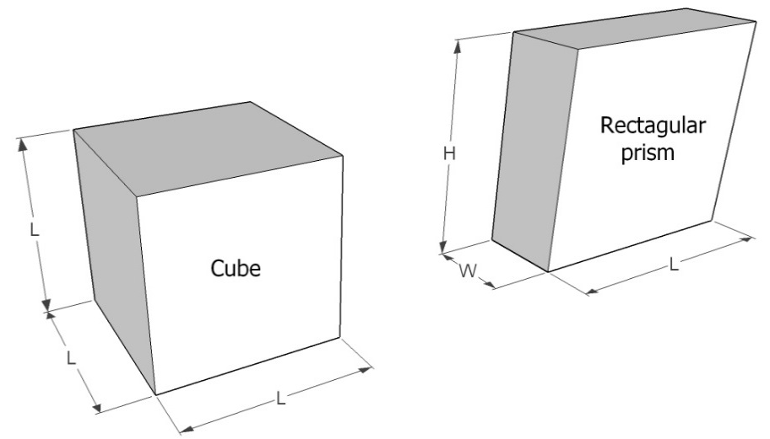

2. What are the equations for the volume and surface area of a cube and rectangular prism?

Volume of a cube: V_{cube} = __________________________________________________________

Surface area of a cube: SA_{cube} = ______________________________________________________

Volume of a rectangular prism: V_{RP} = _________________________________________________

Surface area of a rectangular prism: SA_{RP} = ____________________________________________

3. What is the difference in surface area of the packages below? (Note that they have the same volume.)

4. Sketch a cube-shape package next to the rectangular prism shown below. On your sketch, include dimensions so that your cube and the rectangular prism have the same volume. Show your work.

5. List at least 3 realistic problem criteria and constraints that should be considered in packaging design:

6. Write a paragraph explaining why consumer goods packaged in cube-shaped boxes would use less packaging material than rectangular boxes containing the same product volumes. Provide an example, including sketches of the boxes and their dimensions, to substantiate your explanation. Why aren’t more products in cube-shaped boxes?

