Boxed In and Wrapped Up Assessment Answer Key

1. Identify the problem: Packaging boxes use too much material and create waste

Competing design solutions are shown below
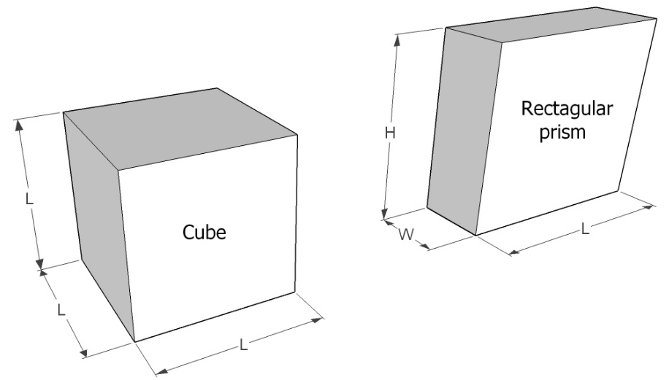

2. What are the equations for the volume and surface area of a cube and rectangular prism?

Volume of a cube: V_{cube} = L x L x L = L³

Surface area of a cube: SA_{cube} = 6 x (L x L) = 6L²

Volume of a rectangular prism: V_{RP} = L x W x H = LWH

Surface area of a rectangular prism: SA_{RP} = 2 x (L x W) + 2 x (L x H) + 2 x (W x H) = 2(LW + LH + WH)

3. What is the difference in surface area of the packages below? (Note that they have the same volume.)

SA_{cube} = 6L² = 6 (20 cm)² = 2,400 cm²
SA_{RP} = 2(LW + LH + WH) = 2 (20cm x 10cm + 20cm x 40cm + 10cm x 40cm) = 2,800 cm²
SA_{RP} – SA_{cube} = 2,800 cm² – 2,400cm² = 400 cm²

4. Sketch a cube-shape package next to the rectangular prism shown below. On your sketch, include dimensions so that your cube and the rectangular prism have the same volume. Show your work.

V_{RP} = LWH = 50cm x 12cm x 25cm = 15,000 cm³
V_{cube} = L³ = 15,000 cm³
L = (15,000cm³)^{1/3} ≅ 24.66 cm

5. List at least 3 realistic problem criteria and constraints that should be considered in packaging design:

Example answers include:
- Material waste should be minimized
- The shape of the product may dictate the shape of the packaging (e.g., spaghetti)
- The method of dispensing the product may also dictate the shape (e.g., cereal, toothpaste)
- Storing the product should be convenient (e.g., cubes may be impractical for cabinets)
- The surface are for marketing the product should be maximized

6. Write a paragraph explaining why consumer goods packaged in cube-shaped boxes would use less packaging material than rectangular boxes containing the same product volumes. Provide an example, including sketches of the boxes and their dimensions, to substantiate your explanation. Why aren’t more products in cube-shaped boxes?

