Name:
Class Period:
Date:

What is Pascal’s Law?

Needed Supplies: Pressure Gauge

Instructions: Read the following about hydraulic force multiplication and how it relates to the PFPD you previously worked on. This particular lesson will build upon your knowledge of forces and area by relating them to the definition of pressure.

Theoretical Background
- Pascal’s Law
  - For a particular position within a fluid at rest, the pressure is the same in all directions.
  - P = F / A (Equation 1.4)
    - P is pressure (in psi)
    - F is force (lbf)
    - A is area (in²)
- Hydraulic Cylinders
  - As you learned in “What is Fluid Flow?”, each side of the piston has its own area.
  - The force that the rod can exert depends upon which side of the piston has pressure acting upon it.
  - When the cylinder extends, the system fluid pushes against an area equal to the area of the cylinder (Ac).
    - The force that the cylinder rod exerts is:
      - F = PAc (Equation 1.5)
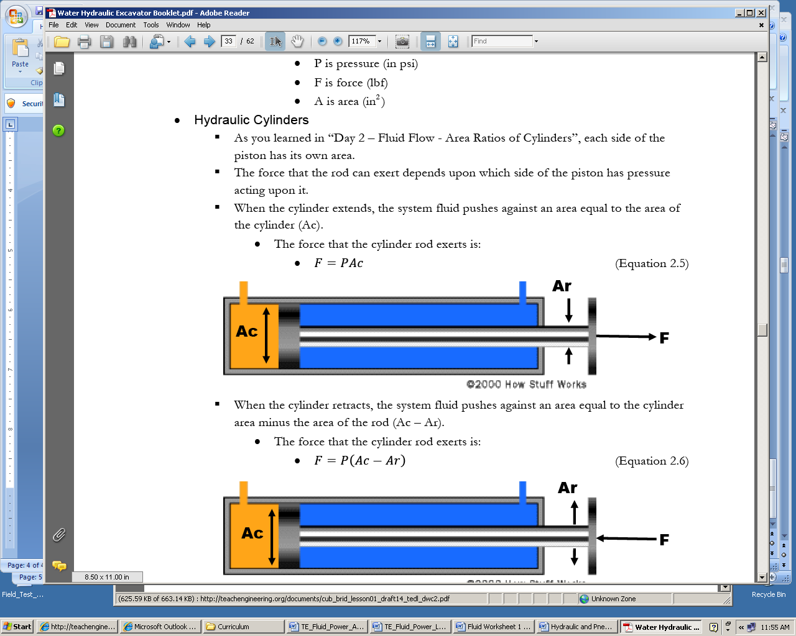
- When the cylinder retracts, the system fluid pushes against an area equal to the cylinder area minus the area of the rod (Ac – Ar).
  - The force that the cylinder rod exerts is:
    - F = P (Ac – Ar) (Equation 1.6)
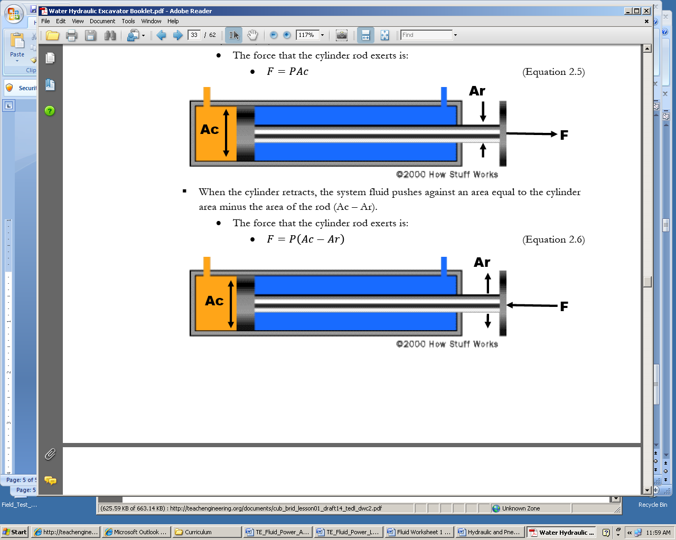

Experiment
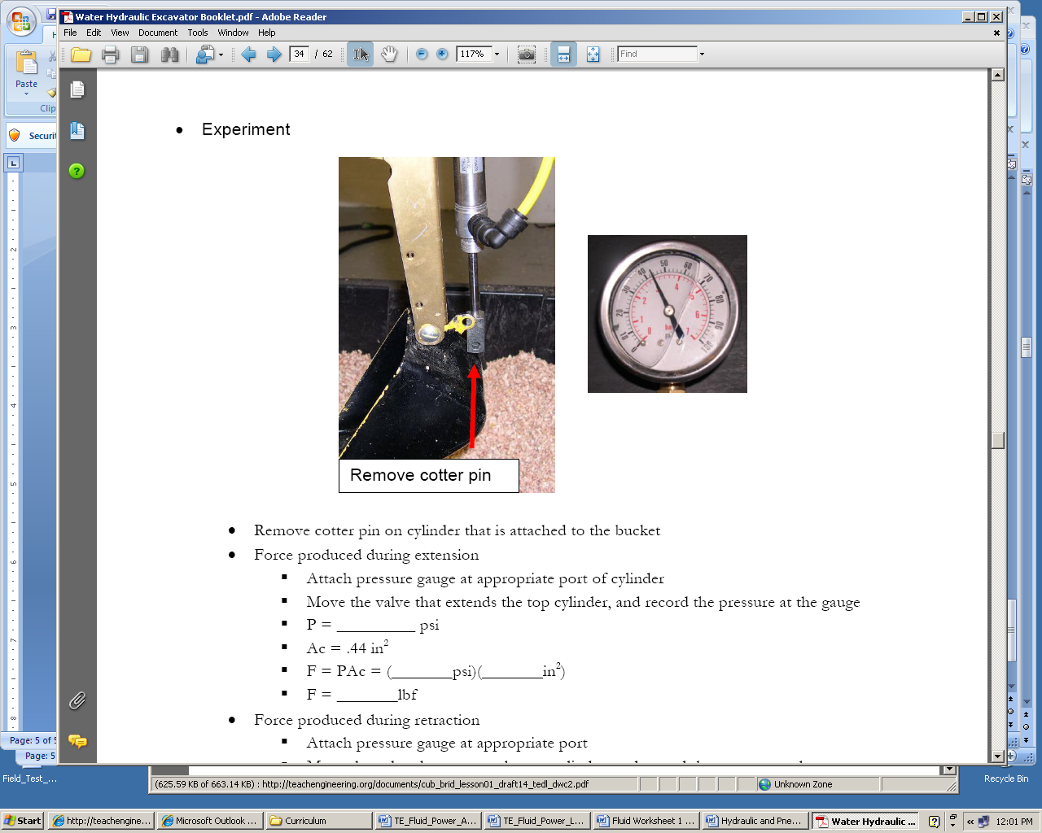
- Remove cotter pin on cylinder that is attached to the bucket
- Force produced during extension
  - Attach pressure gauge at appropriate port of cylinder
  - Move the valve that extends the top cylinder, and record the pressure at the gauge
  - P = ___________ psi
  - Ac = .44 in²
  - F = PAc = (_______psi)(_______in²)
  - F = _______lbf
- Force produced during retraction
  - Attach pressure gauge at appropriate port
  - Move the valve that retracts the top cylinder, and record the pressure at the gauge
  - P = _________ psi
  - Ac = .44 in²
  - Ar = .049 in²
  - F = P (Ac – Ar) = (_________ psi)(_________ in²)
  - F = ________ lbf
Discussion
- Given the same pressure, which side of the piston can produce more force? Why is this? (Refer to equations in theoretical background section)

- What would happen to the forces that the excavator cylinders produce if the system pressure were decreased? (In other words, what if there was a leak in the system?)

