What is a Nanometer?
Measurement & Conversion Worksheet Answers

Background

Nanotechnology is the engineering of functional systems at the molecular scale. While these materials have been around for decades, only recently—because of our improved capability to see at that scale—have they received so much attention. However, traditional material science and physics cannot explain, nor see, phenomena that occur at their tiny length scale. With the birth of quantum mechanics, scientists and engineers are able to model and predict material behaviors at those scales, yet it is all relatively new.

Nano materials are unique because of the relative size compared to the atomic scale. How small? At 100 nm, this is only 10 angstroms, which is ~5 times that of atom interatomic spacing in crystalline solids. This is extremely small and because of this relative size comparison, new interactions start occurring.
Before jumping into an investigation of the applications and improvements using nanotechnology, let’s consider how small a nanometer is. The size description of a nanometer just given is not meaningful to someone who is not a material scientist or engineer. How small is the nano scale compared to tangible, familiar objects? A nanometer is expressed as 1 x 10⁻⁹ m which means 1 meter contains 1,000,000,000 nanometers. This number is one BILLION nanometers in 1 meter. To put this in perspective, this is relatively equivalent to the approximate distance between Saturn and the Sun.

To grasp and understand these distances, we will use practical, everyday references to understand the nanometer. Today, you will measure a series of objects and provide answer in nanometers. You will also compare nanometers to small known objects or living things. By the end of today’s activity, you should have a firm grasp on this unique and important length scale.

Team Materials
Useful Unit Conversions
1 meter (m) = 1 x 10⁹ nanometers (nm)
1 meter (m) = 100 centimeters (cm)
1 inch (in) = 2.54 centimeters (cm)
1 foot (ft) = 12 inches (in)
1 meter (m) = 3.28 feet (ft)
- Two 12-in rulers
- Two 12-in pieces of string
- 1 tennis ball (or round object)
- 1 pencil
- 1 square
- 1-3 scientific calculators

Procedure
- Make sure all supplies are available at your lab station.
- Measure each piece of string and record your result below. This is used to calibrate your string. Make sure to label the units you are measuring in (for example, cm, in, m, ft).
string length: ________________________________
- Answer the questions below.

For each problem below, make your measurements using the appropriate measuring device. Make sure to read the problem carefully and include units of measure for credit!

Measurement 1
Measure the circumference of the round object. Record measurement below and convert to nanometers.
Actual measurement: ________________________________________
How many nanometers: ______________________________________
Measurement instrument used: ______________________________________
Answers will vary.

Measurement 2
Measure the perimeter of the square. Record measurement below and convert to nanometers.
Answers will vary.
Actual measurement: ________________________________________
How many nanometers: ______________________________________
Measurement instrument used: ______________________________________

Measurement 3
Measure the length of the pencil. Record measurement below and convert to nanometers.
Answers will vary.
Actual measurement: ________________________________________
How many nanometers: ______________________________________
Measurement instrument used: ______________________________________

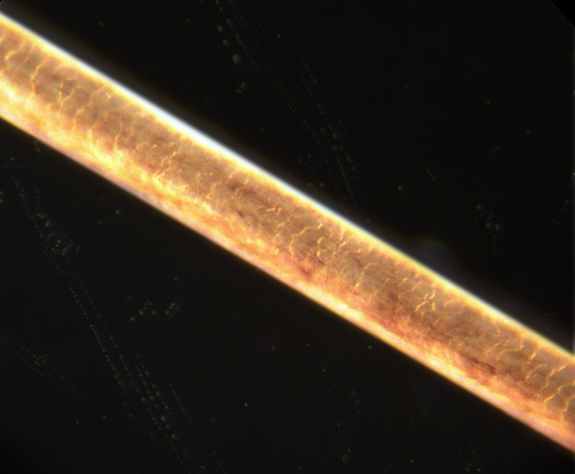
Comparison Calculations
To the right is a photograph of a human hair. A typical human hair has a diameter of 70 micrometers. Calculate the equivalent diameter in nanometers.
70,000 nm
How many nanometers: ___________________
Fun Fact: The world’s smallest radio is approximately 1,000 nm in length and 10 nm wide. How does your hair compare to this radio?
The hair width is 70 times larger than the length of the radio and 7,000 times larger than the width of the radio.

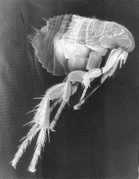

To the right is a photograph of a flea at high magnification. A typical (medium-sized) flea is about 2 mm in length. Calculate the equivalent length in nanometers.
2 x 10⁶ nm
How many nanometers: ___________________
Fun Fact: Fleas are known to jump frequently and have the ability to jump great distances. On average, fleas can leap 200 times their own body length. How far is this distance in nanometers?
200 x 2 x 10⁶ = 4 x 10⁸ nm

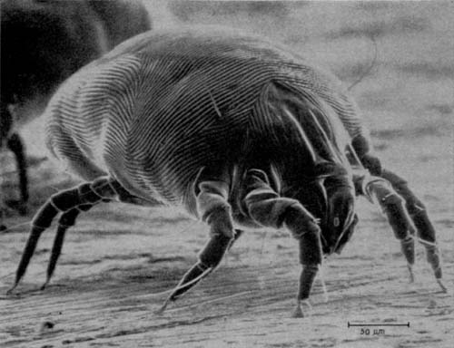
To the right is a photograph of a dust mite at high magnification. Dust mites can grow to 0.4 mm in length and 0.3 mm in width. Calculate the equivalent length and width in nanometers.
width 3 x 10⁶ nm
length 4 x 10⁶ nm
How many nanometers: ___________________

Fun Fact: The world’s smallest machine measures 250 micrometers in length. How does this compare with a dust mite?
~6.25% the size of a dust mite

Image sources (all public domain):
(top) 200X hair by Jan Homann/gemeinfrei from http://commons.wikimedia.org/wiki/File:Menschenhaar_200_fach.jpg
(middle) scanning electron micrograph of a flea by Janice Carr of CDC from http://commons.wikimedia.org/wiki/File:Scanning_Electron_Micrograph_of_a_Flea.jpg
(bottom) scanning electron micrograph of a dust mite by employee of the FDA from http://commons.wikimedia.org/wiki/File:House_Dust_Mite.jpg

Measurement 4
How tall do you think you are in nanometers?
Measure and convert your height in nanometers.
Use your choice of measuring device as long as you label the units.
Example answer: 5ft, 4 inches = 64 inches
1,625,600,000 nm
Answers will vary.
Actual measurement: ________________________________________
How many nanometers: ______________________________________
Measurement instrument used: ______________________________________

Question:
What is a nanometer and how big is it?
A nanometer is a unit of length measurement.
It is equivalent to 1 x 10⁻⁹ m, or very, very, very small!

