Intermolecular Forces Lab Worksheet
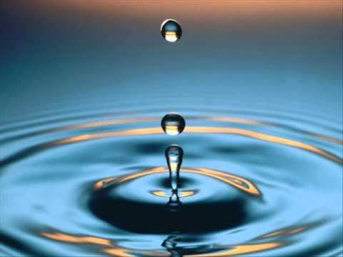
Directions: Today you will complete two experiments that compare the properties of water to isopropanol (a type of rubbing alcohol). Before conducting each experiment, you will first read about the experiment and then make a prediction about what you think will happen. Afterward you do the experiment, you will write an explanation of what was happening at the atomic level that let us observe these properties.

Introduction: In many ways, water is a miracle liquid. It is essential for all living things on earth and it is often referred to as a universal solvent because many substances dissolve in it. Water displays unusual properties due to the ways the individual water molecules interact with each other.

- Draw the structural formula (with lone pairs) for the two molecules we will be comparing today, water (H₂O) and isopropanol (C₃H₈O). Draw a dipole arrow to show the direction the electrons are being pulled and label the areas of partial positive and negative charges.
H₂O | C₃H₈O  Note: the bond between C and H is NOT POLAR. Do not draw dipole arrows or partial charges for those bonds.

- Which molecule is more polar? ______________________________________________________

Experiment #1: Penny
How many drops of water fit on the head of a penny? How many drops of isopropanol fit on the head of a penny?

Prediction:
  - I think _________ drops of water will fit on the head of the penny because ___________________ ______________________________________________________________________________________________________________________________________________________________
  - I think _________ drops of isopropanol will fit on the head of the penny because _______________ ______________________________________________________________________________________________________________________________________________________________
Procedure:
- Place one penny on a paper towel.
- Drop water onto the surface of the penny, slowly, one drop at a time using the dropper bottle with water.
- Count how many drops it takes until the water spills off the penny.
- Record the number of drops.
- Repeat steps A through D for isopropanol using the dropper bottle with isopropyl alcohol.
- Compare the number of drops of isopropanol to the number of drops of water.

Observations:
Drops that fit on the penny
Water
Isopropanol

Conclusions:
Were your predictions correct? Explain. ___________________________________________________________________
___________________________________________________________________________________________________________
___________________________________________________________________________________________________________
___________________________________________________________________________________________________________

Reading:
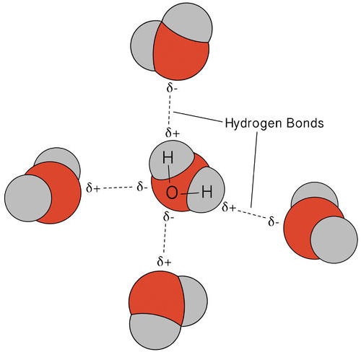
Since the hydrogen and oxygen atoms in the water molecule carry opposite (through partial) charges, nearby water molecules are attracted to each other. The attraction between the δ+ hydrogen and the δ- oxygen in adjacent molecules is called hydrogen bonding.

Hydrogen bonding is an intermolecular force. Intermolecular forces are forces between molecules in a substance. Hydrogen bonding is one of the strongest intermolecular forces and causes water to have many unusual properties.
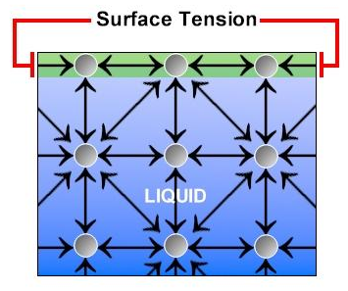
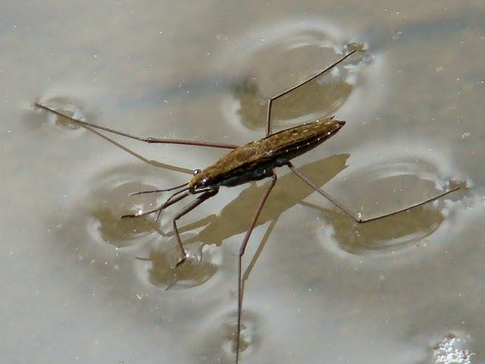
Neighboring water molecules are attracted to one another. Molecules at the surface of liquid water have fewer neighbors and, as a result, have a greater attraction to the few water molecules that are nearby. This enhanced (greater) attraction is called surface tension. It makes the surface of the liquid water slightly more difficult to break through than the interior of the water.

Surface tension (seen on the left) is the force between water molecules at the surface of a sample of liquid water. These molecules form stronger hydrogen bonds with each other than the molecules below. A water strider is an insect that takes advantage of this property of water – the insect can walk along the surface without breaking through.

Explanation: Why did more water drops fit on the surface of the penny then isopropanol drops? Use evidence from the reading about hydrogen bonding and intermolecular forces in your response.

____________________________________________________________________________________________________________________________________________________________________________________________________________________________________________________________________________________________________________________________________________________________________________________________________________________________________________________________________________________________________________

Experiment #2: Evaporation Rates
Which evaporates faster, water or isopropanol?

Prediction: Do you think water or isopropanol will evaporate faster? Why? ________________________________________________________________________________________________________________________________________________________________________________________________________________________________________________________________________________________________________________________________________
Procedure:
- Dip one end of a Q-tip in water. Shake of excess water.
- Dip one end of a different Q-tip in isopropanol. Shake off excess isopropanol.
- At the same time, draw (streak) the tips of each Q-tip across a paper towel in two parallel lines.
- Time how long it takes for each streak to evaporate.
- Watch and wait to determine which liquid evaporates first. (This may take a few minutes.) Record your observations.

Observations:
Time to evaporation
Water
Isopropanol

Conclusions:
Were your predictions correct? Explain. ___________________________________________________________________
___________________________________________________________________________________________________________
___________________________________________________________________________________________________________
___________________________________________________________________________________________________________

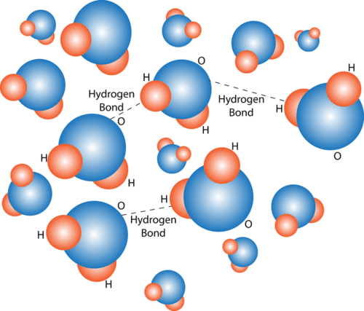
Reading:
Since the hydrogen and oxygen atoms in the molecule carry opposite partial charges, nearby water molecules are attracted to each other. The attraction between the δ+ hydrogen and the δ- oxygen in adjacent molecules is a special type of intermolecular force called hydrogen bonding that causes water molecules to “stick” together in liquid form. This force has to be overcome in order for liquid water to become a gas. It takes a lot of energy to overcome the force of hydrogen bonding.
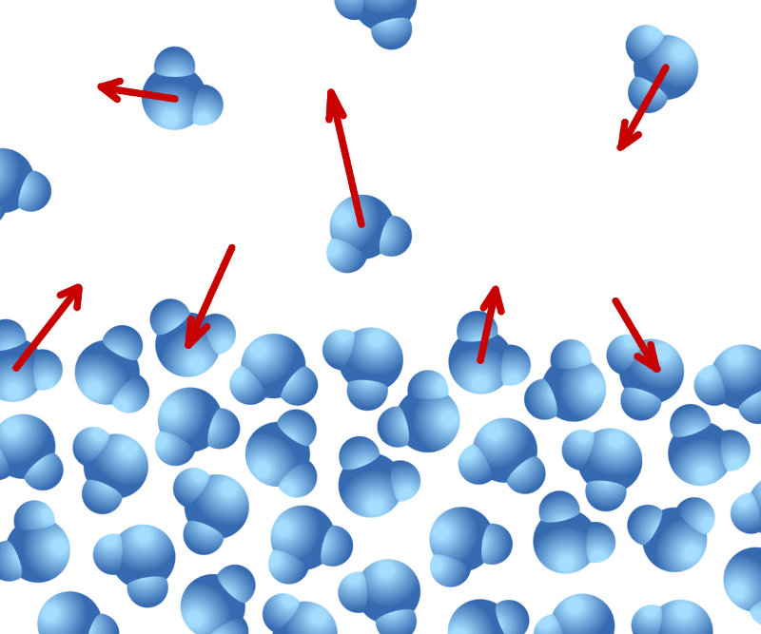
When enough energy has been added to water it boils and turns from liquid to gas. This happens at a temperature of 100˚C. Isopropanol turns from liquid to gas at 82.5˚ C. Since the vaporization of isopropanol occurs at a lower temperature than water, this means it takes less energy to turn isopropanol into a gas, and therefore it will evaporate faster than water. Isopropanol has weaker intermolecular forces holding its molecules together so it takes less energy (a lower temperature) to separate the molecules to enter the gas phase.

Explanation: Why does isopropanol evaporate faster than water? Use the terms hydrogen bonding and intermolecular forces in your response.

____________________________________________________________________________________________________________________________________________________________________________________________________________________________________________________________________________________________________________________________________________________________________________________________________________________________________________________________________________________________________________
__________________________________________________________________________________

