Using Nature as the Solution Worksheet – Answer Key

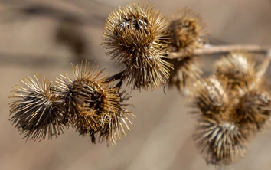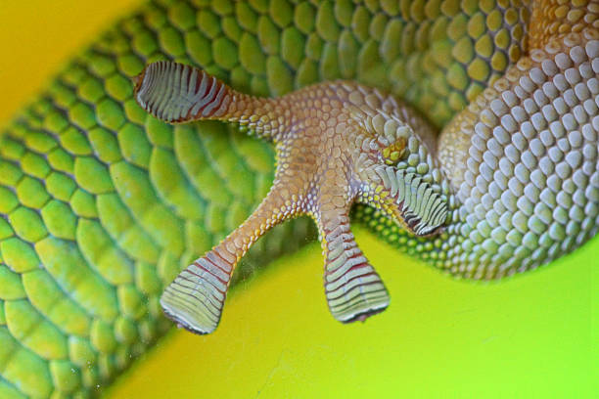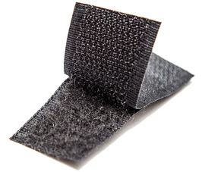

Introduction to Biomimicry
Instructions: Read the paragraphs below and then answer the prompt with your group.

Biomimetics, also known as biomimicry (bio=life, mimic=copy), is a newly developed field that uses concepts and structures developed in nature to solve complex human problems. Biomimicry empowers engineers to create eco-friendly and sustainable solutions inspired by nature. Many of the problems humans face have been solved already in nature. It is by researching nature’s engineers that we can mimic and solve our own problems.

One very important problem engineers try to solve is how to help more people have abundant, clean water. Water affects your life in many ways. With your group, write down as many ideas as you can think of for the prompt below.

- Prompt: List the ways water affects your life.
Student answers will vary but may include the following ideas:
- We need to drink water to stay alive
- We need water to grow crops
- Our pets need to drink water or they could die
- Fish that we eat need water to survive
- Animals that we eat need water to survive
- We need water to shower/take baths
- There is water in the rain and the snow.
- We need fresh water and there is salt water in the ocean, we can’t drink ocean water

Engineers have been studying how to work with water for many years now and have looked to biomimicry to solve problems involving water. When solving problems engineers ask, “How does nature…?” Some questions engineers and scientists are trying to solve are:
- How can we waterproof materials or goods?
- How can we use properties of water such as capillary action to clean?
- How can we harvest water from the atmosphere?
- How can we purify water? How can we desalinate water?
- How can we clean up water from oil spills?
Part I - Biomimicry in Action
Instructions: Watch the Ted Talk, Biomimicry in Action, by Janine Benyus:
https://www.ted.com/talks/janine_benyus_biomimicry_in_action/transcript?language=en
Then discuss and answer the following questions with your group.

- According to Janine, what is biomimicry?
Learning from the natural geniuses in our world.

- Why do you think Janine used the wasp house scenario to begin her presentation on biomimicry?
Humans think that we are the most skilled with architecture and precision, but we often forget that we are not and that other organisms are also skilled and engineer things.

- Why does Janine ask, “How does nature do something?”
Many things that we want to invent or develop, may have already been created or engineered by other organisms.

- What are some new technologies humans have developed as a result of studying nature?
Quieting a train, repelling bacteria, providing freshwater, creating concrete using CO₂, making bridges and cars more lightweight, desalinating (taking salt out of) water, reducing drag on wind turbines, etc.

- In what ways can biomimicry help people access clean drinking water?
The Namibian “critter” that collects water from the fog on its body can get water from fog.

Part II - Examples of Biomimicry
Instructions: At each station, discuss how the pictures are related and how engineers borrowed ideas from nature to solve problems. Then, fill in each column below before rotating to the next station at your teacher’s signal.

Station | Organism | Structure Description and Function | Engineering Uses
Station 1 | 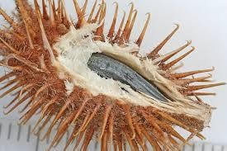  Cockleburs | Hooks on the burrs attach to fabric, fur, and hair | Velcro
 | 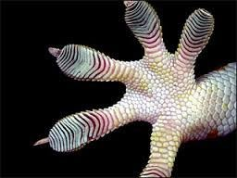  Geckos | Millions of tiny hairs on their feet have molecular forces that keep them attached to walls | Gecko tape to replace sutures or Band-Aids – future could hold spiderman like suits for scaling walls
Station | Organism | Structure Description and Function | Engineering Uses
Station 2 | 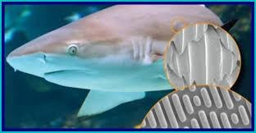  Sharks | Denticles on their skin prevent microorganisms from latching on and help reduce drag | Riblets on boats and windmills that help  reduce drag and ability for micro-organisms to attach.
 | 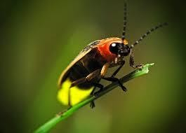  Fireflies | Sharp jagged scales that light up in their bellies | LED lights that are 55% brighter
Station | Organism | Structure Description and Function | Engineering Uses
Station 3 | 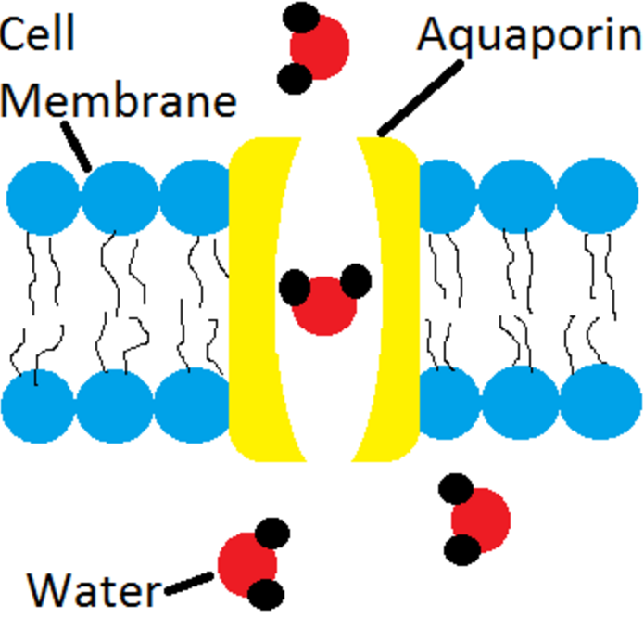  Aquaporins Channel  Proteins & Biological  Membranes | Pores in the cell membranes and cell walls of organisms can trap salt | Synthetic membranes made to desalinate water.
 | 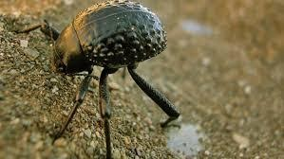Namibian Beetle | Shell catches water from fog because of hydrophilic channel that pass the water to the mouth of the beetle in areas of low water | A water bottle that also traps water from fog and uses chutes to bring it to a basin.
Station | Organism | Structure Description and Function | Engineering Uses
Station 4 | 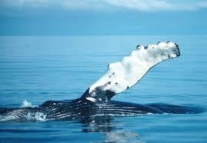  Humpback Whale | Tubercles on the front of the whale  fins reduce drag and increase energy  efficiency when swimming. | Tubercles used on wind turbines to cut down on drag, noise, and increase efficiency.
 | 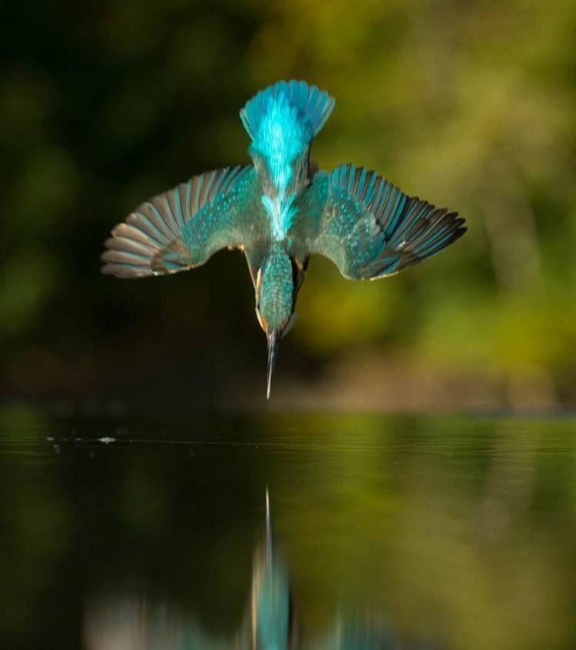  Kingfisher Bird | Kingfisher beak does not create waves when it enters the water hunting for fish. | The bullet train nose was changed so as not to disrupt air waves as much when leaving a tunnel which makes it quieter.

Part III - The Lotus Effect
Instructions: Complete the activity described below and answer the questions with your group. When you finish, watch the Ted Talk, A Very Dry Demo, and answer the questions. https://www.ted.com/talks/mark_shaw_one_very_dry_demo?language=bo
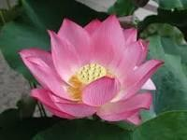
When working with water, one problem we have is the ability to waterproof. Waterproofing is important in anything from the clothes you wear when it is raining to flying a jet. One flower that scientists turned to for answers is the beautiful lotus flower. Lotus flowers are special because they never seem to get wet or dirty, even though they grow out from the mud. Some other plants seem to mimic these same characteristics. We will complete an activity where you will see this effect in action.

With the kale leaves at your table, complete the following activities:

- Take the plastic pipette from the water, place your leaf on a piece of paper towel, and slowly drop 10 droplets of water on the plant leaf. What happened when you dropped the water on the leaves?
The water drops rolled right off the leaf

- Slowly submerge the leaf in the water and then slowly remove it. What happened when you submerge the plant in water and then took it out?
The leaf came out dry and the water drops rolled off the leaf again.

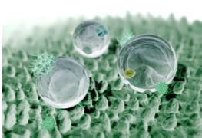

Scientists call this effect the “Lotus Effect” and describe the surface of the lotus leaf as superhydrophobic. So, what makes the surface of the lotus leaf behave in this way? Scientists have discovered that the leaves are in fact extremely rough having many tiny protrusions (bumps), the size of 10 µm, that each are coated with many nanosized waxy bumps. These form nanosized “whiskers” that create a layer of air on the surface of the material causing water to roll off. Since the discovery of these phenomena engineers have created materials that act in a similar manner.

Next watch a short Ted talk, A Very Dry Demo. As we watch, answer the questions below.
https://www.ted.com/talks/mark_shaw_one_very_dry_demo?language=bo

- In what ways did the engineer use biomimicry to solve a problem?
He made a spray (nanotechnology coating) that puts a layer of air around an object because of the superhydrophobic nanoparticles in the spray which prevents it from getting wet when introduced to water.

- Can you think of some applications engineers could utilize the Lotus Effect in everyday life? What about in a water filter?
Student answers will vary but they should include from the video objects that are self-cleaning, antibacterial, anti-ice, anti-corrosion, and anti-wetting.

