Using Nature as the Solution Worksheet

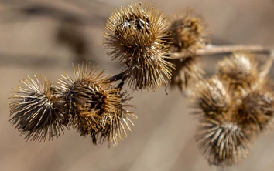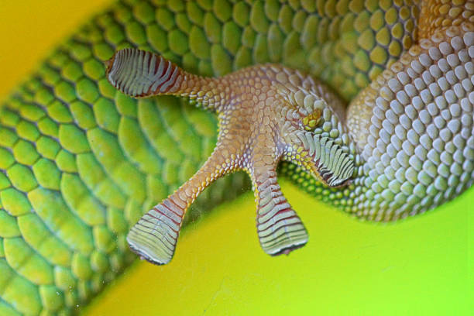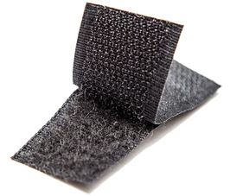

Introduction to Biomimicry
Instructions: Read the paragraphs below and then answer the prompt with your group.

Biomimetics, also known as biomimicry (bio=life, mimic=copy), is a newly developed field that uses concepts and structures developed in nature to solve complex human problems. Biomimicry empowers engineers to create eco-friendly and sustainable solutions inspired by nature. Many of the problems humans face have been solved already in nature. It is by researching nature’s engineers that we can mimic and solve our own problems.

One very important problem engineers try to solve is how to help more people have abundant, clean water. Water affects your life in many ways. With your group, write down as many ideas as you can think of for the prompt below.

- Prompt: List the ways water affects your life.

Engineers have been studying how to work with water for many years now and have looked to biomimicry to solve problems involving water. When solving problems engineers ask, “How does nature…?” Some questions engineers and scientists are trying to solve are:
- How can we waterproof materials or goods?
- How can we use properties of water such as capillary action to clean?
- How can we harvest water from the atmosphere?
- How can we purify water? How can we desalinate water?
- How can we clean up water from oil spills?

Part I - Biomimicry in Action
Instructions: Watch the Ted Talk, Biomimicry in Action, by Janine Benyus:
https://www.ted.com/talks/janine_benyus_biomimicry_in_action/transcript?language=en
Then discuss and answer the following questions with your group.

- According to Janine, what is biomimicry?

- Why do you think Janine used the wasp house scenario to begin her presentation on biomimicry?

- Why does Janine ask, “How does nature do something?”

- What are some new technologies humans have developed as a result of studying nature?

- In what ways can biomimicry help people access clean drinking water?

Part II - Examples of Biomimicry
Instructions: At each station, discuss how the pictures are related and how engineers borrowed ideas from nature to solve problems. Then, fill in each column below before rotating to the next station at your teacher’s signal.

Station | Organism | Structure Description and Function | Engineering Uses
Station 1 | 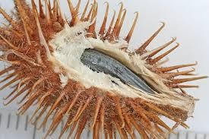  Cockleburs
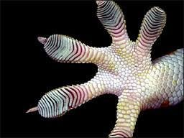
Geckos
Station | Organism | Structure Description and Function | Engineering Uses
Station 2 | 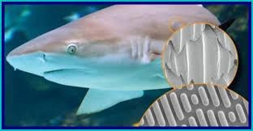  Sharks |  | .
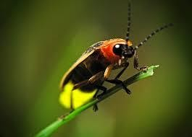
Fireflies
Station | Organism | Structure Description and Function | Engineering Uses
Station 3 | 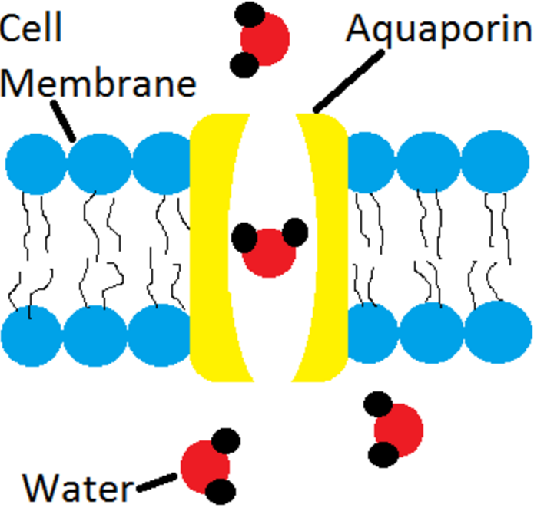  Aquaporins Channel  Proteins & Biological  Membranes
 | 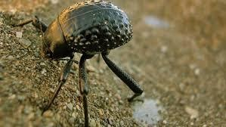Namibian Beetle
Station | Organism | Structure Description and Function | Engineering Uses
Station 4 | 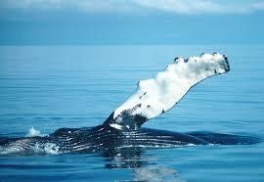  Humpback Whale
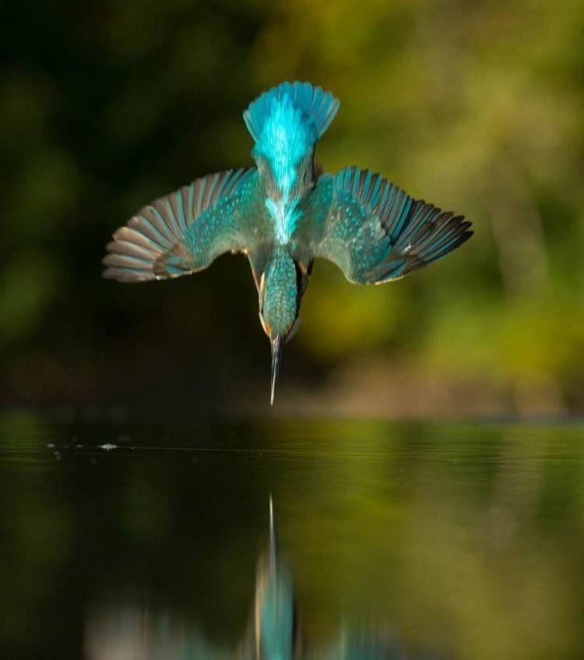
Kingfisher Bird

Part III - The Lotus Effect
Instructions: Complete the activity described below and answer the questions with your group. When you finish, watch the Ted Talk, A Very Dry Demo, and answer the questions. https://www.ted.com/talks/mark_shaw_one_very_dry_demo?language=bo
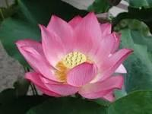
When working with water, one problem we have is the ability to waterproof. Waterproofing is important in anything from the clothes you wear when it is raining to flying a jet. One flower that scientists turned to for answers is the beautiful lotus flower. Lotus flowers are special because they never seem to get wet or dirty, even though they grow out from the mud. Some other plants seem to mimic these same characteristics. We will complete an activity where you will see this effect in action.

With the kale leaves at your table, complete the following activities:

- Take the plastic pipette from the water, place your leaf on a piece of paper towel, and slowly drop 10 droplets of water on the plant leaf. What happened when you dropped the water on the leaves?

- Slowly submerge the leaf in the water and then slowly remove it. What happened when you submerge the plant in water and then took it out?

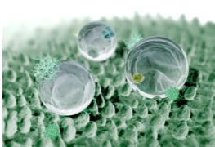

Scientists call this effect the “Lotus Effect” and describe the surface of the lotus leaf as superhydrophobic. So, what makes the surface of the lotus leaf behave in this way? Scientists have discovered that the leaves are in fact extremely rough having many tiny protrusions (bumps), the size of 10 µm, that each are coated with many nanosized waxy bumps. These form nanosized “whiskers” that create a layer of air on the surface of the material causing water to roll off. Since the discovery of these phenomena engineers have created materials that act in a similar manner.

Next watch a short Ted talk, A Very Dry Demo. As we watch, answer the questions below.
https://www.ted.com/talks/mark_shaw_one_very_dry_demo?language=bo

- In what ways did the engineer use biomimicry to solve a problem?

- Can you think of some applications engineers could utilize the Lotus Effect in everyday life? What about in a water filter?

