ELISA Templates

Modeling an Enzyme-Linked Immunosorbent Assay Templates
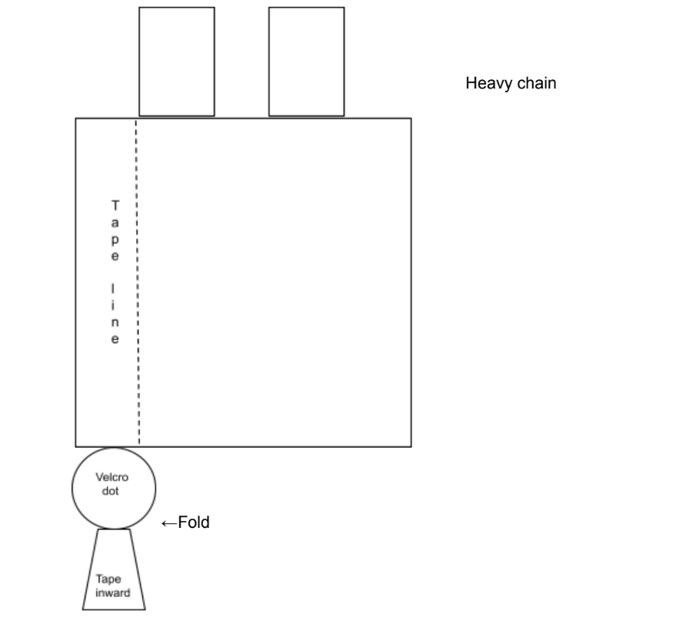

Heavy chain, Primary antibody
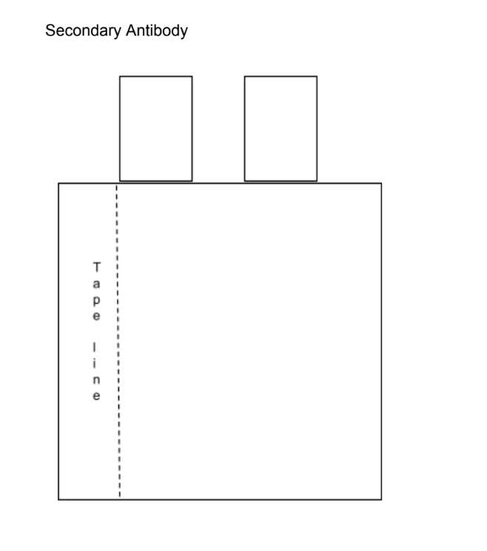Print in a different color
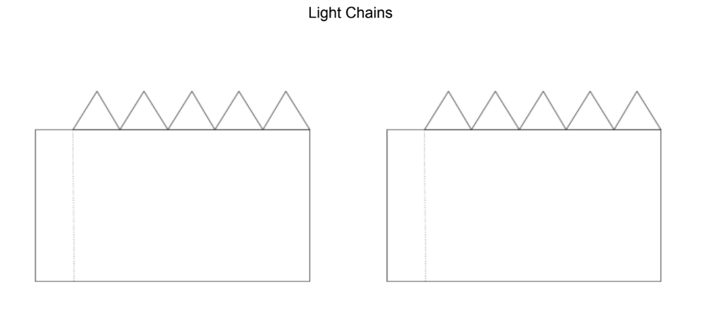
Print twice for two antibodies: Two in the same color as the primary antibody, and two in the same color as the secondary antibody.

