Transportation Fuels Debate Game Board
Gasoline | 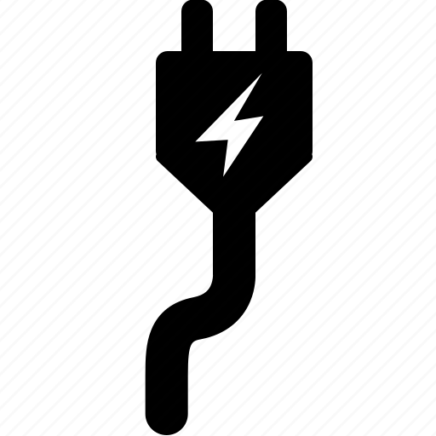  Electricity | Hybrid Electric
 |  |  | +3
 |  |  | +2
 |  |  | +1
 |  |  | Start Here
 |  |  | -1
 |  |  | -2
 |  |  | -3

