Activity: Renew-A-Bead
Purpose
The sources that provide the energy we use every day can be divided into two different groups: Renewable and Non-Renewable. Renewable energy sources are those that are continuously replenished in a reasonable time frame. Non-renewable energy sources are those that are used and cannot be recreated in a short period of time.

In this activity you will be given a bag of “energy beads.” Each bag contains energy provided by both renewable (white beads) and non-renewable (black beads) sources. You will “use” the energy provided by both types of sources by randomly picking beads from a bag – some of the “energy” you use will be renewable, some will be non-renewable. You will see what happens to the renewable/non-renewable energy sources that remain after many years of energy use.

Equipment
  - One paper bag containing 100 beads. The black beads represent non-renewable energy resources and the white beads represent renewable energy resources. (The ratio of white beads to black beads will vary depending on group)
  - Small Cloth
  - Extra bag
  - Calculator
  - Pencil

Procedure
    - Split into groups of 2 students.
    - Collect all equipment and materials necessary to conduct the activity.

Part 1: Simulate the annual consumption of energy - constant rate of energy use
    - Have one person from each group pick out 10 “energy beads” from the bag, without looking. These 10 beads represent the energy that is used in one year.
    - Count the black and white beads and record the number on the attached data collection sheet for Year 1.
    - The black beads represent energy from non-renewable energy sources, so when a black bead is picked it cannot be returned to the bag (place it in the extra plastic bag). The white beads are renewable energy beads, so they should be put back into the bag each turn after counting them.
    - Let another person from the group pick 10 beads to represent energy use in Year 2. Fill in the number of black and white beads on the chart, and return the white beads as in step 5.
    - Repeat the process, returning all white beads to the bag after each person’s turn, until 20 years have passed or until all the black energy beads are gone.

Part 2: Simulate the annual consumption of energy - increasing rate of energy use
    - The world population is increasing by about 75 million people per year. Consider the increasing use of power and energy over time as the world’s population grows. Repeat steps 3 through 7, but increase the amount of energy use by picking out 5 additional “energy beads” each year (pick 10 beads in year 1, 15 beads in year 2, 20 beads in year 3, etc.). Record information on the attached data collection sheet.
    - Complete the discussion questions.

Discussion Questions
- How many years did it take for the non-renewable energy sources to run out when you used 10 energy beads per year? How many years did it take for the non-renewable energy sources to run out with you increased the rate of consumption each year (part 2)? What conclusion can you draw from this about our energy use habits if the population continues to grow?
- What are some examples of renewable and non-renewable energy sources?
- What does this activity demonstrate about our consumption of resources - what will happen if we keep using non-renewable resources?
- Describe what happens to the proportion of renewable vs. non-renewable energy sources that remain available, as energy is used over time.
- Compare the results from teams with different energy mixes. If each bag represents a country, what can you say about countries that currently use a greater fraction of renewable energy? Will they be able to continue to provide for their country’s energy needs?
    - 6. Look at Figure 1, below, and answer the questions that follow:

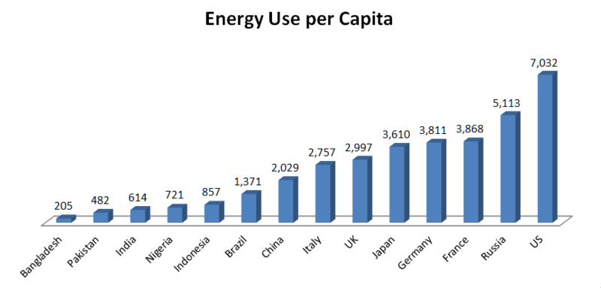
Figure 1. 2011 Energy use per person for different countries in units of Kg of oil equivalent. Source: World Bank via Wikimedia Commons (http://en.wikipedia.org/wiki/File:Energy_Use_per_Capita.png)

a. How many times more energy does a person living in the U.S. use each year compared to a person living in India?

b. Why do you think there are such differences between countries?

c. If the world population increases (as it is expected to) but we could choose how much energy each person uses, which country should we choose as a model to prolong our energy resources?”
Data collection for renew-a-bead –
Part 1: 10 energy beads used each year
Year | Total beads removed | Number black beads | Number white beads | Percent of beads that are renewable  $$\frac{\text{white} \text{beads}}{\text{total} \text{beads}}x\text{100}\text{\%}$$ | Number of beads remaining
1 | 10
2 | 10
3 | 10
4 | 10
5 | 10
6 | 10
7 | 10
8 | 10
9 | 10
10 | 10
11 | 10
12 | 10
13 | 10
14 | 10
15 | 10
16 | 10
17 | 10
18 | 10
19 | 10
20 | 10

Data collection for renew-a-bead –
Part 2: Increasing use of energy each year

Year | Total beads removed | Number black beads | Number white beads | Percent of beads that are renewable | Number of beads remaining
1 | 10
2 | 15
3 | 20
4 | 25
5 | 30
6 | 35
7 | 40
8 | 45
9 | 50
10 | 55
11 | 60
12 | 65
13 | 70
14 | 75
15 | 80
16 | 85
17 | 90
18 | 95
19 | 100
20

