Energy Choices

A board game for middle school children

Energy-related issues are particularly relevant to today’s students. The limited supply of fossil fuels, combined with detrimental environmental effects associated with energy use, are dictating dramatic changes in the way we harness and use energy. An educational program that provides students with the ability to critically analyze and problem solve will prepare them to interpret energy issues and make sound actions and choices, as voters, consumers, and professionals.
A board game has been developed by students and staff from Clarkson and St. Lawrence Universities as part of their NSF-Funded K-12 Project-Based Learning Partnership Program. The game is used to introduce the concepts of energy use in our lives and the very real impact that personal choices can have on our energy consumption, energy bills and fuel supply.
The game begins as each student selects cards that define their mode of transportation and home design (see examples on reverse). The players roll dice and move around the board, landing on “choice” or “situation” blocks and selecting cards that describe consumer choices and real life events that impact their energy consumption and annual energy bills. As the players pass gasoline stations or energy bill gates, they must pay annual expenses as defined by their original cards, with amounts altered by the choices they’ve made along the way. Gasoline cards are collected to represent their total consumption. Too many gas guzzling vehicles can result in total depletion of their gasoline supply – at which point everyone must walk or ride the bus.
The game provides some context for serious classroom discussions about our current energy situation. Discussion points can include:

  - How did the choices you made affect how much money you had at the end?
  - Which home system wound up with the most money at the end? Why?
  - Which car wound up with the most gas cards at the end? What do you know about this type of car? (big, gas guzzler) How did having a lot of gas cards affect the owner’s financial state?
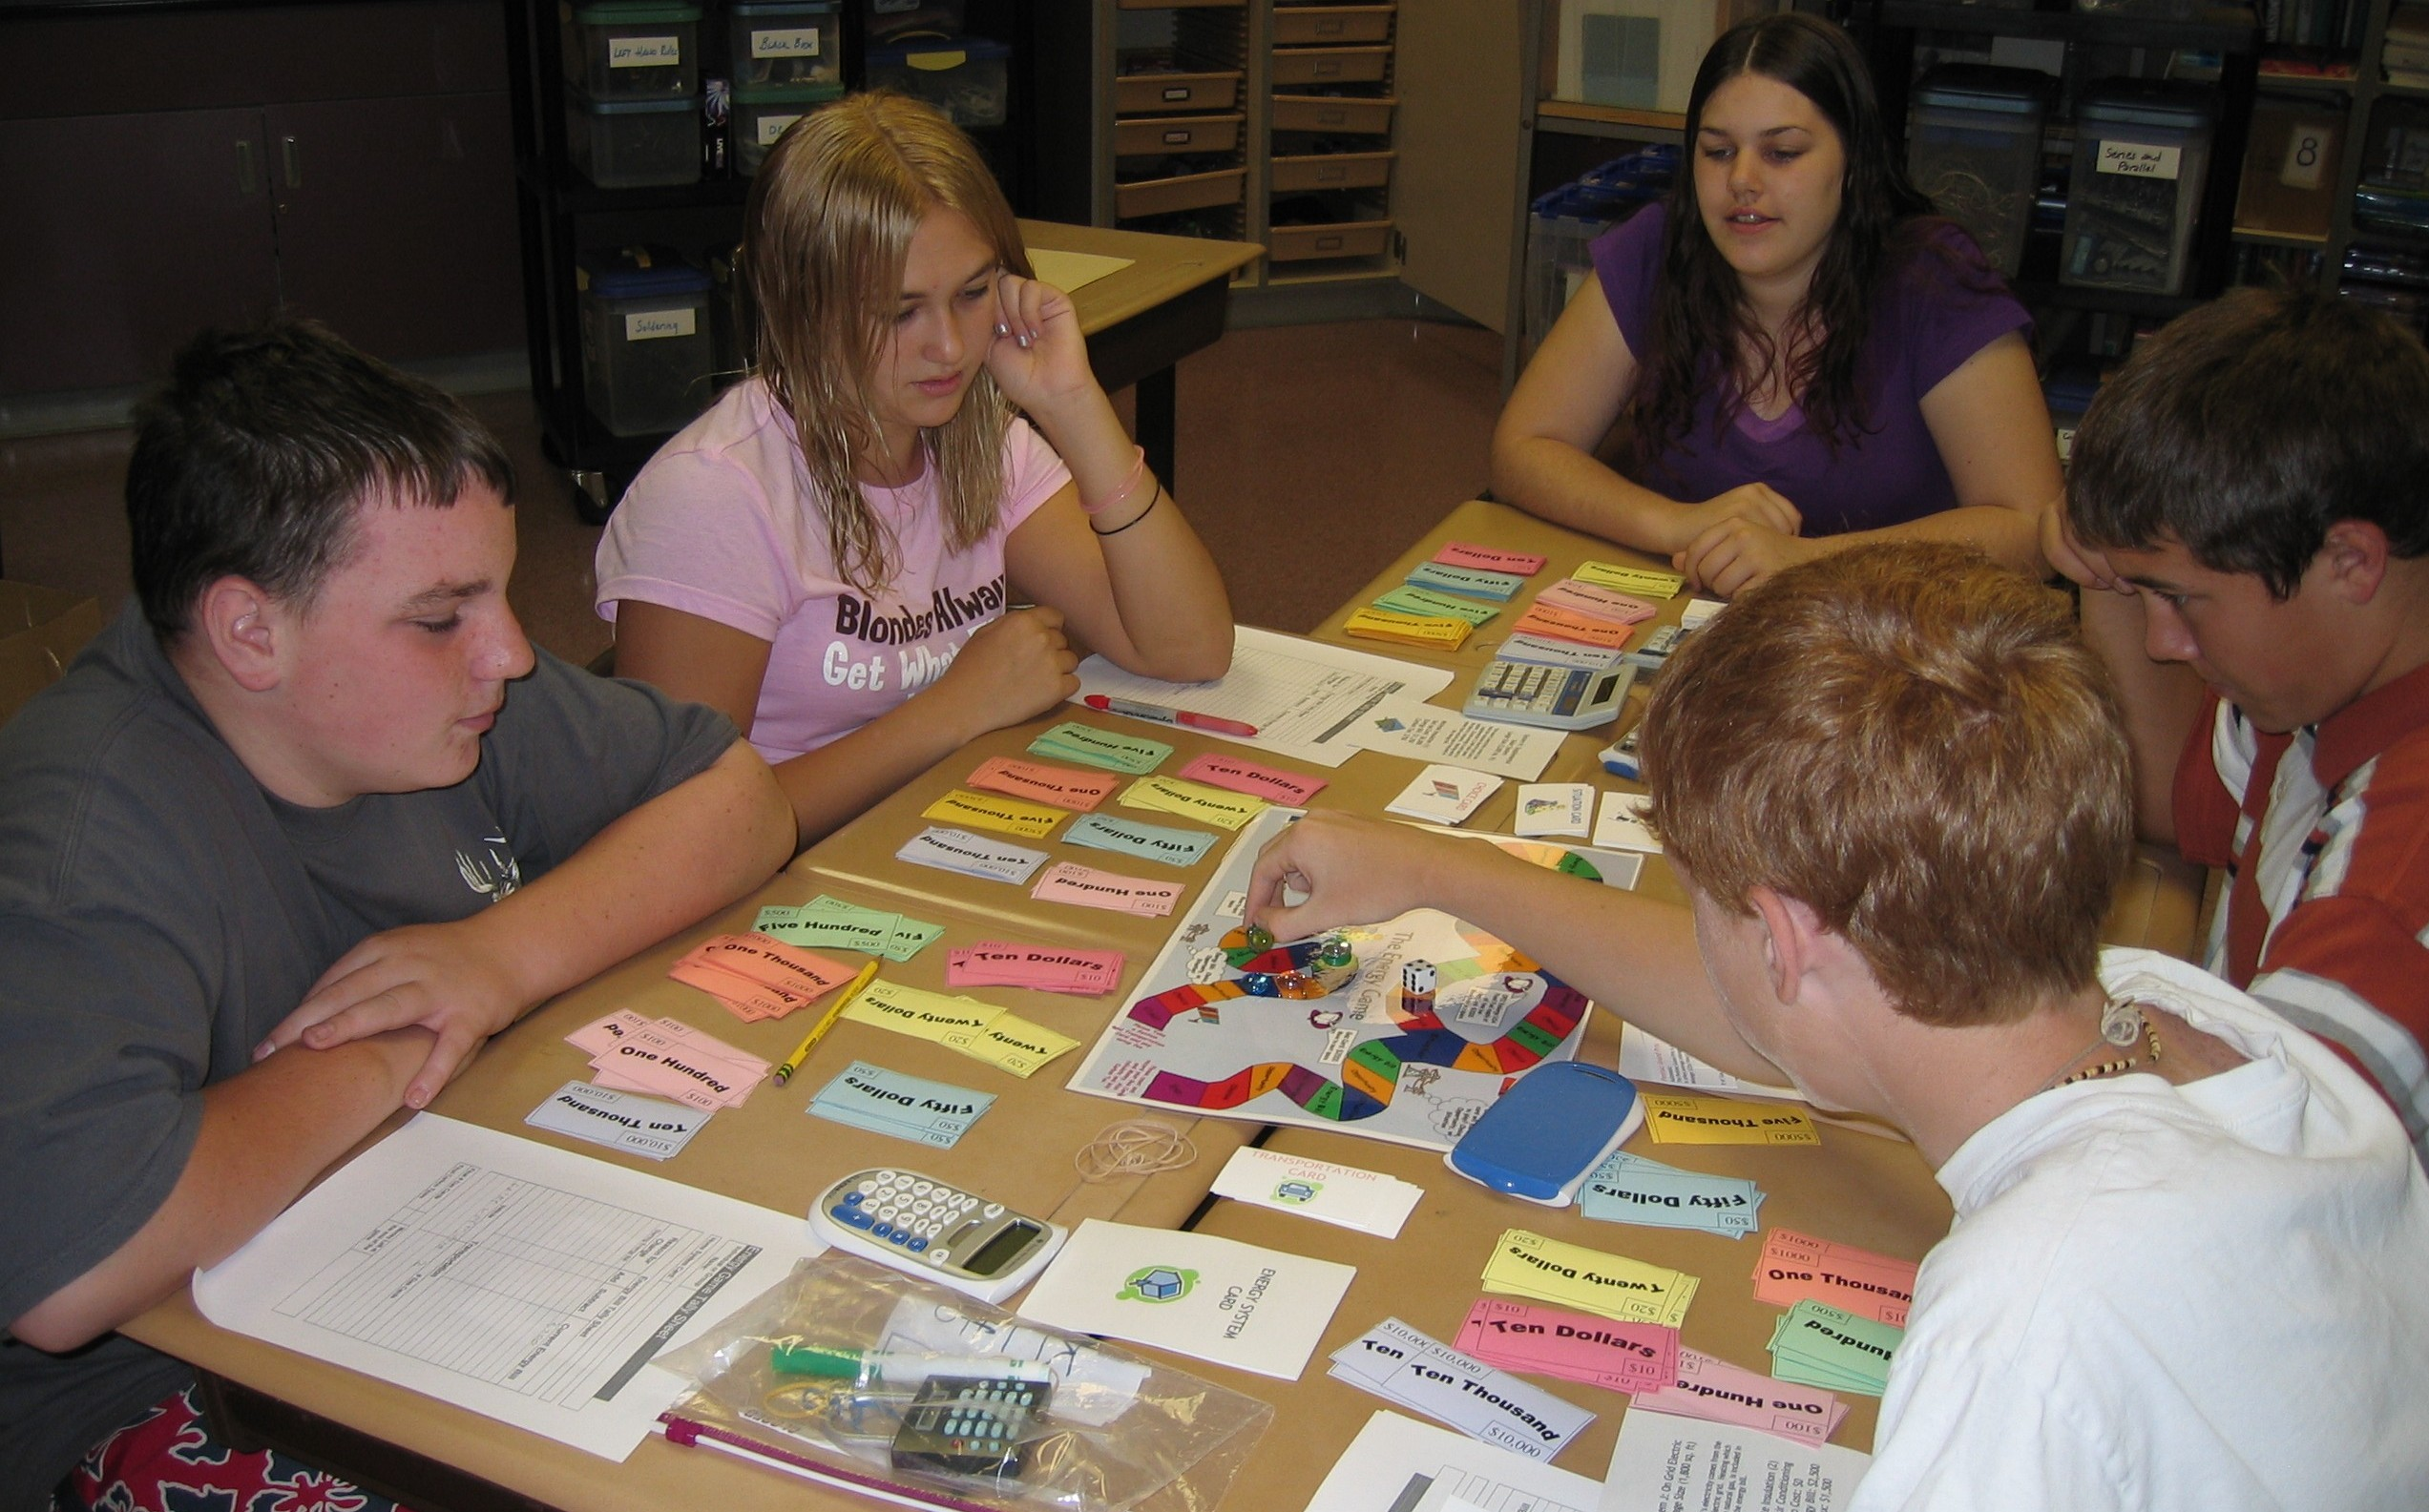
  - What do you think the carbon tax you paid at the end of the game represents?
  - Why did gasoline and home energy prices increase throughout the game? Do you think this will be an issue in your own lives?
  - Did any teams run out of gasoline cards? What does this represent? Which type of transportation contributed most to the depletion of gasoline cards?

Example cards used in the Energy Choices game
Two-door hybrid  (Two Seater) Automatic Transmission  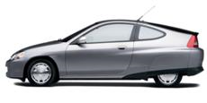  Small hybrids offers great mileage and aids in reducing pollution and global warming by switching between a gas engine and electric motor.  Mileage (City/Hwy): 57/56  # of Gas Cards: 1 | Big, luxury vehicle  Automatic Transmission  This sleek black sedan is a great car if you like fast and beauty. However it requires Premium gasoline which is expensive and it needs a lot of it.    Mileage (City/Hwy): 19/27  # of Gas Cards: 5
System B: On-Grid Electric  Large Size (3,000 sq. ft)  This home’s electricity comes from the national electric grid. Heating which comes from natural gas, is included in the energy bill.  Minimal Insulation (1)  Central Air Conditioning  Set-Up Cost: $0  Annual Energy Bill:  3,900 zaps  Carbon Tax: $2,500 | System E: Supplemental  Solar System  Average Size (1,800 sq. ft)    This home’s electricity comes from both the electric grid and a supplemental 1KW solar panel system. Excess energy is sold back to the electric company. Heating, which comes from natural gas, is included in the energy bill.  Moderate Insulation (2)  Set-up Cost: $6,000  Energy Bill: 1,000 zaps  Carbon Tax: $600
Situation:  Heat Wave strikes!  All players pay:  if Air Conditioning pay $200  if Fans pay $50  if Insulating Window Shades pay $0 | Situation:    Tax Rebate for alternative energy production!  Any player with an alternative energy system receives $500.
Choice: You win the festival for the most beautiful holiday lights decoration!! You will be giving the key to the town and one week vacation in Disney World.  Cash Prize: $200 Energy Bill: +1,000 zaps | Choice: Ride the bus?  Cost: $300  Present this at the next gas station and you don’t have to buy gas.

