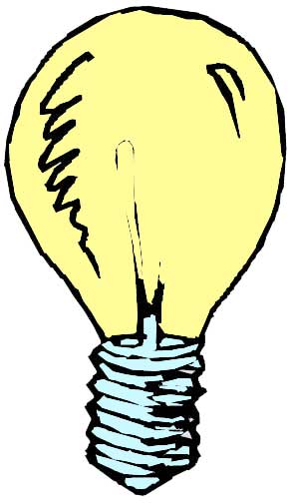
Homework – Home Light Bulb Use

Name: _______________

Lighting accounts for 20-25% of all the electricity used in the United States. On average a household sets aside 5-10% of its energy budget to lighting. A commercial industry on the other hand consumes 20-30% of their energy in lighting only. 50% or more of the energy used is wasted by obsolete equipment, inadequate maintenance, or inefficient use. Energy savings for lighting will require either reduction in use or more efficient usage. The purpose of this homework is to:
- Determine your current electric lighting situation
- Decide if you could benefit from changing from incandescent to compact fluorescent bulbs

Fill in the attached chart, following these instructions.
Remember to show all work including formulae, answers, and units.

  - Walk around your house and examine any lights that you may have. Fill in the chart below to charactarize your bulbs. Remember the class activity “Light or Heat Bulbs” when identifying the type and power rating of the bulbs. Fill in the columns on Table 1.

  - Convert the rated power of your light bulbs from Watts (W) to Kilowatts (kW) on Table 1. Remember that there are 1000 Watts in 1 Kilowatt.

  - Estimate the number of hours you use each bulb in a day and fill in the appropriate column in Table 1

  - Calculate the daily energy used each day by each bulb type by multiplying and filling in the last column of Table 1:

Total Daily Energy (kWh per day)
= Number of Bulbs x Rated Power (kW) x # of Hours Used per Day (h per day)

- Sum the values in the last column to find the total amount of energy used by light bulbs in your house each day.

- To find out how much energy that only the INCANDESCENT bulbs consume in a day, add values in the last column of Table 1 that correspond to only the COMPACT FLUORESCENT bulbs and subtract it from the Total found in step 5. Record this value.

- You can now find out how much energy you can save by switching your incandescent bulbs to compact fluorescent bulbs.

- For each type of INCANDESCENT bulb that you found and recorded in Table 1, find its corresponding row in Table 2. In this row, you can see how much power an equivalent compact fluorescent bulb consumes.

- Copy your information about the “number of bulbs” and “# of hours used per day” from your INCANDESCENT bulbs in Table 1 to their corresponding rows in Table 2.

- To calulate how much energy that equivalent compact fluorescent bulbs would use in a day, perform the following multiplication and fill in the last column in Table 2.

Total Daily Energy (kWh per day) = Number of Bulbs x Equivalent Compact Fluorescent
Power (kW) x # of Hours Used per Day (h per day)

Questions:

- How much energy does your home currently use for lighting per day? (kWh/day)

- How much energy does your home use for INCANDESCENT lights per day? (kWh/day)

- How much energy would you save by switching to COMPACT FLUORESCENT lights per day? (kWh/day)

4. If you pay $0.083 per kWh, how much money could you save on your electric bill per year by switching?
Type of Bulb (Incandescent or Compact Fluorescent) | Number of Bulbs | Rated Power (W) | Rated Power (kW) | # of Hours Used per Day (h per day) | Total Daily Energy Consumption (kWh per day)
 |  |  |  | TOTAL Energy Use:
 |  |  |  | TOTAL Incandescent Energy Use:

Table 1: Your current light bulb situation

Table 2: Upgrading to Compact Fluorescent
Incandescent Bulb Power (W) | Equivalent Compact Fluorescent Power(W) | Equivalent Compact Fluorescent Power (kW) | Number of Bulbs | # of Hours Used per Day (h per day) | Total Daily Energy Consumption (kWh per day)
40 W | 11 W | 0.011 kW
60 W | 13 W | 0.013 kW
75 W | 18 W | 0.018 kW
100 W | 23 W | 0.023 kW
 |  |  |  | TOTAL Compact Fluorescent Energy Use:

