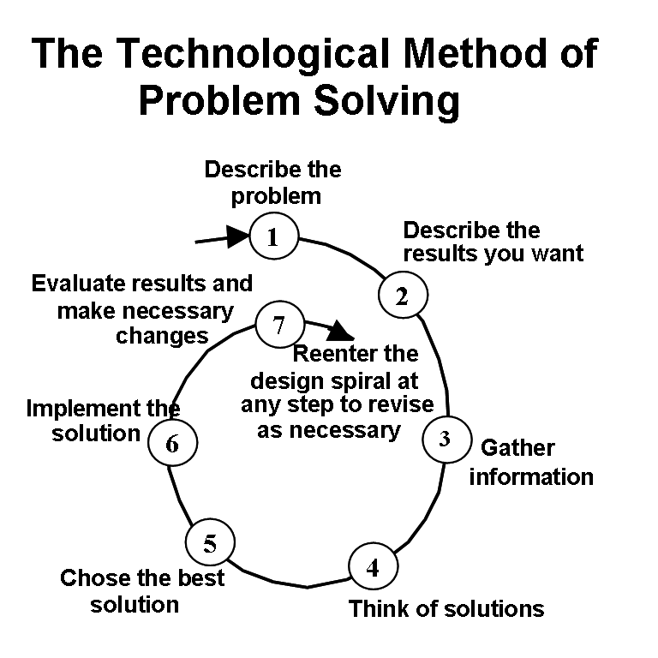

adapted from Hacker, M, Barden B., Living with Technology, 2nd edition. Delmar Publishers, Albany NY, 1993

Table 1: The seven steps of problem solving

- Identify the problem
- Clearly state what the problem is.
- Short, sweet and to the point
- This is the “big picture” problem, not the specific project you’ve assigned

- Establish what you want to achieve
- Completion of a specific project that will help to solve the overall problem
- In one sentence answer the following question:
- How will I know I’ve completed this project?
- List criteria and constraints
- Criteria are things you want the solution to have
- Constraints are limitations, sometimes called specifications, or restrictions that should be part of the solution. They could be the type of materials, the size or weight the solution must meet, the specific tools or machines you have available, time you have to complete the task and cost of construction or materials.

- Gather Information
- Research
- Research sometimes needed both to better understand the problem itself as well as possible solutions
- Don’t reinvent the wheel – looking at other solutions can lead to better solutions.
- Use past experiences

- Brainstorm possible solutions
- List and/or sketch (as appropriate) as many solutions as you can think of

- Choose the Best Solution
- Evaluate solution by:
- Comparing possible solution against constraints and criteria
- Making trade-offs to identify “best”

- Implement the solution
- Develop plans that include (as required):
- Drawings with measurements
- Details of construction – Construction Procedure
- Define tasks and resources necessary for implementation
- Implement actual plan as appropriate for your particular project

- Test and Evaluate the solution
- Compare the solution against the criteria and constraints
- Define how you might modify the solution for different or better results

