Energy Basics Assessment

Name: ________________________

You have 20 minutes to complete all of the questions. Questions 1-4 all correspond to the diagram below. Questions 5-9 are separate and must be answered within the allotted time.

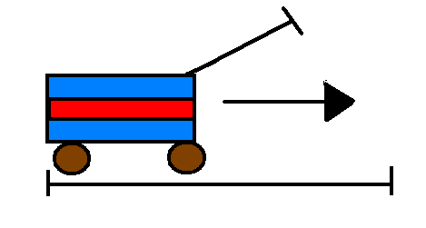
- Write the equation for WORK.

- If it takes 5 Newtons of force to move the wagon 5 meters, how much work is being done? Remember to use the correct units.

- What are the units for POWER?

- If it took 10 seconds to move the wagon, how much power was provided?

- What is the definition of ENERGY?

- What S.I. unit do we use for MASS?

- A Btu is used to describe what type of measurement?

- FORCE is measured using (please circle the correct answer)
  - Newtons
  - Joules
  - Kilograms

- List three choices you can make to reduce the amount of energy you use in your life.

10. Explain why it is important to think about how much energy you use in your life.

