Energy Basics - Solutions

Name: ________________________

You have 20 minutes to complete all of the questions. Questions 1-4 all correspond to the diagram below. Questions 5-8 are separate and must be answered within the allotted time.

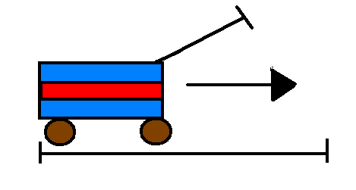
- Write the equation for WORK.
Work = Force x distance

- If it takes 5 newtons of force to move the wagon 5 meters, how much work is being done? Remember the correct units.

Work = 5 newtons x 5 meters = 25 joules

- What are the units for POWER?
Watts, Kilowatts

- If it took 10 seconds to move the wagon, how much power was provided?
Power = Work/time = 25 joules/10 seconds = 2.5 Watts

- What is the definition of ENERGY?
The ability to do work

- What Si unit do we use for MASS?
Kilograms

- A Btu is used to describe what type of measurement?
Another form of Energy Units –British Thermal Units

- FORCE is measured using (please circle the correct answer)
  - Newtons
  - Joules
  - Kilograms

- List three you can do to reduce the amount of energy you use in your life.
Turn of lights, buy energy efficient appliances, buy CFB instead of incandescent, etc…

- Explain why it is important to think about how much energy you use in your life.
The depletion of oil, environmental, societal, and economical impacts.

