Subject Areas: physical science, measurement, data analysis and probability
Associated Unit: Energy Systems and Solutions
Associated Lesson: Energy Basics
Activity Title: Human Power
Header:
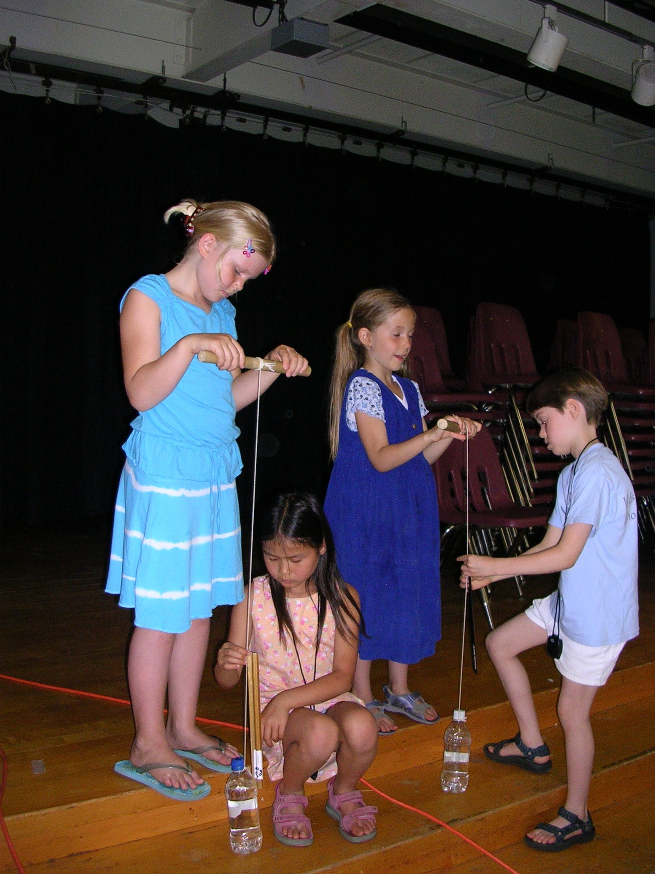
image 1
ADA Description: Two teams of students hold human power apparatuses and are ready to lift the mass of water to determine their own power.
Caption: Human power experinent
Image file name: Human Power Experiment.JPG
Source/Rights: none

Grade Level: 8 (6-8)
Time Required: 40 minutes
Group Size: 3
Summary:
Students do work by lifting a known mass over a period of time. The mass and measured distance and time is used to calculate force, work, energy and power in metric units. The students’ power is then compared to horse power and the power required to light a 60 W light bulb.
Engineering Connection
The basic concepts of work, force, energy and power are fundamental physics concepts utilized in many engineering calculations and design. Every engineered device that moves, lifts or pushes requires energy. An engineer must know how to calculate the power and energy needed to do the necessary work or provided the required heat.

Most of the world uses metric units to quantify engineering terms. But the USA is still one of the few countries that performs some of its engineering work in the old British system. Metric units are all based on fundamental physics quantities. That makes the metric Joule, Newton and watt much easier to use and calculate than the British Btu (British thermal unit), horse power, pound force, and slug.

Keywords:
acceleration, energy, force, Joule, horsepower, measurement, Newton, power, work

Educational Standards
- NSES Science (5-8): A1.3, A1.4, A1.5, A1.8, A2.3, B3.1
- NCTM Math (6-8): A1.4, A2.1,A2.2, B1.2, B2.1, B2.3, B3.1, D1.1, D1.2, D2.2, D2.6, E3.1, F2, I3, J3

Learning Objectives
- The student will be able to define and contrast energy, work, and power.
- Given mass, distance, and time, the student will be able to calculate work, force, and power using appropriate units.
- Given the conversion formulas, the student will be able to convert between horsepower and kilowatts.
- Students will use measurement tools to apply the concepts of work, power, and energy to a real life example

Materials List
Per class:
- Scale (~500-1000 g)
Per group:
- Stopwatch
- large bottle filled with water (500 mL – 1 L water or soda bottle)
- meter stick
- pole (2-3 cm dowel, ~ ½ m long)
- rope/string to tie bottle to dowel with ½ - 1 m length between
- Activity sheet and data table (1/student)

Introduction / Motivation
Power, the rate at which work is done, is now measured in units of watts after James Watt. Mr. Watt built the first steam engine. When he was selling it, he advertised to farmers and miners that it could give more power than a horse. He said that it had 1.5 horsepower. Although the unit of horsepower is still used today, it does not accurately describe how many horses it replaces because not every horse is the same. Not every person is the same either. How many of your own person power does it take to equal a horse? How about to light up a 60 W lightbulb? Do you think you have enough power to do that?
Procedure
Before class:
- Prepare the bottle/dowel apparatuses. Fill water bottle full and cap tightly. Tie ~1 m long string to the top of the bottle, the other end to the middle of the dowel.
With the students
- Have a student demonstrate the basic concept of the human power experiment – (no measurement)
  - Hold the dowel horizontally with a hand on either side of the string and with the string and bottle hanging down. The student might need to stand on a chair to hold the dowel high enough to lift the bottle off the floor.
  - The student holds the dowel out in front of his/her body and rotates the dowel in his/her hands to raise the bottle as the string wraps around the dowel.
- Discuss what happened – use discussion to review energy, work, and power– go over equations and units for force, work, power.
  - Want to determine POWER
  - Power = work/time
  - Work = force x distance
    - Where Force = mass x acceleration (know acceleration of gravity, need to measure mass)
- Ask students – if we wanted to determine how much work student just did, what could we measure? (mass, time, distance – can’t measure force directly in this case)
- Introduce Human Power Activity. This activity will require students to collect data for mass, distance and time. The activity sheet lists equipment needed, but you may want to substitute heavier bottles so the students can “feel” the work they do (2-liter or ½ gallon milk jugs work well).
- Using the data collected in the Activity, calculate average time and apply the appropriate formulas to calculate work and power. Calculate a few of the trials in class, have students finish the calculations for homework.
- Hold up a 60 Watt light bulb and ask if anybody in the class produced enough power to light the bulb (hopefully no one actually does). Ask if they could produce more power possibly with their legs. (Give the example of the human powered bike headlights).
- Ask and/or lead a student (on the board) through a calculation of how many of themselves it would take to light the bulb, based on their power output from the activity. # of people to light 60 Watt bulb = 60 watts/power from the activity. (For example, if the student’s name was Nate and it took 300 of them to light the bulb, it is therefore a 300 BILLpower bulb (for a student named Bill))
- If time allows, convert watts to horsepower in activity.

Attachment
Human power student worksheet (human_power_lesson3_activity1.doc)

Assessment
Have students complete the activity worksheet and discussion questions and turn in.

Redirect URL:
This lesson plan and activities are included at: http://www.clarkson.edu/highschool/k12/project/energysystems.html
This URL has been included in the Engineering Pathways web site and can be found with a search on “energy choices.”
http://www.engineeringpathway.com/ep/index.jhtml
Owner
Office of Educational Partnerships, Clarkson University, Potsdam, NY

Contributors
Susan Powers, Jan DeWaters, and a number of Clarkson and St. Lawrence students in the K-12 Project Based Learning Partnership Program. This unit was developed under National Science Foundation grants No. DUE-0428127 and DGE-0338216.

Copyright
Copyright © 2008 by Clarkson University, Potsdam NY 13699.

Version: December 2008

