Name: ________________________
Energy Sources, Systems, and Conversions Quiz

You have 25 minutes to finish this quiz. Please make sure to fill in all blanks.

- What does “SCREAM Today” stand for?

- Why is wind a renewable source?

Answer the next question using the picture below
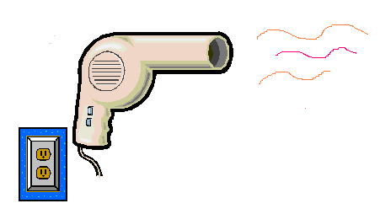

- The energy is converted from the __________ form to the ___________ form.

- Energy can be produced and lost. True or False? (please circle the correct answer) and explain

- What is kinetic energy?

- Draw the energy forms and conversion block diagram for a light bulb.

- ___________ is a biomass material that can be used to produce electricity.

- What is one interesting fact that you learned while doing the energy source research.

