Name: ________________________
Energy Sources, Systems, and Conversions Quiz

You have 25 minutes to finish this quiz. Please make sure to fill in all blanks.

- What does “SCREAM Today” stand for?

sound, chemical, radiant (light), electrical, atomic (nuclear), mechanical, thermal (heat)

- Why is wind a renewable source?

The supply of wind can never be depleted-- we will never run out of wind.

Answer the next question using the picture below
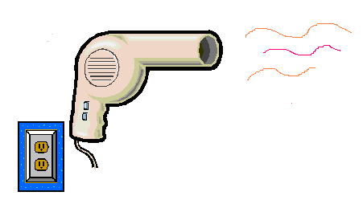

- The energy is converted from the electric form to the heat and mechanical form.

- Energy can be produced and lost? True or False (please circle the correct answer) and explain. The laws of thermodynamics say that energy is conserved. It cannot be created or destroyed, just converted from one form to another.

- What is kinetic energy?

Energy of motion (or in moving things)

- Draw the energy forms and conversion block diagram for a light bulb.

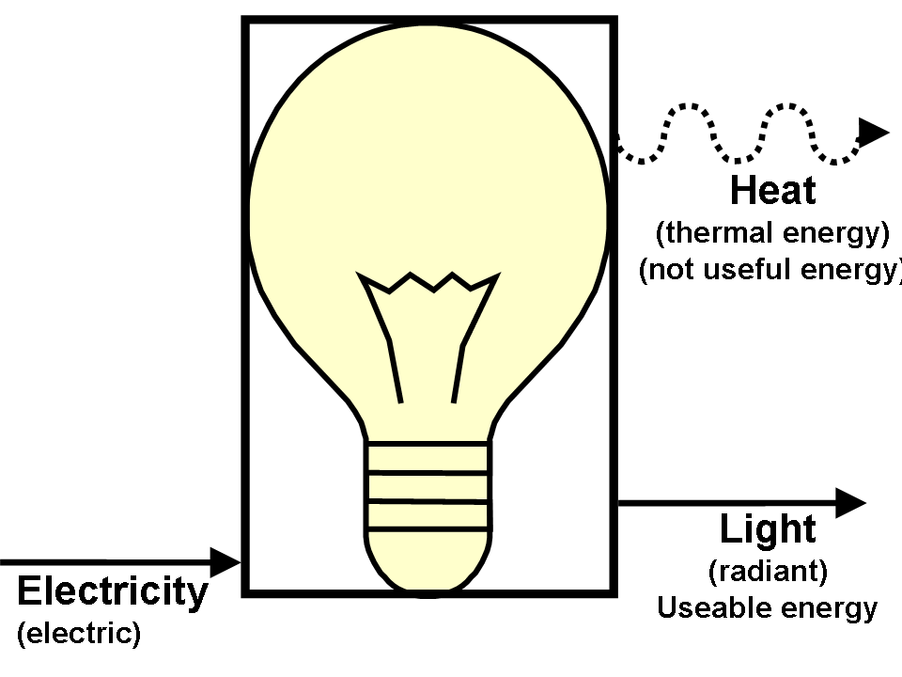
- Manure is a biomass material that can be used to produce electricity.

- What is one interesting fact that you learned while doing the energy source research.

