Energy Decisions Homework
Name:_________________________________________________ Date:_________________________________
It is now time for you to make some decisions about how you will make a difference in the current energy situation. Remember the problem statement: Identify, defend, and carry out a personal energy decision that affects your future and that of others.

Fill in the problem solving spiral below using the problem statement. Use this spiral as you complete your project.
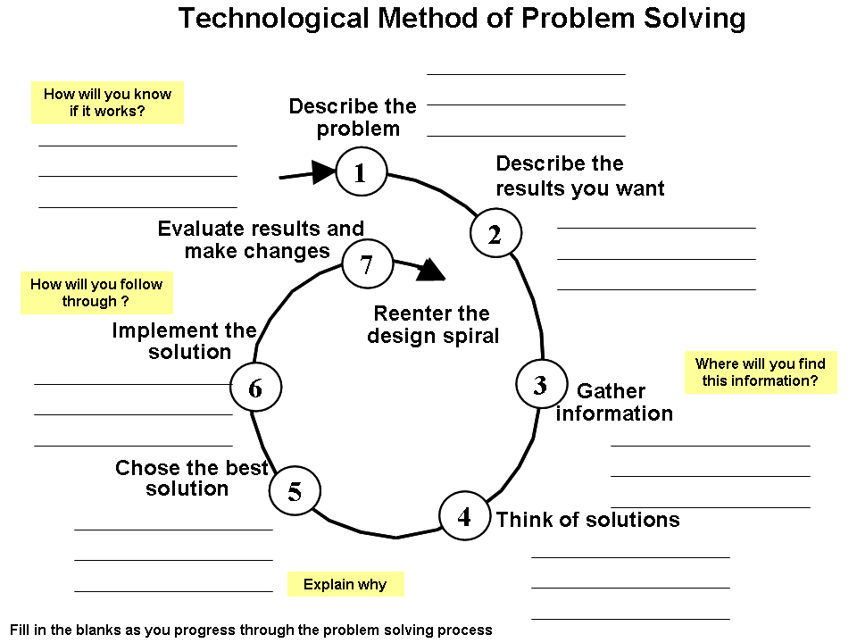
Project Homework

Please describe in paragraph form (at least 3-4 sentences), what DECISION you will be making and project that will address the problem statement.
__________________________________________________________________________________________________________________________________________________________________________________________________________________________________________________________________________________________________________________________________________________________________________________________________________________________________________________________________________________________________________________________________________________________________________________________________________________________________________________________________________________________________________________________________________________________________________________________________________________________________________________________________________________________

MATERIALS LIST:

Please list all of the materials you will need in order to successfully complete your project.

Tasks
Define the specific steps you need to do to complete your project

