Anatomy of a Wave Worksheet Answers
Objective: Identify the parts of a wave and draw your own diagrams of waves.
Background: Many types of waves exist, including electromagnetic waves and mechanical waves. Waves move in different ways and have different properties.
Part 1
In the diagram below, identify the parts of a wave by using the provided definitions.
#__5_ = crest The highest point of the wave above the line of origin.
#__2_ = trough The lowest point of the wave below the line of origin.
#__1_ = line of origin Signifies the original position of the medium.
#__3_ = wavelength The distance between two consecutive crests.
#__4_ = amplitude The distance from the line of origin to a crest or trough of a wave.
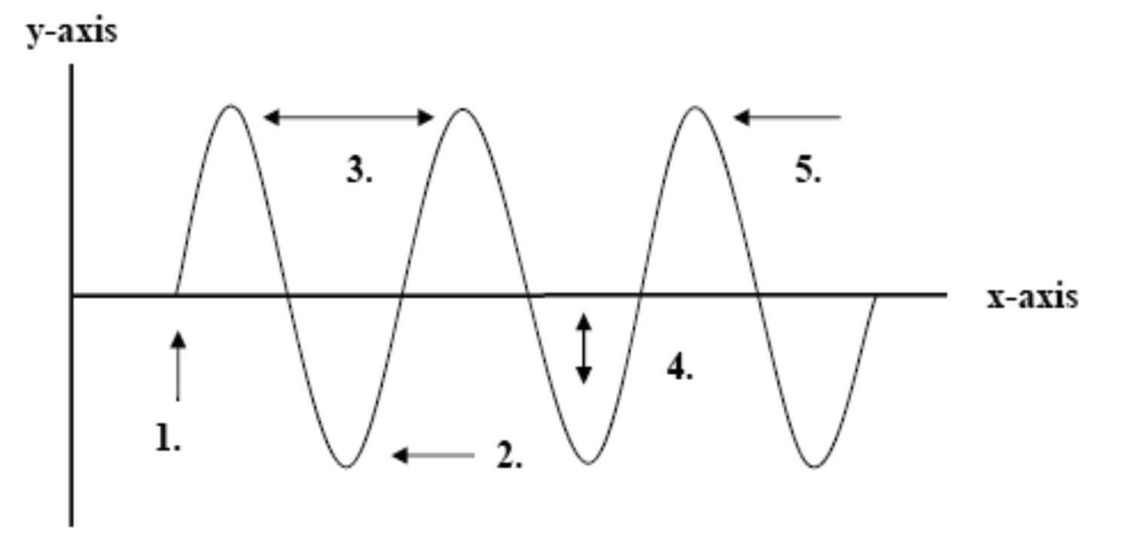

Part 2
On separate sheets of graph paper, draw four different waves with the following measurements.
Label the parts and include the measurements.
wave # | crest | trough | wavelength
1 | 1 cm | 1 cm | 2 cm
2 | 3.5 cm | 3.5 cm | 2.5 cm
3 | .5 cm | .5 cm | 3 cm
4 | 2 cm | 2cm | .5 cm
Concluding question: State which wave you think has the highest frequency and which might have the lowest frequency. Explain the reasons for your selections.
#4 has the highest frequency because it has the shortest wavelength, and frequency is inversely proportional to wavelength.
#3 has the lowest frequency because it has the longest wavelength, and frequency is inversely proportional to wavelength.

