All About Light—Notes Outline

The speed of light is _______________ in space. In glass, light slows down to ______________.

Light wave wavelengths go from about ______________ to about ______________ in length.

A nm, ______________, is ______________ meter, which is one ______________ of a meter.
When light strikes an object, it will do one of several things:

It can be ______________; it is ______________ to the object (mainly as ______________).

It can be ____________________, meaning it ______________ the object.

It can be ____________________, or _________________ the object.

______________ objects ______________ allow light to pass through; they ______________ or ______________ it all. ______________ objects can be seen ______________, but not ______________; they ______________, ______________ and ______________ the light.

______________ objects allow ________ of the light to __________, so they can be seen through ______________.

White light is made up of ___________________________. A ______________ splits the light into its ______________________ colors.

We see the color of light that is being ______________ by an object.

A blue object is ______________ blue light and ______________ all the other colors. A black object absorbs ______________, and reflects ______________. A white object ______________ all light and ______________ none.

The three ___________________ colors of light are: ______________, ______________ and ______________.
Light and Reflection
________ types of reflection of light:
- ______________ diffusion occurs when light strikes a ______________ surface causing you to see an ______________ on the surface because most or all of the reflected light ______________ your eyes. Example: a ______________ displays regular reflection, and with a ______________ (flat) mirror, you see an ______________, ______________ -size image. Curved mirrors change the ______________ of the image.
- With ______________ reflection, a ______________ surface ______________ the light in many different ______________ so that not all of it reaches your ________, and you ________ see a reflection.
Light and Refraction
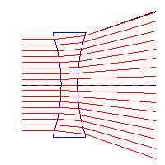
Light ______________ as it goes from space into air, water, or solids. Why? Because the ______________ get in the way. A ______________ is a clear, curved ______________ object used to bend light. ______________ lenses ______________ light and can form an ______________.
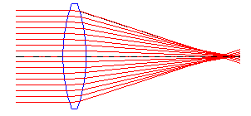

______________ lenses ______________ light rays. 
When light strikes a boundary between two ______________ materials at the correct ______________, all the light gets ______________. This is called total ______________ reflection and it is how ______________ work. It allows the ______________ of light to travel great ______________ over ______________ paths. ⬇
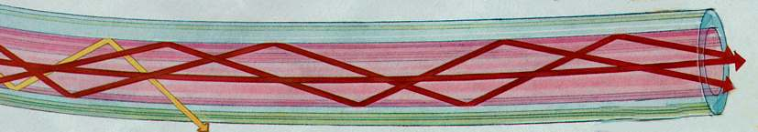

Lasers
The word “lasers” stands for “light ___________ by stimulated ___________ of ___________.” Lasers use ______ wavelength of light so that all the ___________ and ___________ line up. Because they are all lined up, they do not ___________ with each other and ___________ the light out like white light.

