All About Light—Notes Outline Answers

The speed of light is 300,000 km/s in space. In glass, light slows down to 197,000 km/s.

Light wave wavelengths go from about 400 nm to about 700 nm in length.

A nm, nanometer, is 1 x 10⁻⁹ meter, which is one billionth of a meter.
When light strikes an object, it will do one of several things:

It can be absorbed; it is transferred to the object (mainly as heat).

It can be reflected, meaning it bounces off the object.

It can be transmitted, or go through the object.

Opaque objects do not allow light to pass through; they absorb or reflect it all. Translucent objects can be seen through, but not clearly; they absorb, reflect and transmit the light.

Transparent objects allow almost all of the light to pass through, so they can be seen through clearly.

White light is made up of all the colors of the rainbow. A prism splits the light into its component colors.

We see the color of light that is being reflected by an object.

A blue object is reflecting blue light and absorbing all the other colors. A black object absorbs all light, and reflects none. A white object reflects all light and absorbs none.

The three primary colors of light are: red, green and blue.
Light and Reflection
Two types of reflection of light:
- Regular diffusion occurs when light strikes a smooth surface causing you to see an image on the surface because most or all of the reflected light reaches your eyes. Example: a mirror displays regular reflection, and with a plane (flat) mirror, you see an upright, same-size image. Curved mirrors change the shape of the image.
- With diffuse reflection, a rough surface scatters the light in many different directions so that not all of it reaches your eyes, and you do not see a reflection.
Light and Refraction
Light slows down as it goes from space into air, water, or solids.
Why? Because the atoms get in the way.
A lens is a clear, curved transparent object used to bend light.
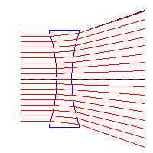
Convex lenses converge light and can form an image. 
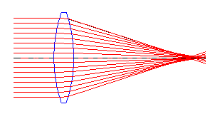

Concave lenses diverge light rays. 
When light strikes a boundary between two transparent materials at the correct angle, all the light gets reflected. This is called total internal reflection and it is how fiber optics work. It allows the transmission of light to travel great distances over curved paths. ⬇
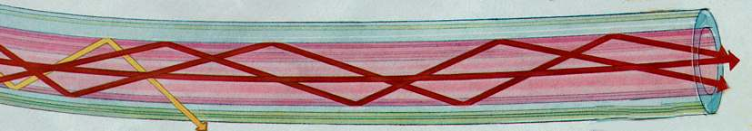

Lasers
The word “lasers” stands for “light amplification by stimulated emission of radiation.”
Lasers use one wavelength of light so that all the crests and troughs line up.
Because they are all lined up, they do not interfere with each other and spread the light out like white light.

