Eye Structure and Seeing Light—Notes Outline
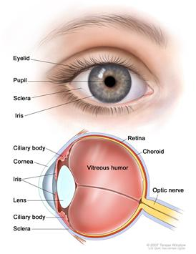
Light __________ your eye through a __________ portion of the __________ (the tough, white, outer covering of the eye), called the __________. The cornea is __________, so it slightly __________ the light as it goes through. Light then passes through the ____________________ (a clear fluid in the _____________ used for eye __________) and then through the __________.
The pupil is simply a _______________ in the __________. The iris is a ______________ that controls how __________ the pupil is. It is the __________ part of the eye. In bright light, the iris ________________ and the pupil gets ________________. In low light, the iris __________ and the pupil gets __________.
Directly behind the iris is the __________. This structure changes __________ to __________ light so that we can see __________. Its shape is __________, meaning it curves __________ on both sides. The __________ muscles above and below the lens control the __________ of the lens.
Behind the lens is a clear gel called the ________________________. Light goes through this, then strikes the __________. This is the __________ on the inside of the __________ of the eye that contains __________ types of cells sensitive to __________: ________ and ________. Rods sense __________ and __________ and can work in _____ light. Cones sense __________, and must have a certain amount of light to work.
__________ kinds of cones: One senses __________ wavelengths of light, in the __________ range, and are called L-cones. The second type sense the __________ wavelengths of light, mainly in the __________ range, and are called __________. The third kind __________, and sense the shorter wavelengths of light, mostly in the __________ range.
The rods and cones send messages through the ________________, which carries the information to the __________. The sight center of your brain is located in the ___________, basically _______________________. This is why a blow to the back of your head can result in blindness or other vision problems.
Causes of Color Blindness
- _____________: You are born with these types. Sometimes a type of cone is __________, or the __________, that a cone recognizes is different than normal. L-cone and M-cone problems result in __________ color blindness (the __________ common type).
- _____________: These types occur after birth. For example, accidents involving the ____________________ of the brain, or Parkinson’s Disease can cause __________ problems.
Source of images: National Cancer Institute at the National Institutes of Health http://www.cancer.gov/cancertopics/pdq/treatment/retinoblastoma/patient/page1/AllPages/Print

