Eye Structure and Seeing Light—Notes Outline
Answers
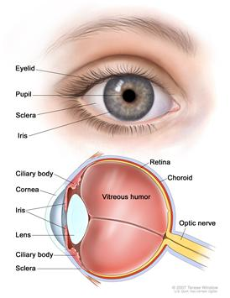
Light enters your eye through a clear portion of the sclera (the tough, white, outer covering of the eye), called the cornea. The cornea is curved, so it slightly bends the light as it goes through. Light then passes through the aqueous humor (a clear fluid in the anterior chamber used for eye nourishment) and then through the pupil.
The pupil is simply a hole in the iris. The iris is a muscle that controls how large the pupil is. It is the colored part of the eye. In bright light, the iris expands and the pupil gets smaller. In low light, the iris contracts and the pupil gets bigger.
Directly behind the iris is the lens. This structure changes shape to focus light so that we can see clearly. Its shape is convex, meaning it curves outward on both sides. The ciliary muscles above and below the lens control the shape of the lens.
Behind the lens is a clear gel called the vitreous humor. Light goes through this, then strikes the retina. This is the lining on the inside of the back of the eye that contains two types of cells sensitive to light: rods and cones. Rods sense black and white and can work in low light. Cones sense color, and must have a certain amount of light to work.
Three kinds of cones: One senses long wavelengths of light, in the red range, and are called L-cones. The second type sense the mid-range wavelengths of light, mainly in the green range, and are called M-cones. The third kind are S-cones, and sense the shorter wavelengths of light, mostly in the blue range.
The rods and cones send messages through the optic nerve, which carries the information to the brain. The sight center of your brain is located in the back, basically between your ears. This is why a blow to the back of your head can result in blindness or other vision problems.
Causes of Color Blindness
- Genetic: You are born with these types. Sometimes a type of cone is missing, or the wavelength that a cone recognizes is different than normal. L-cone and M-cone problems result in red-green color blindness (the most common type).
- Non-genetic: These types occur after birth. For example, accidents involving the vision center of the brain, or Parkinson’s Disease can cause S-cone problems.
Source of images: National Cancer Institute at the National Institutes of Health http://www.cancer.gov/cancertopics/pdq/treatment/retinoblastoma/patient/page1/AllPages/Print

