**The Power of Food – Food Circuits Worksheet**

1. Draw a **series circuit**

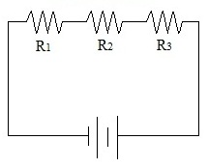

1. Draw a **parallel circuit**

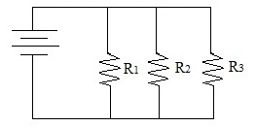

1. Define and draw a labeled **LED (diode)**

**A diode has two electrodes (an anode and a cathode) and allows the current to flow through it in only one direction.**

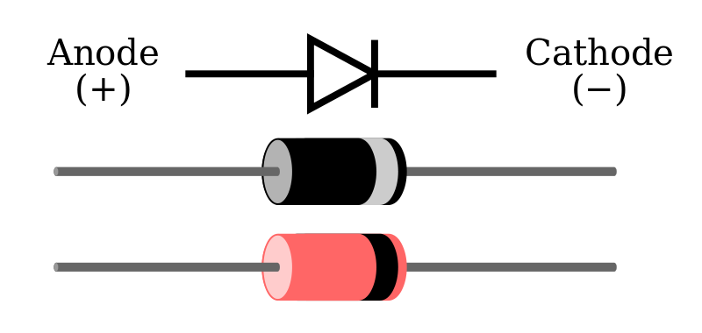

Image source: Wikimedia Commons https://en.wikipedia.org/wiki/File:Diode_pinout_en_fr.svg

1. In the table below, record your observations during your experimentation (fruit used, voltage reading, how many LEDs lit up).

|  |  |  |  |
| --- | --- | --- | --- |
| **Food** | **Voltage (reading)** | **Number of LEDs lit** | **Comments** |
| *Example: lemon* | *5 volts* | *1* | *Lit up easily.* |
| *Example: 2 lemons* | *9 volts* | *2* | *LEDs flickered, but stayed lit.* |
|  |  |  |  |
|  |  |  |  |
|  |  |  |  |
|  |  |  |  |
|  |  |  |  |
|  |  |  |  |
|  |  |  |  |
|  |  |  |  |
|  |  |  |  |
|  |  |  |  |

1. Draw a diagram of your most successful fruit circuit, labeling each part.

