Activity 6: Ranking the Rocks Worksheet
Now you are going to rank the rock types based upon the rock test data you collected in the previous activity. Engineers often create guidelines to help them compare potential solutions.
Remember that even though more than one right answer exists, some answers are better than others! For example, locations A and B may both be suitable cavern locations, but location A might cost less to construct and be closer to a major highway.
To rank the rocks, we will assign “desirability” points based upon the different rock properties. What are our preferred rock characteristics? Below is what we have learned about the importance of the different rock characteristics for building caverns:
Hardness: Very important! Caverns built in soft rock might collapse. But, really hard rock might be difficult to build in.
Color: Not important for design or construction but may be important for how it looks.
Granular: Important. Solid rocks are stronger than granular rocks.
Porosity: Important. Rocks with holes permit water to penetrate and are usually not as strong.
Luster: Not important for design or construction but may be important for how it looks.
The graph and table below provide desirability points for 5 characteristics.
Using the graph, table and ID flow chart, fill in the desirability points table on the next page for the rocks you tested.
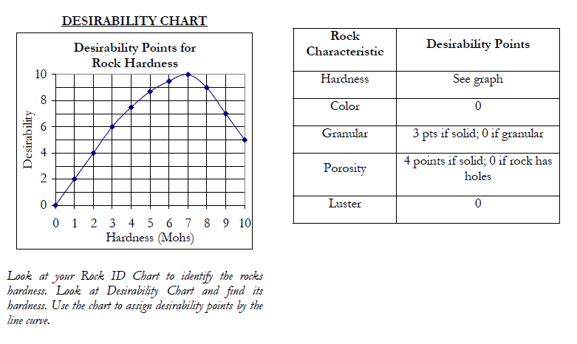
Desirability Chart
Tips: Look at the Rock ID Flow Chart to identify a rock’s hardness.
Then look at the Desirability Chart and find its hardness.
Use the chart to assign desirability points by the line curve.
Desirability Points
Characteristics

Rock

Desirability Points and Rock Ranking
Rock Type | Hardness | Color | Granular | Porosity | Luster | TOTAL POINTS | RANKING
limestone
basalt
obsidian
pumice
sandstone
slate
granite
gneiss

- Based on desirability points, what are the most important and least important rock properties for designing and building caverns, tunnels and underground structures?
Most important rock property:
____________________________________
Least important rock property:
____________________________________

- Look again at the top three locations you listed during Activity 3. Do your top three sites rank in the top three rock types? Fill in the table below with your site evaluation.
Location from Activity 3 | Rock Ranking? | Good Choice?

- Do you notice a highly ranked rock that did not make your top three potential locations? With this new information, if necessary, revise your top three potential locations in the table below.
Location | Explanation why

