**Designing for Disaster Worksheet**

**Objectives:** Investigate how engineers design buildings and structures to withstand earthquakes.

**Materials**: Work in pairs sharing one computer with Internet access.

**Engage:**

1. Look around your classroom. Name one thing that might fail or break during an earthquake. Overall, do you think your school is prepared to withstand an earthquake? Explain why or why not.

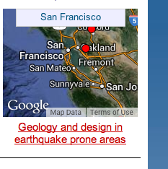

**Explore:**

Navigate to the Earthquakes Living Lab at http://www.teachengineering.org/livinglabs/index.php.

1. Select the San Francisco region (the fourth region). Scroll down the page and select the seventh (last) link: *How do engineers use models and earthquake simulations to test designs for earthquake-resistant buildings and structures?* Watch the earthquakes testing video on the front page. Pay attention so you’ll be able to answer the next question.

Video website: <http://www.windows2universe.org/earth/geology/movies/earthquake_testing_nsf.html>

1. From what you learned in the video, record one type of test that researchers conduct and one design component engineers may use in buildings that experience seismic activity.
2. Now go to the Earthquake Testing Zone, an earthquake simulation at the following link to see a demonstration of different magnitude earthquakes: <https://streaming.discoveryeducation.com/braingames/iknowthat/ScienceIllustrations/earthquake/earthquake_movie.html>. Adjust the magnitude and hit the “Go” button. Repeat again.
3. From your experimentation with the earthquake simulation, note one thing that failed during an earthquake.
4. Navigate back to the San Francisco Earthquakes Living Lab page > select the fifth link titled, *How do earthquakes affect buildings?* To run the “trigger an earthquake” simulation, go to the National Geographic link at <http://www.nationalgeographic.com/forcesofnature/interactive/index.html>. From the Forces of Nature page, go to the earthquake section by “choosing a force.” To do this, click on the earthquakes icon, then read through the information, and then select the button to “set off an earthquake.”



Run through all the simulation combinations, reading the descriptions of what is happening each time.

1. 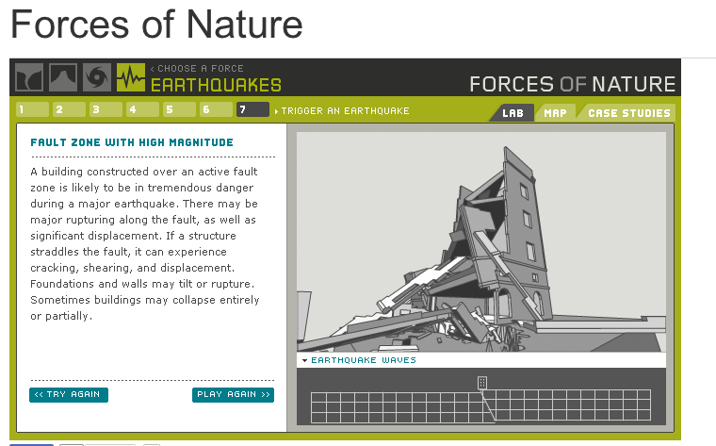From the simulation tests, which ground type results in the least amount of damage to the building?
2. From the simulation tests, which scenario (the combination of ground type and magnitude) results in the most amount of damage to the building?
3. Return to the San Francisco Earthquakes Living Lab page > select the sixth link titled, *How do engineers design buildings that withstand the forces of earthquakes?* at <http://www.exploratorium.edu/faultline/damage/building.html>. Read the article, especially the “Location, location, location” section. From the simulation experiments and what you have read, answer the following question:
4. Overall, compare the impact of seismic waves on structures built on solid rock vs. on softer soils.

**Explain:**

1. After having read the entire Faultline “Damage Control: Engineering” article about engineering design principles related to earthquakes at: <http://www.exploratorium.edu/faultline/damage/building.html>, write an answer to the following question: If you were to design a building in an earthquake area, what factors would you consider to result in the **least** amount of damage?

**Elaborate:**

1. Summarize what you learned about how to design building in earthquake-prone areas. Thinking as an engineer, draw a sketch of a building that could withstand a strong earthquake. Explain your key design features.