**Designing for Disaster Worksheet**

Example Answers

**Objectives:** Investigate how engineers design buildings and structures to withstand earthquakes.

**Materials**: Work in pairs sharing one computer with Internet access.

**Engage:**

1. Look around your classroom. Name one thing that might fail or break during an earthquake. Overall, do you think your school is prepared to withstand an earthquake? Explain why or why not.

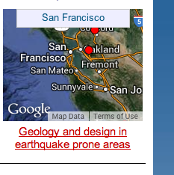*Example answers*: Pictures hanging on the walls, lamps, bookcases, shelves, etc. Answers will vary depending on location, but expect students to justify their answers.

**Explore:**

Navigate to the Earthquakes Living Lab at http://www.teachengineering.org/livinglabs/index.php.

1. Select the San Francisco region (the fourth region). Scroll down the page and select the seventh (last) link: *How do engineers use models and earthquake simulations to test designs for earthquake-resistant buildings and structures?* Watch the earthquakes testing video on the front page. Pay attention so you’ll be able to answer the next question.

Video website: <http://www.windows2universe.org/earth/geology/movies/earthquake_testing_nsf.html>

1. From what you learned in the video, record one type of test that researchers conduct and one design component engineers may use in buildings that experience seismic activity.

Structural tests and shake tables are some tests. Shake tests move in three directions at once to simulate the movement of earthquakes. Double mid-ply wall and steel rods are some construction materials and techniques mentioned.

1. Now go to the Earthquake Testing Zone, an earthquake simulation at the following link to see a demonstration of different magnitude earthquakes: <https://streaming.discoveryeducation.com/braingames/iknowthat/ScienceIllustrations/earthquake/earthquake_movie.html>. Adjust the magnitude and hit the “Go” button. Repeat again.
2. From your experimentation with the earthquake simulation, note one thing that failed during an earthquake.

Answers will vary. *Example answers*: Glass windows and lights are the first things to break. Brick chimneys are knocked off roofs. Expect answers to include details about the destruction to homes, cars, roads, trees and light poles. Expect students to gather from the demo that strong-magnitude earthquakes affect everything.

1. Navigate back to the San Francisco Earthquakes Living Lab page > select the fifth link titled, *How do earthquakes affect buildings?* To run the “trigger an earthquake” simulation, go to the National Geographic link at<https://www.nationalgeographic.org/interactive/forces-nature/>. From the Forces of Nature page, go to the earthquake section by “choosing a force.” To do this, click on the earthquakes icon, then read through the information, and then select the button to “set off an earthquake.”



Run through all the simulation combinations, reading the descriptions of what is happening each time.

1. From the simulation tests, which ground type results in the least amount of damage to the building?

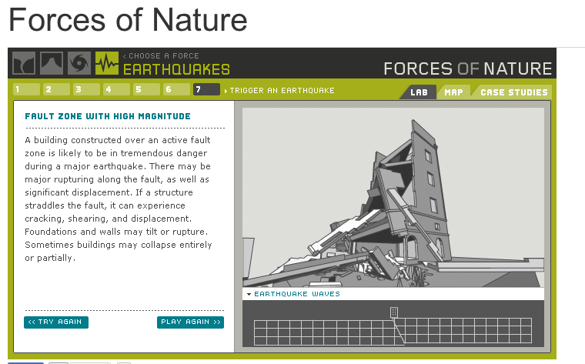Structures built on bedrock (the hard, solid material found under some soil and sediment layers) sustain the least amount of damage and withstand earthquake forces best. The most amount of damage is sustained by structures on active fault zones and landfill soil.

1. From the simulation tests, which scenario (the combination of ground type and magnitude) results in the most amount of damage to the building?

The most amount of damage happens during high-magnitude earthquakes to buildings constructed over active fault zones. Structures located on active fault zones sustain the most amount of damage because the ground rips apart.

The next most dangerous scenario is building on landfill (soft, loose, sandy soil and sediment, often wet), especially during high-magnitude earthquakes. This type of ground material is very dangerous because it is susceptible to liquefaction (acts like a liquid, kind of like quicksand) during tremors.

1. Return to the San Francisco Earthquakes Living Lab page > select the sixth link titled, *How do engineers design buildings that withstand the forces of earthquakes?* at <http://www.exploratorium.edu/faultline/damage/building.html>. Read the article, especially the “Location, location, location” section. From the simulation experiments and what you have read, answer the following question: Overall, compare the impact of seismic waves on structures built on solid rock vs. on softer soils.

*Excerpt from article*: Bedrock absorbs more wave energy than sandy soils or landfill, so buildings on solid rock are much less affected by earthquakes than those built on softer soils. In addition, if softer soils have water in them, they are susceptible to liquefaction, which is when they lose their strength and behave like liquid (more like quicksand) due to the vibrating seismic waves passing through them. Buildings on top of liquefied soil sink, and often topple.

**Explain:**

1. After having read the entire Faultline “Damage Control: Engineering” article about engineering design principles related to earthquakes at: <http://www.exploratorium.edu/faultline/damage/building.html>, write an answer to the following question: If you were to design a building in an earthquake area, what factors would you consider to result in the **least** amount of damage?

Expect students to talk about building height, location and support elements and/or flexibility.

*Excerpt from article*: The taller a structure, the more flexible it is. The more flexible it is, the less energy required to keep it from toppling or collapsing when the Earth's shaking makes it sway. You can feel this same phenomenon while you riding a bus or subway train. It requires less effort to remain standing if you flex your body and flow with the bumps and jolts than if you stiffen up and try to defy them. Because shorter buildings are stiffer than taller ones, a three-story apartment building is considered more vulnerable to earthquake damage than a 30-story skyscraper. When planning the seismic safety of a building, structural engineers must design the support elements of shorter buildings to withstand greater forces than those of taller buildings. Another consideration: The ground below a structure is as important a safety consideration as its construction.

**Elaborate:**

1. Summarize what you learned about how to design building in earthquake-prone areas. Thinking as an engineer, draw a sketch of a building that could withstand a strong earthquake. Explain your key design features.

Expect student sketches to include some design considerations such as height, support beams and materials. Have students share or present their designs to the rest of the class.