Finding Epicenters and Measuring Magnitudes Worksheet
Objective: To use seismic data and an interactive simulation to triangulate the location and measure the magnitude of an earthquake.
Materials: Work in pairs sharing one computer with Internet access.
Engage:
- You may have heard news coverage saying something like “the earthquake was a 6.3 on the Richter scale” or “the epicenter was located just outside the city.” Describe in your journal what you think these statements mean. Student answers will vary.
Explore: Navigate to the Earthquakes Living Lab at http://www.teachengineering.org/livinglabs/earthquakes/.
- The Earthquakes Living Lab has four main components to it, each based on one of four historic earthquakes. For this activity, select the “Chile” box.
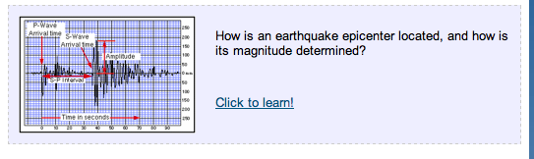
- Take a few minutes to read the information on the left side of this page for the 2010 earthquake off the coast of central Chile. Then locate and click the link in the center of the page under the question: “How is an earthquake epicenter located and how is magnitude determined?”

- This opens a new window to Michigan Tech’s UPSeis informational site about earthquakes and seismology. Read through the sections “What Is Seismology and What Are Seismic Waves?,” “Where Do Earthquakes Happen?,” and “Why Do Earthquakes Happen?” to answer the following questions:
  - What is an earthquake?
An earthquake is a sudden release of stored energy that built up over time as a result of tectonic forces within the Earth. When one side of a fault moves rapidly relative to the other side of the fault, the sudden motion causes shock or seismic waves that travel through the Earth and produce ground motion.

  - What is a seismic wave?
A seismic wave is the transferring of energy from one spot to another within the Earth. They are caused by the sudden breaking of rock within the Earth.

  - What is the difference between S waves and P waves?
P (primary) waves, which are similar to sound waves, come first. The S (secondary) waves come second. Within the Earth, P waves can travel through solids and liquids, whereas S waves can only travel through solids.

- After reading about earthquakes, open a new window to an Earthquake Simulator at https://www.newpathonline.com/free-curriculum-resources/virtual_lab/Earthquake_Simulator/4/8/1835. Select the location of South America (the middle location).
- Follow the simulation instructions. As you read and complete the activity, take notes so you can complete the Explain questions next.
Explain:
- How is an earthquake located?
We locate earthquakes by looking at seismogram recordings of seismic waves, P waves and S waves, because they travel at different speeds and thus arrive at seismic stations at different times. P waves travel faster, so they arrive first. S waves travel at about half the speed of P waves, so they arrive later. The time between the arrival of a P wave and the arrival of an S wave, called the S-P time or S-P interval, measured at three seismic stations can be used to triangulate the epicenter location.
- What is an epicenter?
The point on the Earth’s surface that is directly above where the earthquake originated, or where the tectonic plates along a fault-line slipped past one another. [In this activity, students find this point through triangulation.]
- How are S waves and P waves used to determine how far away epicenters are?
To locate the epicenter of an earthquake, you must estimate the time interval between the arrivals of the earthquake’s P and S waves (the S-P interval) on the seismograms from three different stations. The interval is measured to the closest second and then a graph is used to convert the S-P interval to the epicentral distance. Using information from three stations, the epicenter is triangulated.
- How does distance from the epicenter affect the S-P time interval?
With increasing distance from the earthquake, the time difference between the arrival of the P waves and the arrival of the S waves increases. Put more simply, the higher the time between the S and P waves (the S-P interval), the farther the distance.
- Describe the process of triangulation to locate an epicenter.
Triangulation requires seismic data from three centers. First the distance from each center is calculated using the S-P interval and this distance serves as the radius for a circle around the center. The location where the three circles overlap is the triangulated epicenter.
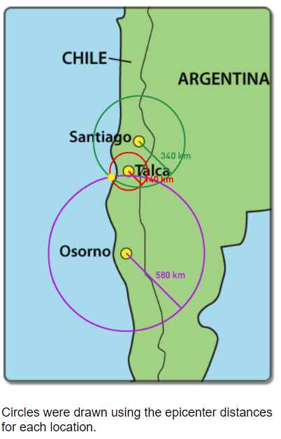

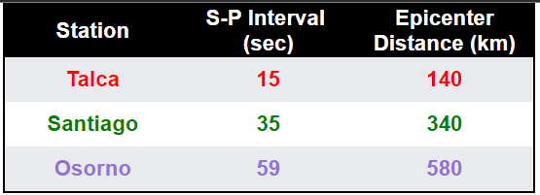

- What is the “magnitude” of an earthquake? Describe it.
The magnitude of an earthquake is an estimate of the total amount of energy released during fault rupture. Since the 1930s, earthquakes have been measured using the Richter magnitude scale, and now big earthquakes are measured using the moment magnitude scale; both scales essentially rank the power (energy release) of the earthquake.
- What data is used to determine magnitude?
The magnitude determination is based on seismic data. A graphical device, called a nomogram, is used to estimate the magnitude from the earthquake’s data. A nomogram requires two measurements: the S-P time interval (which yields distance) and the maximum amplitude of the seismic waves.
Elaborate:
- Why might the triangulation method not always produce an exact point (other than any measurement errors)?
Triangulation assumes that the seismic waves traveled at the same velocities to all three seismic stations. In reality, ground material composition may differ between stations and the waves may travel at different speeds. S waves can only travel through solids, and not through liquids, which is another factor to consider for stations near bodies of water.
- How does distance from the epicenter affect the magnitude (height) of the seismograph reading?
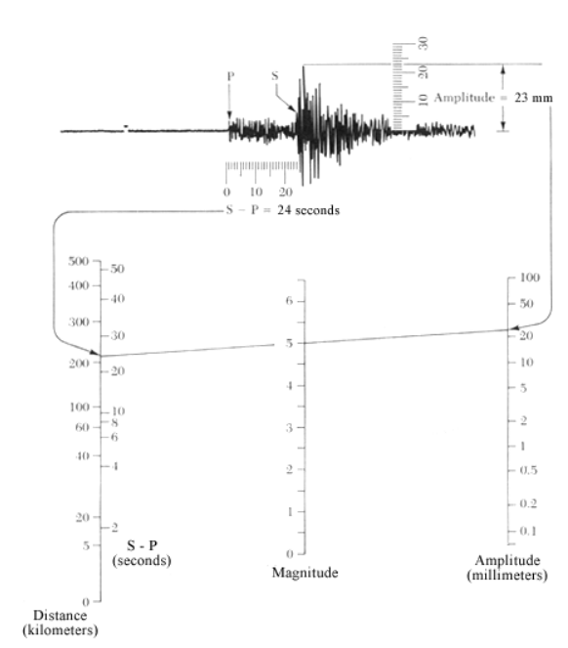
The magnitude decreases as the distance increases. Thus, the distance must be calculated first, in order to calibrate the magnitude.

Evaluate:
- Some scientists and educators believe seismology (locating, measuring and predicting earthquakes) is a very reliable science and will one day allow us to predict future earthquakes. Other scientists and educators believe seismology is not a very exact science. Write a paragraph (or more) to express your opinion on this topic. Based on what you learned in this activity, is locating and measuring earthquakes a well-defined science? Be sure to include details from the Explore and Elaborate questions. Including some sketches and/or images is helpful, such as an image of a seismograph with key features labeled to support your explanation.
This is an opinion-based question, but expect students to bring in what they know about triangulation/distance calculation, seismograms/nomograms and/or the magnitude scale.
- How do you think engineers use seismic data? Include specific examples.
Engineers use seismic data in many ways: to possibly predict future earthquakes (at least general predictions, not very specific), to design buildings to withstand certain magnitudes, to locate particularly active fault planes, etc.
Congratulations—you have completed this activity! Feel free to complete the “virtual seismologist” information at the end of the simulation to get your virtual certificate. For more practice, return to the beginning of the simulation and complete the steps again for one or more of the other locations.

