Exploring Regional and Local Resources Worksheet
Example Answers
Objective: To become familiar with the Renewable Energy Living Lab interface and use potential solar energy data to evaluate solar energy resources in different U.S. locations.
Engage: You have probably heard of renewable and non-renewable energy. In your journal, list three or four types of renewable and non-renewable energy sources. If you cannot think of any, visit this website for some background information: http://www.nrel.gov/learning/re_basics.html. Also, describe one or more specific examples of solar panels or wind turbines you have seen.
In this activity, you will use the Renewable Energy Living Lab website to explore where the most common sources of renewable energy are distributed across the U.S. and in your local area.
Explore:
Basic Navigation of Renewable Energy Living Lab (High School level)
- Begin by navigating to http://www.teachengineering.org/livinglabs/index.php > and clicking to enter the Renewable Energy Living Lab > then select the grades K-12 portal.
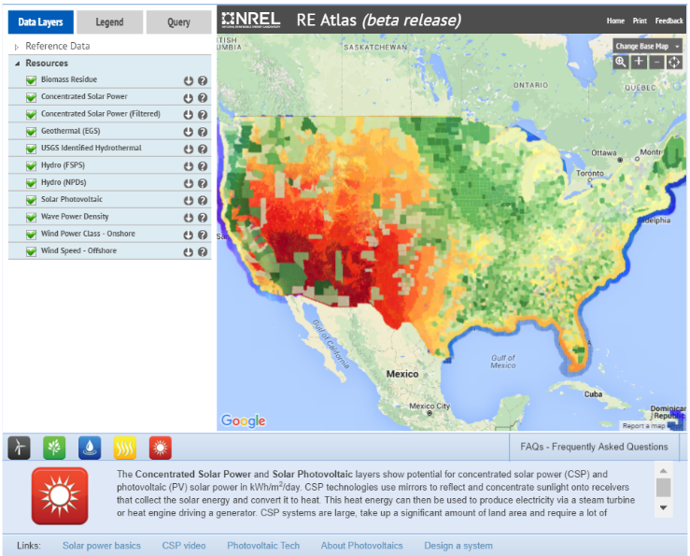
- The data provided in this living lab is presented through what is called a “geographic information system” (GIS), which is composed of multiple layers and presents numerous ways to access data.
- Notice the five square icons in the lower left of the page. They control which renewable energy sources background and supporting information is visible. Select the “solar” icon to get to some information on solar as well as additional links for general information, as needed.
- The left menu controls which layers are visible (or turned “on”). Turn “off” all of the resource layers except “solar photovoltaic.” Also, select US States under Reference Data. Now the map should look more like this:
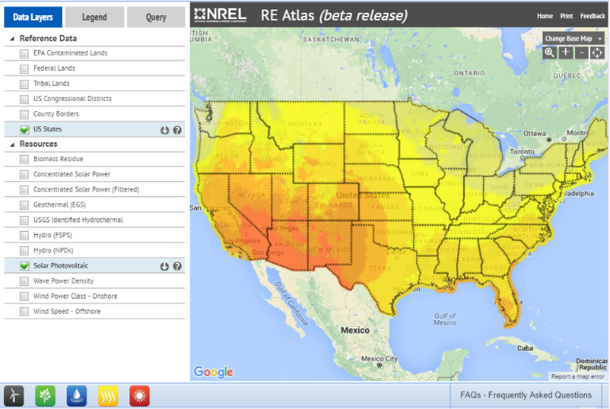

- What do the colors indicate? If your intuition suggests that brighter colors might indicate more solar energy—you are correct! But this assignment is about data so let’s get some numbers. Go back to the menu at the left and choose the “Legend” tab from the options at the top of the menu. Doing this “hides” your layers options and brings up a color key for solar energy with values and units.
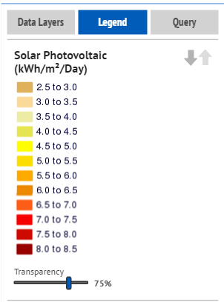

Finding More Detailed Information (How to Conduct a Query)
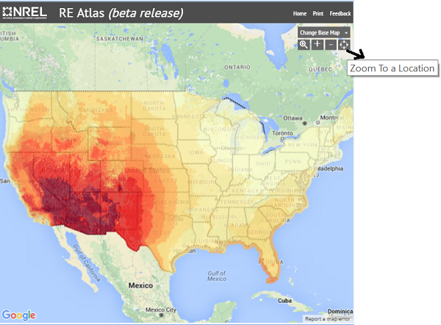
For some inquiries about the data, the color code legend provides enough information. For other questions, you may need more information. The GIS system has a built-in “query” function so you can find very specific information that was used to generate the larger trends shown in the color-coded map. Follow the steps below to conduct a query:
- Zoom in on the map using the zoom tools at the top of the map.
- For a first attempt, try zooming in to the county or city scale by using the “Zoom To a Location” button in the top right corner of the map. Pick a random place, or maybe your home town. Below is an example of the Denver Front Range region.
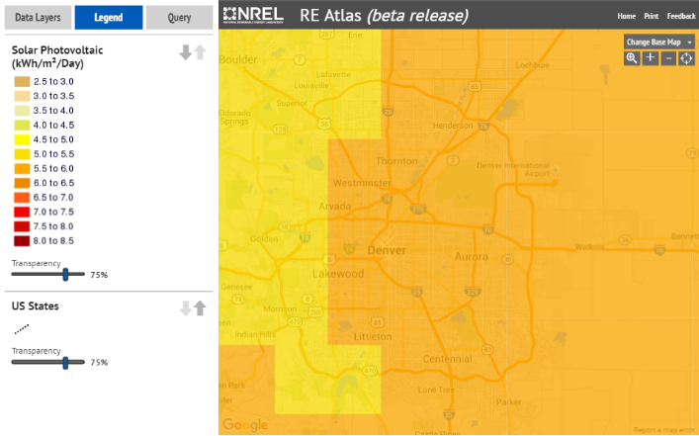
- Select the “Query” tab beside the Legend tab.

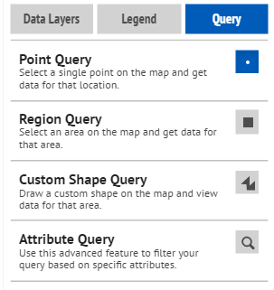
- Choose what type of query (point, region, custom shape, or attribute query). Depending on the type of query, locate the region from which you want specific data.
- The query function returns up to 100 results from the region you select.
  - Assuming you still have only one layer on and that layer is solar photovoltaic, the query results show you the annual average (which is used to make the color-coded map) and monthly averages for specific locations in your region.
  - Looking at monthly data is helpful if you are considering questions such as how seasonal variations affect the amount of available solar energy in a specific location.
- A few tips for GIS queries:
  - Even if your area has thousands of data points, you only receive 100 results. So, the smaller your target area, the better your data. You can always do multiple queries if you need more areas.
  - You receive 100 results for EACH LAYER that is turned on. So, if you have lots of layers turned on, it might take a few minutes (or more) to perform the query and the data may be a bit overwhelming to deal with.
  - Notice the “download results” function at the top of the query results. Use this to export the query results to a Microsoft Excel-compatible file, which can be sorted, graphed, etc.
  - Important: When you are finished with a query, return to the “query” drop-down menu and select “clear results.” If you forget to do this, your last query area (blue box) remains on all of the maps you look at after that.
Now that you are familiar with the living lab website and how to obtain data, complete the following tasks to test your aptitude at working with data.
- Look at the regional map (no query) of the U.S. and identify the highest and lowest potential solar photovoltaic energy locations and compare them to where you live.
Students may answer Las Vegas, NV, Phoenix, AZ, Tucson, AZ, Albuquerque, NM, or other towns or cities in this area as having the highest potential solar photovoltaic energy. The location of the lowest potential solar photovoltaic energy is in the northwestern corner of Washington state, including towns and cities such as Olympia, Aberdeen, and Bellevue. Unless students live in one of these areas, they should find that the potential solar photovoltaic energy in the place they live is higher than the lowest area and lower than the highest area.
- Query the solar photovoltaic energy data for your home town.
Answers will vary based on students’ home towns. They should include data from the Renewable Energy Living Lab map somewhere between 3.5 – 7 kW/m²/day.
Explain: Which months have the highest and lowest solar energy and what is the annual fluctuation? If you were designing a photovoltaic system, how would this information influence your design?
By conducting a regional query on their home towns, students should find that the highest solar energy occurs during months with the longest days and/or summer months of the year (April –September), although some fluctuation might occur, based on the region. The lowest solar energy should occur during the months with the shortest days and/or winter months (November – February). Again students may notice some fluctuation based on the region. The overall annual fluctuation will be different based on the regions, but for most areas is between 2000 – 3000 kWh/m²/day. Answer will vary on how this might influence the design.
Return to the main map and turn off the solar photovoltaic layer and turn on the concentrated solar power layer. What is concentrated solar power (CSP)? Refer to this link for background info http://www.nrel.gov/learning/re_csp.html.
Elaborate: Compare and contrast the two solar energy maps (photovoltaic vs. CSP).
  - If they are both solar power, why are they so different?
They differ in the ways that they capture and use solar energy to produce electricity. Photovoltaics convert sunlight directly to electricity using the semiconductor materials in solar panels. Concentrated solar power plants first concentrate the sun's energy with reflective devices and then capture it in a heat-transfer fluid that is used to create steam that drives conventional turbine generators to produce electricity. Unlike photovoltaics, CSP technologies can provide electrical power both day and night because storing the sun’s heat in fluid form means it can continually generate electricity even during cloudy weather or at night. Looking at the maps, the potential for photovoltaics is widespread across the country and the potential for CSP is extremely high in regions some areas where photovoltaics is high, mainly in the southwest region. In areas where the potential for photovoltaics drops, such as in the northeast, the potential for CSP is extremely low. The difference in the maps reflects how CSP technologies require much space and infrastructure in addition to a lot of sunlight and intensity.
  - What regions of the country are good for both technologies?
Areas with high solar potential such as the Southwest region of the country.
  - Is CSP a good option in your state/town? Why or why not?
CSP is a good option in regions with high energy potential from CSP, including the southwest and most of the western half of the country. Looking at the map with the CSP filter, areas that show a potential for 5.0 kWh/m²/day or greater represent areas in which CSP would be a good option. Areas in which CSP is not a good option are regions with less than 5.0 kWh/m²/day of potential solar power, which is roughly the eastern half of the country.
Evaluate: Spend some time examining the distribution of other renewable energy resources (hydro, geothermal, biomass, wind). Do a query for each energy type and describe the detailed information provided for each.
  - If you were hired as an engineer to develop a renewable energy resource plan for your local community, on what type(s) of renewable energy would you focus your efforts? Include specific data from the Renewable Energy Living Lab to support your choice(s).
Answer depends on the region that the student is from, but should include data on all the different forms of renewable energy potential for that area. Students should base their decisions on their data and fully explain their reasoning in detail.
Congratulations. You have completed this activity. This is just a small sampling of all there is to know about renewable energy, and scientists and engineers are learning new things all the time. Feel free to come back to this resource as often as you like to keep exploring.

