The Great 1906 San Francisco Earthquake Worksheet

Objective: Use real-world seismic data to relate the geology of the land to an earthquake’s magnitude.

Materials: Work in pairs sharing one computer with Internet access.

Engage:
1. What factors influence the magnitude of an earthquake?

Example possible answers: Soil type, bodies of water, size of the fault, nearness to a fault, etc.
Explore: Navigate to the Earthquakes Living Lab at http://www.teachengineering.org/livinglabs/index.php.
2. Select San Francisco, the fourth region > click the third link on the right side of the page titled,
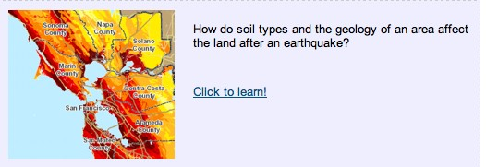
“How do soil types and the geology of an area affect the land after an earthquake?” at https://www1.wsrb.com/blog/the-effects-of-soil-type-on-earthquake-damage.

3. Explore and read the WSRB web page and then answer the following questions:

- Was soil type one of the factors you listed in the Engage section?

- What makes this an important variable in the resulting magnitude of earthquakes?

Example answer: Soil is the factor of focus, and different soil properties can affect seismic waves as they pass through a soil layer. In some areas, many different types of soil are layered one upon another before hard rock is encountered. In some cases, ground shaking may be amplified and this influences what needs to be done to structures to help them fare better in earthquakes. In addition, liquefaction or ground failure can occur, which is extremely destructive.

c. Record a specific example of how geology has an effect on earthquakes.
Possible example answers:
Soft soil amplifies shear waves.
Bodies of water can distort seismic waves.
Five soil types each have different effects on seismic waves. Water-saturated mud has the strongest amplification of shaking.

d. Which soil type has the strongest amplification of shaking?

Soil type E (200 m/sec > Vs), which includes water-saturated mud and artificial fill. [Listed in the
Soil Types and Shaking Amplification colored chart on the page.]

e. How might engineers use this data?
Engineers may recommend that land owners not build on this soil type, or they might design earthquake-proof buildings and homes that take the soil type into consideration

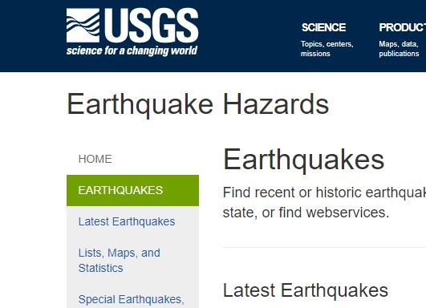
5. Navigate to the left corner of the USGS web page: https://www.usgs.gov/natural-hazards/earthquake-hazards/earthquakes and select “Earthquakes.” Find two earthquakes of the same magnitude and answer the questions below.

a. Compare and contrast two earthquakes with the same magnitudes but different locations in the world. Use the links to view where on the map these earthquakes occurred.

Students may choose different earthquakes, but they should be within .2 magnitude of each other. Expect students to click on the links and make observations such as “both regions are coastal” or “both regions are near the equator.”
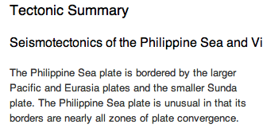
b. Looking at the two earthquakes you chose, record information from the “Tectonic Summary” for both locations. (The “Tectonic Summary” information is below the map for each location.) Are
any variables the same in both locations?

Again, expect answers to vary depending on the earthquakes chosen. Expect students to note something about the location, soil type or fault lines.
6. Return to the original USGS web page and click the far-left link labeled “Special Earthquakes, Earthquake Sequences, and Fault Zones.” Click on the 1906 San Francisco Earthquake. Then scroll about halfway down, under Publications and Documentaries, and click on the link for the “1906 San Francisco Earthquake,” which gets you to a USGS web page at https://earthquake.usgs.gov/earthquakes/events/1906calif/18april/.

a. Read about the 1906 San Francisco earthquake and explore the different links on the left side of the page.

b. Record at least five observations, including at least one from the 1906 earthquake photos.

• It was an earthquake resulting from the San Andreas Fault.
• Communities in sediment-filled valleys received stronger shaking than nearby bedrock sites.
• The strongest shaking occurred in regions where ground reclaimed from San Francisco Bay failed in the earthquake.
• The 1908 Lawson report is important in relating the earthquake to geology.
• The earthquake created a fire in San Francisco.
• Shaking damage was severe along the fault rupture.
• The photographs show a large fire and building crumbling.
• The earthquake lasted 45 to 60 seconds.

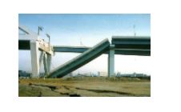
7. Return back to the Earthquakes Living Lab main page at http://www.teachengineering.org/livinglabs/earthquakes/ and select Japan. Read the paragraph on a 1995 earthquake located on the left side of the page, then click on the second picture on the right-hand side, which takes you to the Kobe earthquake of 1995 page at https://www.britannica.com/event/Kobe-earthquake-of-1995.

8. Read through this information, paying special attention to the photographs. Record at least five observations about this earthquake.
• Three crustal plates meet near the coast of Japan, near Kobe.
• The Nojima Fault is under Kobe.
• The earthquake caused a fire.
• The ground beneath some buildings was liquefied.
• Roads and buildings were re-designed following this earthquake.
• The pictures show destruction and fire caused by the earthquake.
• The area was considered “earthquake prone” because of the fault and the moving crusts.
• The focus was very shallow.
• The earthquake only lasted 20 seconds.
9. How are the effects of these earthquakes the same? How are they different? What are some possible reasons for the differences between these earthquakes and the damage they caused?
Both earthquakes caused fire and building/road destruction. Both earthquakes were also caused from underlying faults. The earthquake in Japan had settlement and liquefaction. The earthquakes may differ because they have different soil types and building types.
Explain:
10. What patterns did you notice between geology and magnitude?
The answer to this question is found in the Explore section, question 4, from this USGS page: http://earthquake.usgs.gov/regional/nca/soiltype/. Soil type is an important factor, and soft soil creates higher magnitude earthquakes and results in more destruction due to liquefaction.
11. How do you think engineers might use this information?

Engineers apply this information to their building designs and construction methods. They must be aware of a region’s active faults and areas of soft soil in order to design safe structures that are able to withstand the anticipated forces and movement from earthquakes.
Elaborate:
12. How do you think seismologists and geologists might work together to create maps of where earthquakes are most likely to occur (probability maps) of earthquake areas?

Seismologists and geologists work together to look at active faults and areas with soft soil and soil susceptible to liquefaction. They may use known past earthquake data to predict where future earthquake might occur.

Evaluate:
13. Your engineering team is hired to create a public service announcement (PSA) about the soils found
in the San Francisco area and the hazards related to earthquakes. Create a one-minute announcement that informs people about these hazards. Use any information found on the Earthquakes Living Lab and USGS pages.

