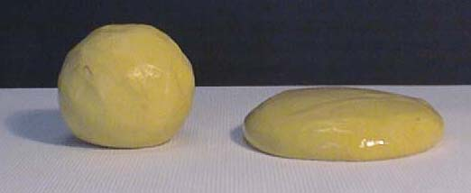
Let’s Make Silly Putty Student Handout

Introduction:

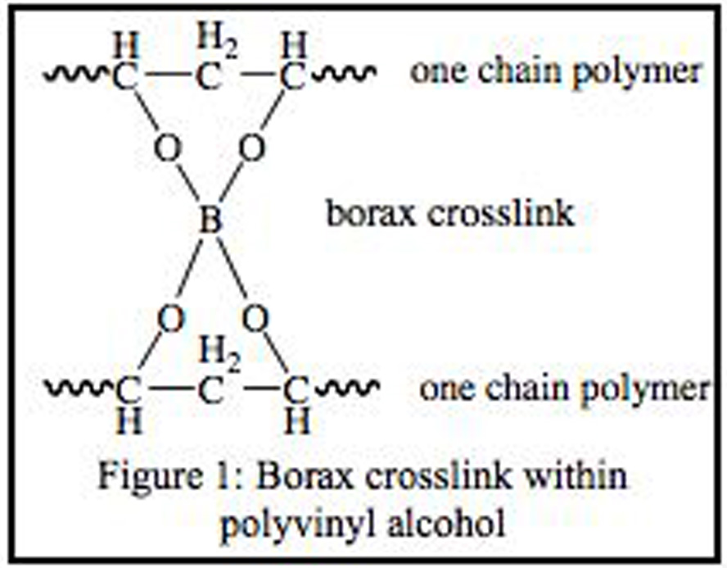
Polymers are encountered in everyday life and are used for many purposes. Polymers are chains made up of monomer subunits. The structure and chemical composition of the polymer chain determines the physical properties of the material. Some polymers are used for their rigid strength, others for their flexibility, and still others for resistance to corrosion.
In this activity, we will use poly(vinyl alcohol) and sodium tetraborate solutions to make a slimy polymer resembling silly putty.
Poly(vinyl alcohol), the main ingredient in Elmer’s Glue, is a long chain of repeating ethyl alcohol monomers -(CH₂-CHOH)- that you can think of as long strands of spaghetti. Sodium tetraborate (Borax) is an ionic compound that acts as a linker between the long chains of the polymers (see diagram above).
Depending on the ratios of polymer and sodium tetraborate solutions the putty can tend to be more bouncy, gooey or stretchy.

Historic Note:
The recipe for silly putty was originally created by James Wright of General Electric in an attempt to make a synthetic rubber compound. During World War II, Japan occupied many of the natural rubber manufacturing countries in the Far East and cut off supply to the US. This began to hamper war production efforts, especially of jeep/truck tires and boots. Although the invention of James Wright was not found to have good practical uses, silly putty did find utility as a toy for children in 1949.

Safety:
- Sodium tetraborate solution (Borax) is a bleaching agent and can burn eyes
- Goggles should be worn at all times
- Do not taste, eat or lick the silly putty
- Hands should be washed after working with the putty

Materials:

- Water
- Sodium tetraborate (Borax) Solution (Na₂B₄O₂•10 H₂O)
- 4 % Poly(vinyl alcohol) (CH₂CHOH)_{x}
- 20% Poly(vinyl alcohol) (Elmer’s Glue)
- 3 Dixie Cups
- 1 Scupula or Glass Stir Rod
- 1 Graduated Cylinder
- 1 Meter Stick
- Food Coloring

Procedure:
1)Use a graduated cylinder to add 10 mL of water to a Dixie Cup. With a pen, mark the level of the water on the outside of the cup. Add an additional 10 mL of water to the cup and mark the water level. Repeat 2 times until a total of 40 mL has been added to the cup. Now dump out all the water. These marks will be used to measure out the proper amounts of other ingredients.

Formulation 1: 4% Poly(vinyl alcohol)

1)Using the marks on the Dixie cup, measure out 20 mL of 4% poly(vinyl alcohol) solution directly into the cup, followed by 3-4 drops of food coloring, if desired. (Remember, yellow and blue makes green, blue and red makes purple and yellow and red makes orange.)
2)To the colored poly(vinyl alcohol) solution, add 10 mL of the saturated sodium tetraborate solution and stir immediately! It often works best to have someone else continually stir while another lab partner adds the borate solution.
3)Remove putty from Dixie cup (leaving any excess water in the cup) and knead the putty on a paper plate until the desired consistency is reached. The paper plate helps to absorb excess water.

Formulation 2: 20% Poly(vinyl alcohol) (Elmer’s Glue)

1)Measure 10 mL of water into the Dixie cup and add 3-4 drops of food coloring.
2)Using the markings on the Dixie cup, add ~10 mL of glue directly to the cup and mix gently until the mixture has a uniform consistency.
3)To the diluted Elmer’s glue solution, add 10 mL of the saturated sodium tetraborate solution and stir immediately! It often works best to have someone else continually stir while another lab partner adds the borate solution.
4)Remove putty from Dixie cup (leaving any excess water in the cup) and knead the putty on a paper plate until the desired consistency is reached.

Observations:

Use the table (below) to record observations about the starting reagents and each polymer formulation produced. Record these observations in bullet or picture form. Be sure to include any observations about the starting reagents before mixing and then record all observations after the two reagents are mixed. Use these observations to help your team create a better formulation for the design challenge.

Sodium Tetraborate | Poly(vinyl alcohol) | Formulation 1 | Formulation 2 | Design Putty

Design Challenge:

1) Create a polymer with the highest bounce.
OR
2) Create a polymer with the longest stretch.

Choose either Formulation 1 or 2 and redesign or modify the procedure to make a material that is either elastic (stretchy) or rigid (bouncy). Experiment with different ratios of poly(vinyl alcohol) & saturated sodium tetraborate (borax) solution to make putty that can bounce or stretch the best. Each groups’ material will be measured with a meter stick. Record the best distance of three trials in centimeters. For the bounce test, putty can be dropped from 15 cm (do not throw the putty, this will disqualify a bounce). For the stretch test, hold one end of the putty and allow gravity to stretch the material. Measure the length of the putty before it breaks (Note: Groups that stretch their putty with their hands will be disqualified).

Design Putty  Hypothesis | Design Putty  Procedure | Design Putty  Observations of Material Properties

- Did you redesign formulation 1 or 2? Please explain how you redesigned the formulation procedure?

- Describe the material properties of the imitation silly putty made using your redesigned procedure. Is the formulation more or less rigid or elastic?

- Are these material properties expected based on the changes you made to the original formulation procedure?

- How did your redesigned formulation 1 or 2 perform in the bounce or stretch test? Please include the exact distance in centimeters.

- How would you redesign your formulation further to improve your material properties so your putty would perform even better in the design challenge test?

Questions:

- How does the addition of sodium borate change the physical properties of the poly(vinyl alcohol) solution?

- Draw a schematic of a polymer that would be stretchy or one that would bounce well.

- Where can you find polymeric materials?

- Give an example of a commercial product that is made from a polymer.

- In your own words, describe a polymer.

- What happens when a cross-linker is added to a polymer material?

- What are the physical properties you observed about saturated sodium tetraborate solution?

- Prior to the experiment, what was your hypothesis for how the sodium tetraborate would effect the poly(vinyl alcohol) solution?

- Do you think the crosslinking event is a physical or chemical reaction? Explain your reasoning.

- In your own words describe how sodium tetraborate interacted with the poly(vinyl alcohol) chains in formulation 1 and formulation 2?

