Air Quality and Particulate Matter Datasheet
How can we know how clean and healthy the air is?

Together, we are going to find out:
- How can we measure how clean (healthy) the air is that we breathe?
- Does the air carry particulate matter (PM)?
- What should we do when the air is dirty (unhealthy)?

1. Let’s figure out how air quality is measured and why it’s important to know.
First, watch the Wildfires in the West Cause Air Pollution. Do a think-pair-share on what you observed:
- Why do wildfires cause air pollution?
- What happens to the air when there is a wildfire?
- How do you think smoke from wildfire travels so far away?
The Air Quality Index, or AQI for short, is a rating system that tells us how healthy the air outside is.
- Watch Why is Coco Orange? to learn about how air quality is measured.
- What does Coco say you should do when the air outside is not healthy?
- As a class, look at the Air Quality Index chart.
- What information does it tell?
- Which colors mean the air is healthy?
- Which colors mean the air is unhealthy?

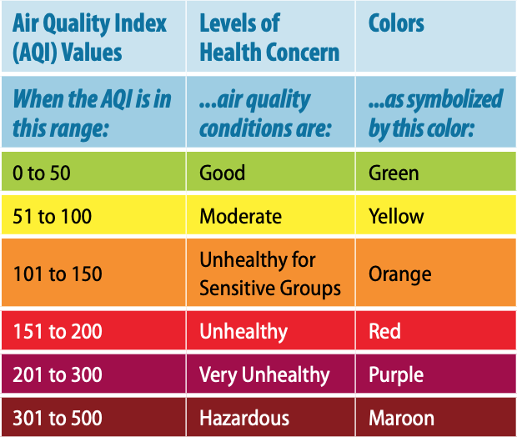

- Use the AQI chart to help you complete the “What Color is Your Air Today?” activity sheet for grade K or grades 1-2.

2. Wind and PM Data Table: Collect at your school!
Date | Wind Direction  Use the Wind Streamer to observe the direction the wind is blowing from.  Circle the wind direction on the compass. | Wind Speed  Estimate the wind strength by observing trees, flags, etc.  Circle the box that matches how much the wind is blowing | PM 2.5 Level  Write the PM 2.5 number from AirNow.gov | Air Quality Color  Color the circle to match the PM level  (green, yellow, orange, red, or purple)
Day: 1  Date: | 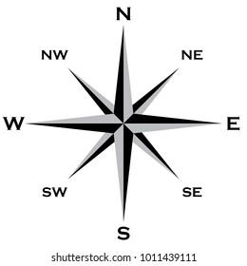 | ⃞ No Wind  ⃞ Light Wind  ⃞ Strong Wind | PM 2.5 level: | PM 2.5 Air Quality Color:
Day: 2  Date: |  | ⃞ No Wind  ⃞ Light Wind  ⃞ Strong Wind | PM 2.5 level: | PM 2.5 Air Quality Color:
Date | Wind Direction | Wind Speed | PM 2.5 Level | Air Quality Color
Day: 3  Date: |  | ⃞ No Wind  ⃞ Light Wind  ⃞ Strong Wind | PM 2.5 level: | PM 2.5 Air Quality Color:
Day: 4  Date: |  | ⃞ No Wind  ⃞ Light Wind  ⃞ Strong Wind | PM 2.5 level: | PM 2.5 Air Quality Color:
Day: 5  Date: |  | ⃞ No Wind  ⃞ Light Wind  ⃞ Strong Wind | PM 2.5 level: | PM 2.5 Air Quality Color:

3. PM Catcher: Use a hand lens to count how many PM particles are trapped.
- Place your PM Catcher in the space below (sticky side down for tape, sticky side up for Vaseline)
- Using a hand lens to view, look closely to see if it contains small pieces of PM.
- Can you see PM pieces? If yes, count how many pieces are on the PM Catcher.
Write the number of PM pieces: __________

4. Let’s analyze our PM 2.5 data and PM Catcher results.
Review the Air Quality Index (AQI) below and the Wind and PM data table where you recorded data in section 2 of the datasheet.

- Look at your PM data table. Count the number of PM 2.5 air quality days for each AQI color:
- Number of green days 🌝:________________
- Number of yellow days 🙂:________________
- Number of orange days 🙁:________________
- Number of red days 🙁:________________
- Number of purple days 🙁:________________
- We’re there more good air quality days or bad air quality days? Circle your results:
🙂 More clean, healthy air days 🙁 More dirty, unhealthy air days
- Circle the type of PM Catcher you made: Tape Vaseline
- Was PM on your PM Catcher? No Yes, number of PM pieces: _______
Class Reflection: Share your thoughts on the following questions as a class:
- What did you enjoy in learning about Air Quality (AQ)?
- Explain what PM is in your own words.
- How do the AQ colors help us know how good or bad the air is?
- What is one thing we should do when the AQ is not healthy?

