Air Quality and Weather Connections Datasheet
How can we know how clean and healthy the air is?

Together, we are going to find out:
- How can we measure how clean (healthy) the air is that we breathe?
- Does the air carry particulate matter (PM)?
- What should we do when the air is dirty (unhealthy)?

1. Let’s figure out how air quality is measured and why it’s important to know.
First, watch the Wildfires in the West Cause Air Pollution. Do a think-pair-share on what you observed:
- Why do wildfires cause air pollution?
- What happens to the air when there is a wildfire?
- How do you think smoke from wildfire travels so far away?
The Air Quality Index, or AQI for short, is a rating system that tells us how healthy the air outside is.
- Watch Be Smoke Ready: Know the Colors of the Air Quality Index (AQI) to learn about how air quality is measured.
- What should you do when the air outside is not healthy?
- As a class, look at the Air Quality Index chart.
- What information does it tell?
- Which colors mean the air is healthy?
- Which colors mean the air is unhealthy?

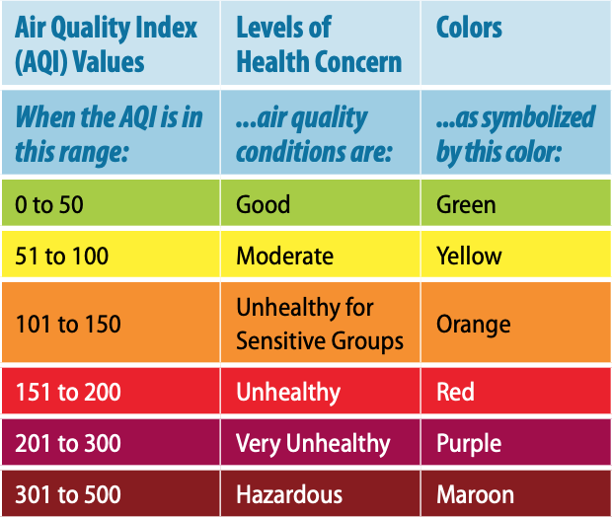

- Use the AQI chart to help you complete the “What Color is Your Air” activity sheet for grades 3-5.

2. Weather and Air Quality Data Table: Collect data at your school!
Date | Weather Conditions &  PM 2.5 and Ozone Levels |  |  |  | Air Quality Action Day?
Day 1  Date: | Wind direction: | ⃞ Clear sky  ⃞ Slightly hazy sky  ⃞ Very hazy sky | PM level: | PM color: | Yes  No
 | Wind speed: | Temperature: | Ozone level: | Ozone color:
Day 2  Date: | Wind direction: | ⃞ Clear sky  ⃞ Slightly hazy sky  ⃞ Very hazy sky | PM level: | PM color: | Yes  No
 | Wind speed: | Temperature: | Ozone level: | Ozone color:

Date | Weather Conditions &  PM 2.5 and Ozone Levels |  |  |  | Air Quality Action Day?
Day 3  Date: | Wind direction: | ⃞ Clear sky  ⃞ Slightly hazy sky  ⃞ Very hazy sky | PM level: | PM color: | Yes  No
 | Wind speed: | Temperature: | Ozone level: | Ozone color:
Day 4  Date: | Wind direction: | ⃞ Clear sky  ⃞ Slightly hazy sky  ⃞ Very hazy sky | PM level: | PM color: | Yes  No
 | Wind speed: | Temperature: | Ozone level: | Ozone color:
Day 5  Date: | Wind direction: | ⃞ Clear sky  ⃞ Slightly hazy sky  ⃞ Very hazy sky | PM level: | PM color: | Yes  No
 | Wind speed: | Temperature: | Ozone level: | Ozone color:

3. PM Collector: When done collecting PM data, place this grid face down over the sticky side of the PM Collector.

Use a hand lens to count how many PM pieces are trapped in each square of the PM Collector. Record the number of pieces in section 4 of the datasheet.
1 | 2
3 | 4

4. Let’s analyze our PM 2.5 data and PM Catcher results.
Review the Air Quality data table in section 2 where you recorded PM 2.5 and ozone data.
- Count the number of PM 2.5 air quality days for each AQI colors:
- Number of green days 🌝:________________ Total good PM air quality days: _______
- Number of yellow days 🙂:________________
- Number of orange days 🙁:________________ Total bad PM air quality days: _______
- Number of red days 🙁:________________
- Number of purple days 🙁:________________
- Count the number of ozone air quality days for each AQI colors:
- Number of green days 🌝:________________ Total good ozone air quality days: _______
- Number of yellow days 🙂:________________
- Number of orange days 🙁:________________ Total bad PM air quality days: _______
- Number of red days 🙁:________________
- Number of purple days 🙁:________________
- Adding PM and ozone data together, we’re there more good air quality days or bad air quality days overall? Circle your results:
🙂 More clean, healthy air days 🙁 More dirty, unhealthy air days
- Record your PM Collector data:
- Total number of PM pieces in square 1: ___________
- Total number of PM pieces in square 2: ___________
- Total number of PM pieces in square 3: ___________
- Total number of PM pieces in square 4: ___________
- Average number of PM pieces (add totals 1 through 4 and divide by 4): ___________
Class Reflection: Share your thoughts on the following questions as a class:
- What is one thing you enjoyed in learning about Air Quality?
- In your words, explain the connection between haze and PM?
- Do you think the wind affects the amount of PM in the air?
- We collected data for a short time. Do you think air quality changes over a longer time?

