Creative Crash Testing Worksheet
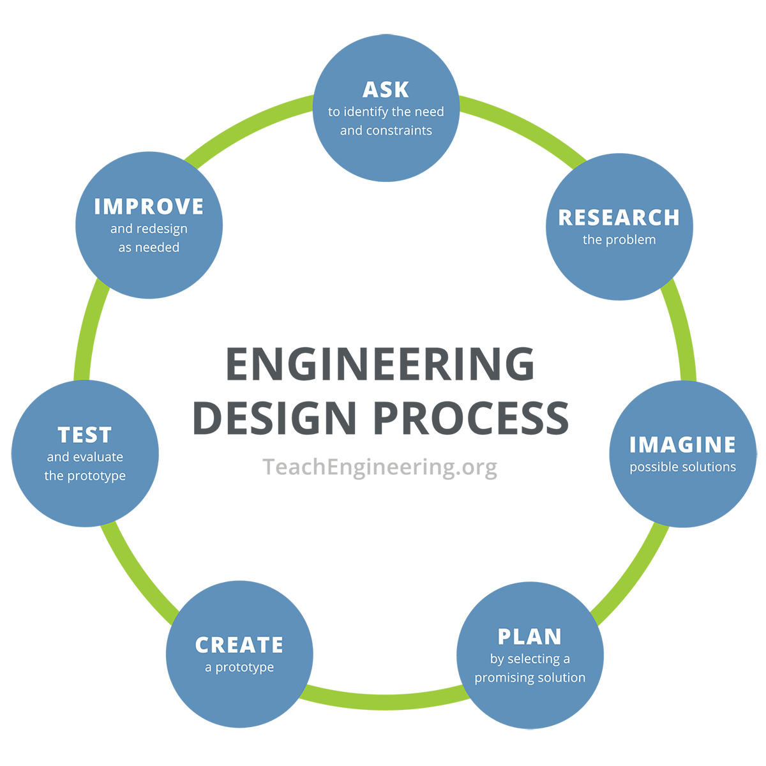

Ask
- In your own words, what problem are you trying to solve in this activity?

- What are the constraints for this activity?

Research
Vehicle Safety Feature | How it works / What it is made of

Imagine
- Generate Ideas: What a Safe Vehicle Looks Like—Prototype Ideas

Plan
Design Solution for Your Best Plan to Prototype and Test
Explain the design approach that you will prototype and test… (Example: We think cushion-type safety features are the best during a head-on collision. And we think that heavier cars better survive head-on collisions.)

Initial Design Materials Used
Model Material | How many/How much | What it’s being used for
Cotton fill
Cardboard
Tag board
Felt
Foam paper
Craft sticks
Chenille stems/pipe cleaners
Balloons
Rubber bands
Plastic straws

Plan
Sketch your final design with materials identified.

Test
Initial Testing & Analysis
Car/Group # | Car Mass (grams) | Run Length (meters) | Run Time (seconds) | Testing Success (Y/N) | Car speed | Momentum (m*v=p)
1
2
3
4
5
6
7
8
9
10

Test
Initial Results Summary
Initial results: (List details of what happened to your vehicle during/after crash.)

What worked and what didn’t work?

Improve
Redesign/Rebuild Materials Used
Model Material | How many/How much | What it’s being used for / Problem that is being fixed
Cotton fill
Cardboard
Tag board
Felt
Foam paper
Craft sticks
Chenille stems/pipe cleaners
Balloons
Rubber bands
Plastic straws

Redesign Approach
To improve on our first design, we decided to…

Because…

Redesign Testing & Analysis
Car/Group # | Car Mass (grams) | Run Length (meters) | Run Time (seconds) | Testing Success (Y/N) | Car speed | Momentum (m*v=p)
1
2
3
4
5
6
7
8
9
10
Redesign Results Summary
Final results: (List details of what happened to your vehicle during/after crash.)

What worked? What didn’t work? Why?

Final conclusions:

