Air Composition Pie Chart Worksheet
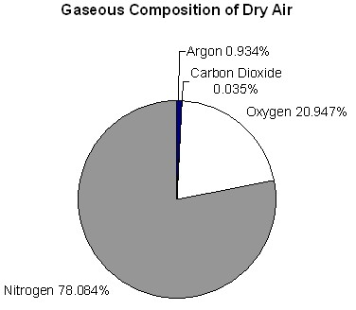

Gaseous Composition of Dry Air
Gas | Percentage
Total

