The Carbon Cycle Diagram

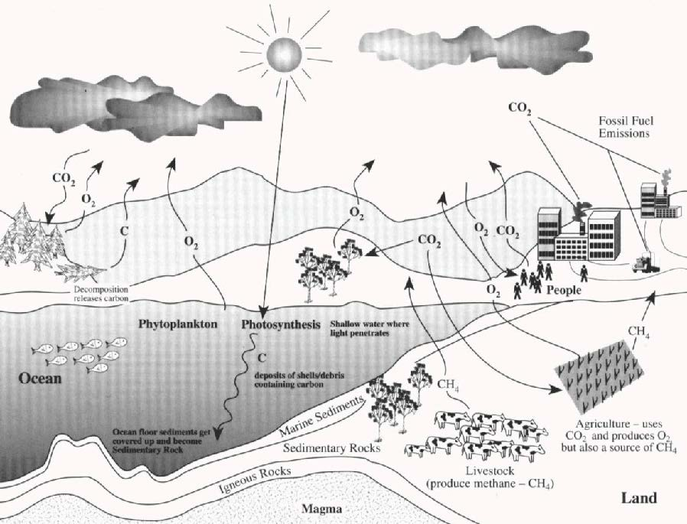
Source: Earth Science Enterprise, NASA, http://kids.earth.nasa.gov/seawifs/images/carboncycle.gif.

