**High School VOC Worksheet**

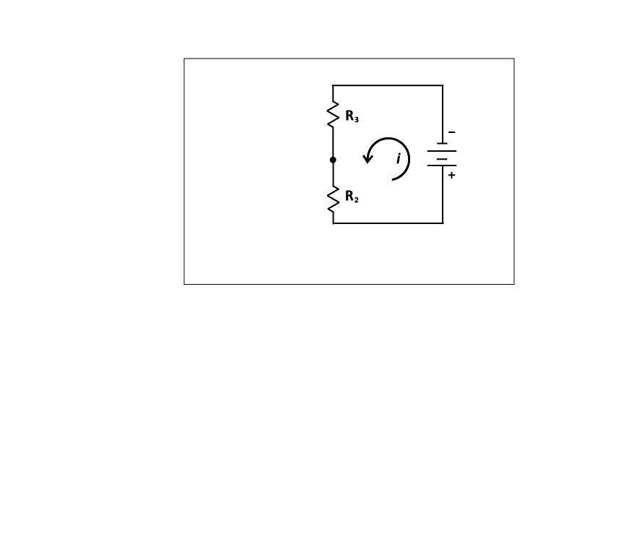

1. Given Equation 1,, and a total voltage of 10V, a current of 2A, and resistor 2 value of , what is the value of resistor 3?
2. If you increase the value of resistor 2 to, what happens to the value of resistor 3?
3. What if you reduce the value of resistor 2 to?
4. If the value of  increases, the value of  ___________. If  decreases,  ______________. This relationship is called proportionality ( ).
5. Ohm’s Law states that Plug Ohm’s Law into Equation 1 so that it contains only voltage values.
6. When VOCs come into contact with the surface of the sensor, a reaction occurs, and the resistance of resistor 2 decreases. Assume that you are testing a spray cleaner for VOCs. Before you spray the cleaner into your classroom,    and  You spray the cleaner, and  changes from  to  What happens to and 