**High School VOC Worksheet Answers**

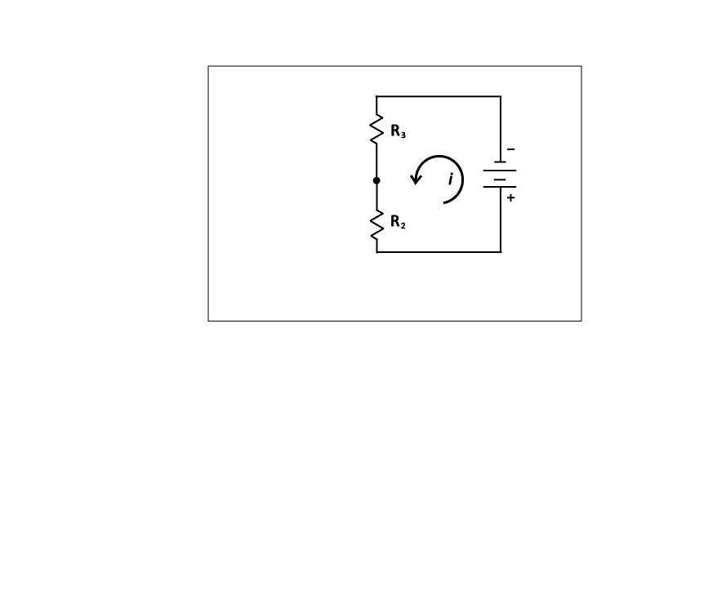

1. Given Equation 1,, and a total voltage of 10V, a current of 2A, and resistor 2 value of , what is the value of resistor 3?

Answer:



1. If you increase the value of resistor 2 to , what happens to the value of resistor 3?

Answer: It decreases.



1. What if you reduce the value of resistor 2 to ?

Answer: It increases.



1. If the value of  increases, the value of  ___________. If  decreases,  ______________. This relationship is called proportionality ( ).

Answer: decreases; increases

1. Ohm’s Law states that Plug Ohm’s Law into Equation 1 so that it contains only voltage values.

Answer: 

1. When VOCs come into contact with the surface of the sensor, a reaction occurs, and the resistance of resistor 2 decreases. Assume that you are testing a spray cleaner for VOCs. Before you spray the cleaner into your classroom,    and  You spray the cleaner, and  changes from  to  What happens to and 

Answer:  goes down (from 4V to 2V) and  goes up (from 4V to 6V)