How a Cyclone Cleans Polluted Air
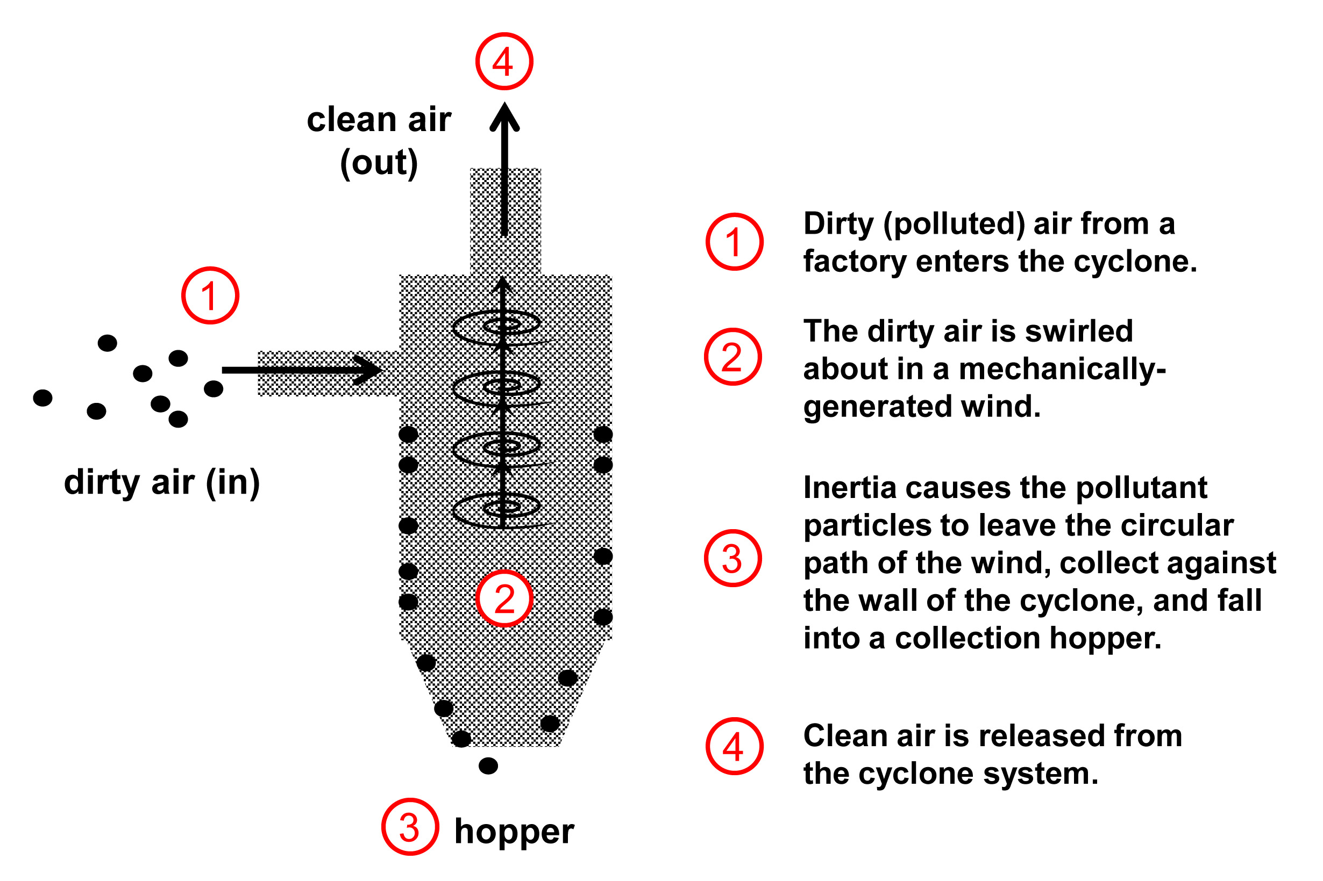

Source: Natalie Mach and Ben Terry, ITL Program,
College of Engineering, University of Colorado Boulder, 2004 and 2011

