Pre-Activity Problem Set

Answer the following questions.
- What is the chemical equation for complete combustion?

- What pollutants might result if incomplete combustion is occurring?

- Is NOx formed from the fuel itself? If not, where does it come from? Yes or No

- Which fuel has a higher energy content? Gasoline or Diesel

Answer the following questions using the example data in the table below.
Independent Variables |  |  | Dependent Variables  (concentrations observed at tailpipe)
Fuel | Formula | Combustion temperature (°C) | CO₂ (ppm) | VOC (ppm) | NOx (ppm)
Case 1: Gasoline | C₈H₁₈ | 1500 | 3000 | 30 | 20
Case 2: Diesel | C₁₂H₂₃ | 1900 | 3000 | 50 | 40
Case 3: Ethanol | C₂H₅OH | 1500 | 4000 | 10 | 20

- What is similar about the chemical formulas for all of the fuel sources?

- What is different about ethanol, and why might that difference result in lower VOCs?

- Which requires more oxygen to reach complete combustion? Gasoline or diesel? And, why?

- Which fuel type results in the most NOx and why?

- In the following table, circle the A or B that best completes the row. Then explain your rationale.
Claim | Evidence | Reason
Vehicle 1 produces more total pollutants than vehicle 2. | We observe higher CO₂ and higher VOCs in the vehicle 1 data. | - Vehicle 1 has an older engine.  - Vehicle 1 has a larger engine.
Vehicle 2 exhibits more complete combustion than vehicle 1. | - We observe more VOCs from vehicle 1 than vehicle 2.  - We observe more VOCs from vehicle 2 than vehicle 1. | Vehicle 2 is newer and operating more efficiently, therefore it is displaying more complete combustion.
- The combustion in vehicle 1 is hotter.  - The combustion in vehicle 2 is hotter. | We observe more NOx from vehicle 1 than vehicle 2. | Vehicle 1 has a diesel engine.

Explanations

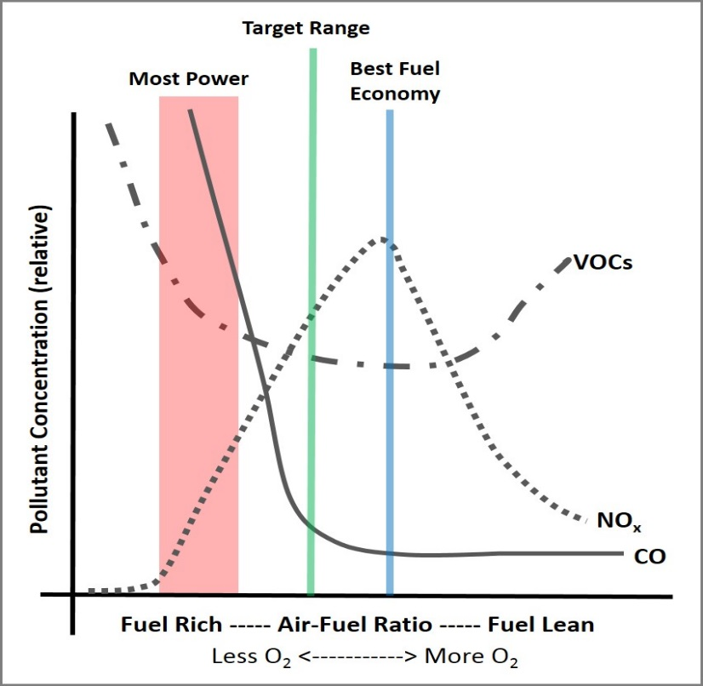
CHALLENGE QUESTION
- To the air-fuel ratio plot on the right, add a line for CO₂. Explain your line placement.

