Pre-Activity Problem Set Answer Key

Answer the following questions.
- What is the chemical equation for complete combustion?
Fuel + O₂ CO₂ + H₂O

- What pollutants might result if incomplete combustion is occurring?
CO, VOCs, particulate matter (and still CO₂ and H₂O)

- Is NOx formed from the fuel itself? If not, where does it come from? Yes or No
Thermal NOx is formed form the N₂ already present in the air (air ~ 21% O₂ and 79% N₂).

- Which fuel has a higher energy content? Gasoline or Diesel

Answer the following questions using the example data in the table below.
Independent Variables |  |  | Dependent Variables  (concentrations observed at tailpipe)
Fuel | Formula | Combustion temperature (°C) | CO₂ (ppm) | VOC (ppm) | NOx (ppm)
Case 1: Gasoline | C₈H₁₈ | 1500 | 3000 | 30 | 20
Case 2: Diesel | C₁₂H₂₃ | 1900 | 3000 | 50 | 40
Case 3: Ethanol | C₂H₅OH | 1500 | 4000 | 10 | 20

- What is similar about the chemical formulas for all of the fuel sources?
All contain carbon and hydrogen.
- What is different about ethanol, and why might that difference result in lower VOCs?
Ethanol has oxygen in the fuel, which facilitates more complete combustion and therefore fewer VOCs.
- Which requires more oxygen to reach complete combustion? Gasoline or diesel? And, why?
Diesel, because it contains more carbon, or a higher carbon/hydrogen ratio; you need two oxygens for each carbon to get to CO₂.
- Which fuel type results in the most NOx and why?
Diesel, because of the higher combustion temperature.

- In the following table, circle the A or B that best completes the row. Then explain your rationale.
Claim | Evidence | Reason
Vehicle 1 produces more total pollutants than vehicle 2. | We observe higher CO₂ and higher VOCs in the vehicle 1 data. | - Vehicle 1 has an older engine.  - Vehicle 1 has a larger engine.
Vehicle 2 exhibits more complete combustion than vehicle 1. | - We observe more VOCs from vehicle 1 than vehicle 2.  - We observe more VOCs from vehicle 2 than vehicle 1. | Vehicle 2 is newer and operating more efficiently, therefore it is displaying more complete combustion.
- The combustion in vehicle 1 is hotter.  - The combustion in vehicle 2 is hotter. | We observe more NOx from vehicle 1 than vehicle 2. | Vehicle 1 has a diesel engine.

Explanations
Row 1: A larger engine uses more fuel, which results in more overall emissions, while an older engine may run poorly and may exhibit more incomplete combustion, but not necessarily more emissions.
Row 2: More incomplete combustion leads to more VOCs.
Row 3: Diesel engines run at a hotter temperature and typically produce more NOx.
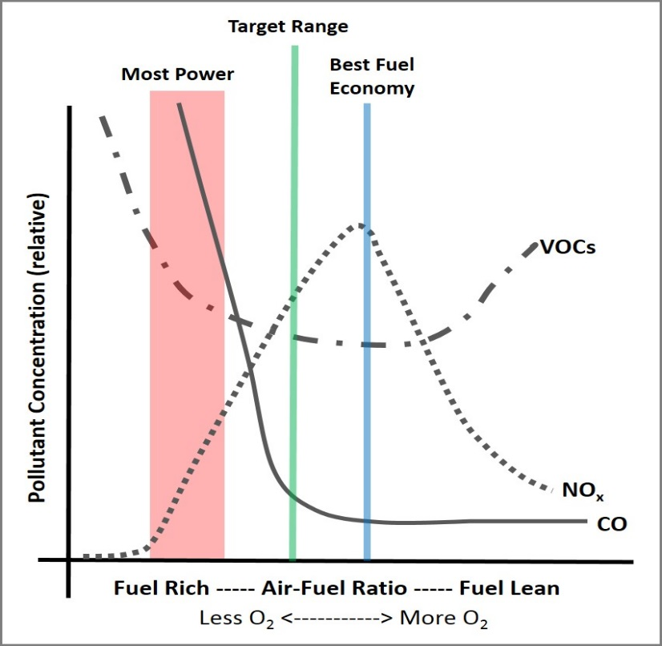
CHALLENGE QUESTION
CO₂
- To the air-fuel ratio plot on the right, add a line for CO₂.
Explanation of CO₂ line placement (the red line). Moving from left to right:
CO₂
- To begin with, CO₂ will be at a minimum.
- It will increase as more O₂ is added.
- It will plateau as CO reaches a minimum (and achieves more complete combustion).
- As the VOCs increase, the CO₂ decreases slightly.

