Pre-Activity Reading

Overview
For this activity, we will compare the emissions from different vehicles using low-cost air quality monitors. To prepare, read this document and then answer the Pre-Activity Questions.

Background Information
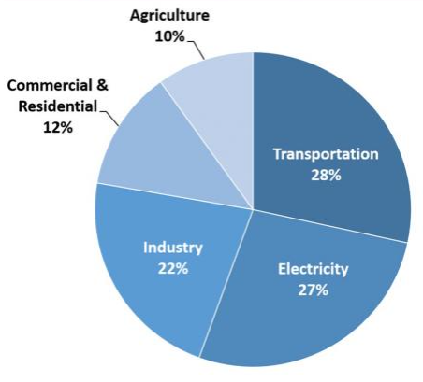
According to the Inventory of U.S. Greenhouse Gas Emissions and Sinks, in 2018, transportation accounted for 28% of greenhouse gas emissions. Since transportation is such a major contributor to poor air quality and climate change, it is important that we monitor and study emissions from all forms of transportation.
Measurements of emissions from transportation are made in a variety of ways: individual cars undergo testing, monitors are placed on roadways (or interstate on-ramps), and data analysis from stationary monitors can sometimes provide an idea of how much of each pollutant comes from vehicles versus industry (which is called source apportionment). In this activity, you will conduct a low-tech emissions monitoring experiment, but first we need to learn a little about combustion chemistry and internal combustion engines.
Total U.S. greenhouse gas emissions by economic sector in 2018.

Combustion Chemistry
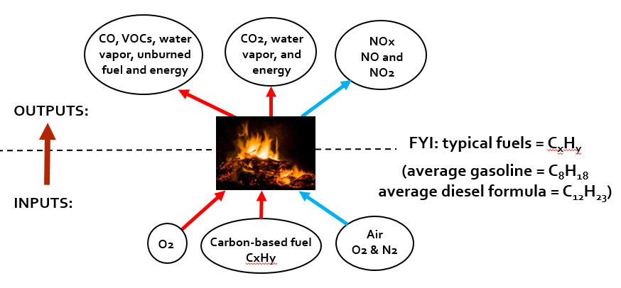

Combustion in vehicles involves a carbon-based fuel burning in the presence of air (oxygen and nitrogen), which results in the production of energy and combustion by-products. Fuel is represented by the formula C_{x}H_{y}, which represents x number of carbons and y number of hydrogens. C₈H₁₈ is average gasoline and C₁₂H₂₃ is the average diesel formula. A different composition of fuel results in different physical properties. For example, diesel fuel has a higher energy content than gasoline. For comparison, these energy contents are listed below.
- Gasoline energy content = 122,364 BTU/gal
- Diesel energy content = 138,490 BTU/gal
3 Important Combustion Reactions
Reaction 1: Complete Combustion C_{x}H_{y} + O₂ → CO₂ +H₂O
Complete combustion occurs when enough oxygen is present to fully combust each carbon in the fuel, or enough oxygen to provide two oxygen molecules for each carbon molecule. The by-products of complete combustion are water vapor and carbon dioxide. Since carbon dioxide is not a concern for human health, this type of combustion is (generally) the cleanest.
Reaction 2: Incomplete Combustion C_{x}H_{y} + O₂ → CO + VOCs + CO₂ + H₂O
Combustion is incomplete when not enough oxygen is present to completely combust the fuel supply. As a result of the lack of oxygen, by-products like carbon monoxide (CO) and volatile organic compounds (VOCs) are created. CO is harmful to human health and VOCs can be harmful depending on the compound. CO₂, along with CO, VOCs and H₂O, are by-products of incomplete combustion.
Reaction 3: Thermal NO_{x} Formation N₂ + O₂ → NO/NO₂
This reaction does not involve a direct interaction with the fuel. Thermal NO_{x} formation is the result of high-temperature combustion. At high temperatures, the oxygen (O₂) and nitrogen (N₂) in the air are split and bond to one another, creating NO_{x} (including both NO and NO₂). NO_{x} is a concern for human health.

Internal Combustion Engines and Air Fuel Ratio
The air-to-fuel ratio is the relative amounts of air and fuel available to the engine for combustion, and can affect how internal combustion engines perform in vehicles. The air-fuel ratio impact how much energy is produced and what combustion by-products are released. For comparison purposes, the table below lists the advantages and disadvantages of the fuel rich and fuel-lean combustion scenarios. Basically:
- Fuel rich means there is more fuel and less air, which results in more power, but also more incomplete combustion by-products
- Fuel lean means there is less fuel and more air, which results in more complete combustion, but less power.
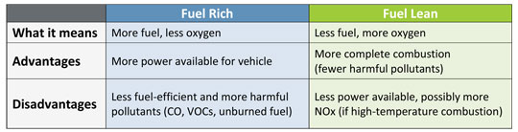

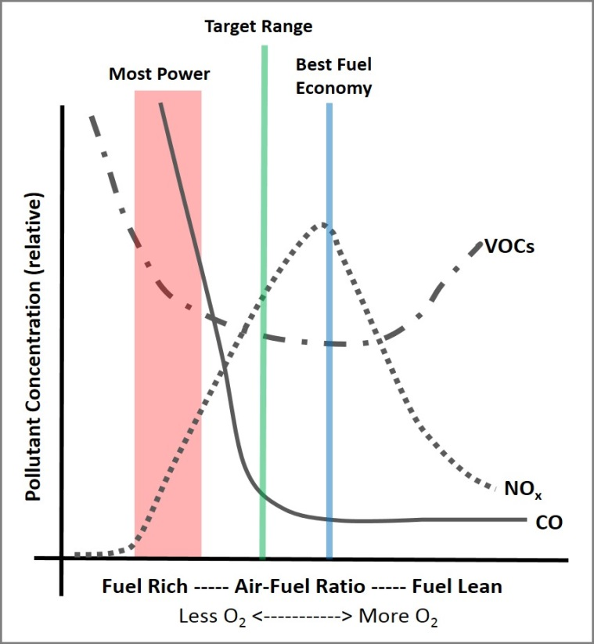
The plot to the right shows how pollutants can vary with different air-fuel ratios. Observations:
- CO is the highest on the fuel-rich side
- NO_{x} is the highest when we have the “best economy” or we are using the fuel most efficiently. This means we also have the most effective and complete combustion, thus the highest temperatures
- VOCs are high both on the fuel rich side (when not enough O₂ is present to combust the fuel) AND when we are very fuel-lean (in this case, fuel is being heated, thus increasing volatilization, but the fuel is not combusting).
- If we were to add CO₂, we would also have the most CO₂ when we have the best fuel economy.

Control Technologies
The air-fuel ratio is also determined by effective operation of control technologies. Below is a diagram of a catalytic converter, which is one well-known control technology that was added to cars starting in the 1970s. This device uses oxidation and reduction reactions to convert harmful pollutants (CO, VOCs, NO_{x}) to gases that are not dangerous to human health (CO₂ and water vapor).
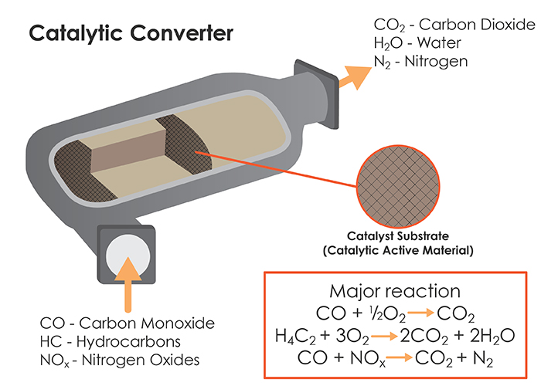

Other examples of control technologies and strategies related to transportation include the removal of lead from gasoline and the addition of filters to diesel engines to catch particulate matter.

Sources of Greenhouse Gas Emissions, U.S. EPA http://www.epa.gov/ghgemissions/sources-greenhouse-gas-emissions (See Pre-Activity Presentation for image source information.)

