Sample Data
This is a set of data collected using the same procedure listed on your data sheet. Use this data to answer the Results and Reflection Questions.
Experimental Information
- Vehicle 1: car, newer (<2 years old)
- Vehicle 2: truck, older (>6 years old)
- Each vehicle was sampled twice
Experimental Setup Photo
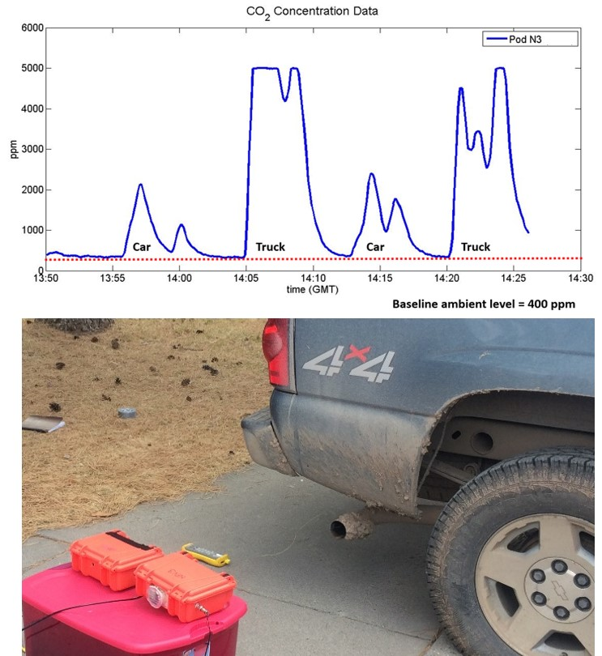

Carbon Dioxide Concentration Data (note the baseline indicated in red)

Complete Data from Four Vehicle Tests

