Brainstorming Guide
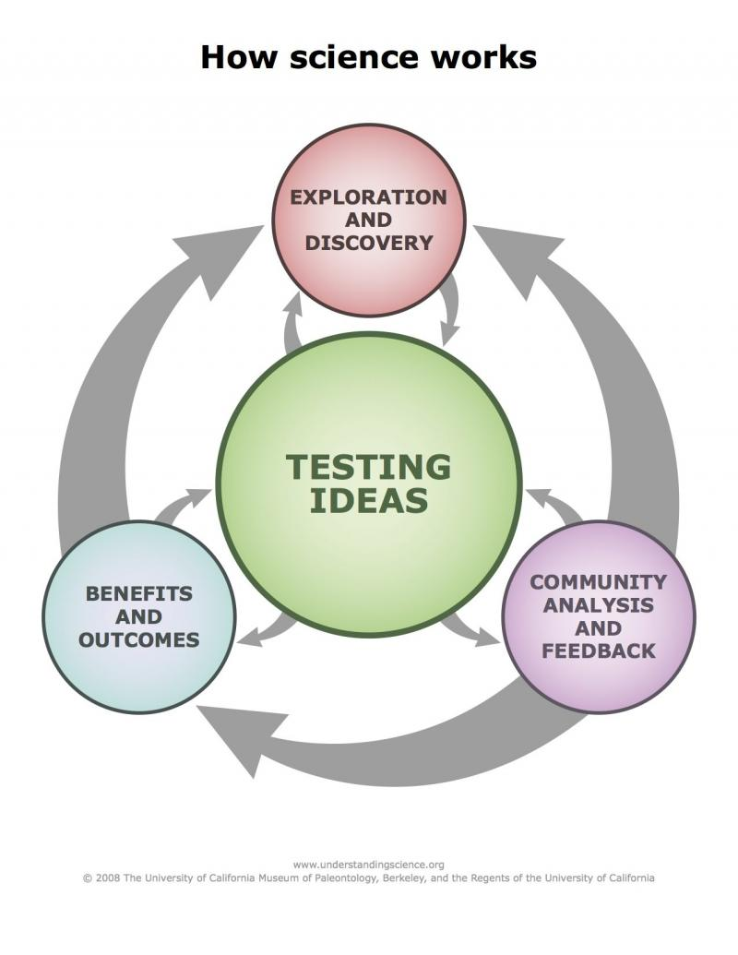
Start here:
Brainstorm, discuss, outline your investigation

Next:
Define your hypothesis
Complete a “project plan”
Collect data
Examine, analyze and interpret your data
Last:
Share your work
Communicate your findings
Make a poster
Present to colleagues and other scientists

Brainstorm
Discuss lots of ideas with your team members. Below are some questions that might help. The scientific inquiry process diagram on the other side of this sheet shows all of the project components so you can see where you are heading.
- What are some activities you see on a daily basis that might affect air quality?
- Is there a particular pollutant you would like to better understand?
- Are there locations you would like to compare?

List three topics and a possible hypothesis or research question for each.

Topic 1:

Research Question or Hypothesis:

Topic 2:

Research Question or Hypothesis:

Topic 3:

Research Question or Hypothesis:

