Guide to Making Scientific Research Posters
The following guide walks you through the steps to making scientific research posters. The guide is also helpful for preparing written reports and Microsoft PowerPoint slide presentations, too.

Step 1: Download a PowerPoint poster template, or make your own
- Download already sized and formatted Microsoft PowerPoint templates from: http://www.makesigns.com/SciPosters_Templates.aspx.
Choose a free template that is 36 x 48 inches. Vertical or horizontal orientation is fine.
- To make your own, open Microsoft PowerPoint, then go to Design >Slide Size > Custom slide size. Edit the size to 36 x 48 inches.

Step 2: Edit your poster
Once you have a correctly sized PowerPoint file, add text boxes, charts and photos, modify the background and use the many font and graphic tools.
Include the following sections on your poster:
- Project Title: Write a descriptive and engaging title.
- Authors and Institution: List everyone in your group and your school name.
- Overview/Summary: In a few sentences or bullets, explain your project—what your research question is, when and where you collected data, and why your project matters.
- Introduction/Background Information: Provide your audience with information to help them understand your project, such as where the pollutants that you measured come from.
- Methods and Materials: Describe what you did and how you did it.
- Results: What did you find? Include data, charts and statistics.
- Discussion: What do your results mean? Did your hypothesis hold true? Did you answer your research questions? What are the limitations of your data? What would be the next steps if you continued this research?
- References: Cite the sources you used.
- Acknowledgements Thank your teacher or anyone else who assisted your group with the project.
- Disclaimer: Your teacher may ask you to add some text to the bottom of your poster, such as: “This data was generated as part of a research learning experience and is intended only for that purpose.”

Step 3: Complete and proofread your poster
- Save the final PPTX poster file as a PDF file.
- Open the PDF and check one more time for any formatting issues and typos.
- Fix any problems and make any final improvements. Then resave the PPTX and make a PDF.
- Once you are satisfied with the poster, follow your teacher’s instructions to get it printed.

Tips
- Layout
  - Think about the way in which your audience will “read” your poster; you want to create a logical flow through the poster. Decide on a layout that feels natural to read. Think about leading your audience through the “story” of your project.
  - Add charts. Make them as large as possible. Make sure the axes labels are correct and the text is readable.
  - Add photos. Use them to illustrate your experimental setup or the equipment you used.
  - A person should be able to understand your poster even if you are not there to explain it.
- Aesthetics
  - Font sizes: For readability on a 36 x 48-inch poster, good font sizes are:
    - 90-120 pt for main titles
    - 60-80 pt for subtitles
    - 35-60 pt for content/body text
    - It is okay to use text larger than these ranges, but try not to go any smaller.
  - Colors: Contrasting colors are easiest for the eye to read. Avoid choosing similar colors for fonts and backgrounds.
- Final check: It can be helpful to display your poster on a projector to make a final check for layout, readability and overall aesthetics before you save and print it.

Prepare your presentation
- Prepare a ~5 minute presentation to share your work with the audience.
- Consider communicating by using a storytelling framework, which works well for all types of presentations. Storytelling in science parallels to traditional storytelling.
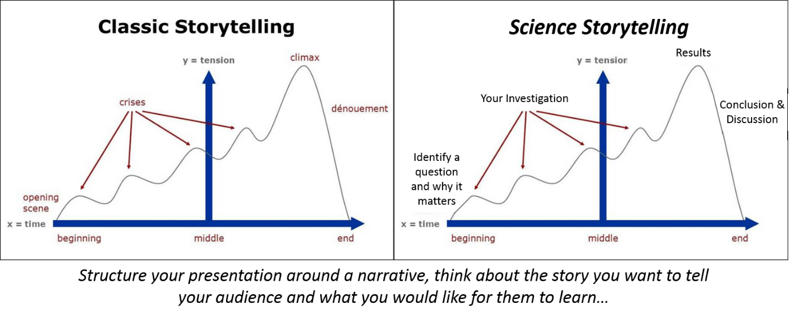

- Consider how to engage your audience and walk them through your experiences during the project, which helps you communicate what you learned and would like for them to understand.
See more poster tips in Chapter 13 of the Introductory Engineering Design: A Projects-Based Approach textbook at https://www.colorado.edu/eplus/resources/introductory-engineering-design-textbook.

