Hand Dynamometer
Assembly Instructions

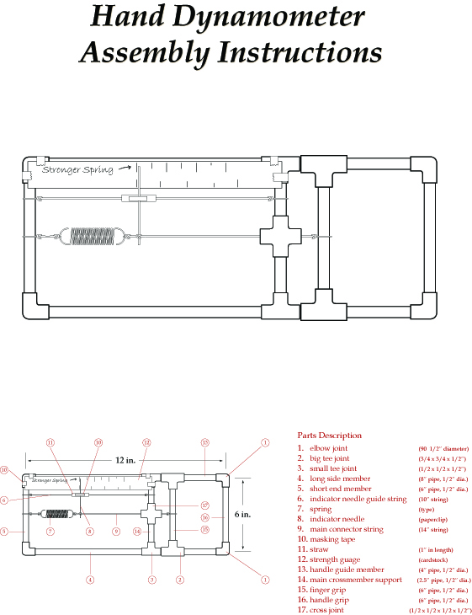
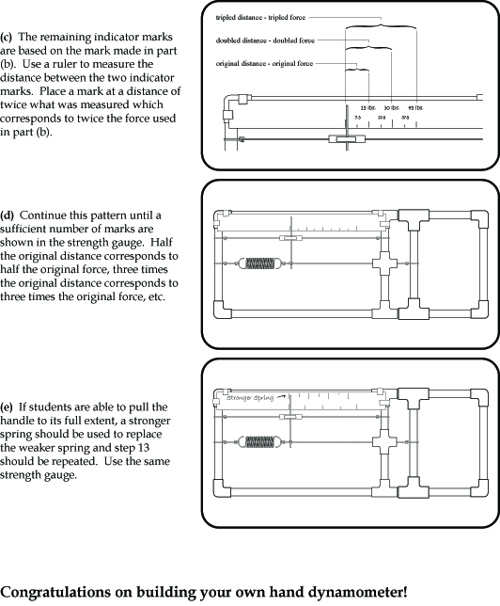
Parts Description
- elbow joint (90°, ½-in diameter)
- big T-joint (¾ x ¾ x ½-in)
- small T-joint (½ x ½ x ½-in)
- long side member (8-in pipe, ½-in diam.)
- short end member (6-in pipe, ½-in diam.)
- indicator needle guide string (10-in string)
- spring (3-in size)
- indicator needle (paperclip)
- main connector string (14-in string)
- masking tape
- straw (1-in length)
- strength gauge (cardstock)
- handle guide member (4-in pipe, ½-in diam.)
- main cross-member support (2.5-in pipe, ½-in diam.)
- finger grip (6-in pipe, ½-in diam.)
- handle grip (6-in pipe, ½-in diam.)
- cross joint ( all ½-in diam.)

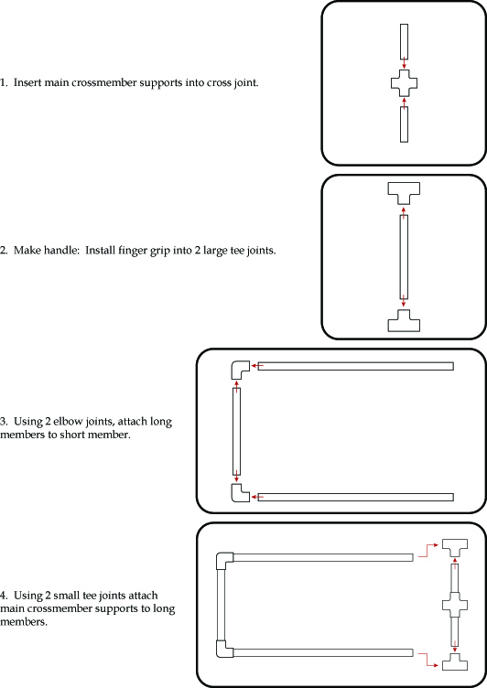
- Insert main cross-member supports into the cross joint.

- Make handle: Install finger grip into two large T-joints.
- Using two elbow joints, attach long members to short member.
- Using two small T-joints, attach main cross-member supports to long members.

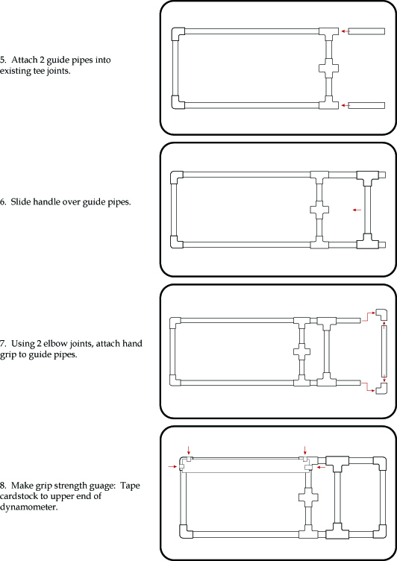
- Attach two guide pipes into existing T-joints.

- Slide handle over guide pipes.
- Using two elbow joints, attach hand grip to guide pipes.
- Make grip strength gauge:
Tape cardstock to upper end of dynamometer.

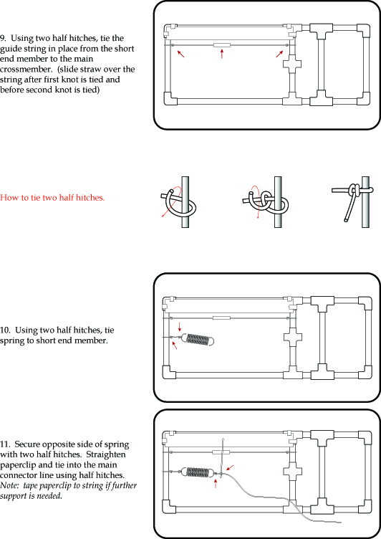
- Using two half hitches, tie the guide string in place from the short end member to the main cross-member. Slide straw over the string after the first knot is tied and before the second knot is tied.

- Using two half hitches, tie spring to short end member.
- Secure opposite side of spring with two half hitches. Straighten paperclip and tie into the main connector line using half hitches. Note: If further support is needed, tape paperclip to string.
How to tie two half hitches:

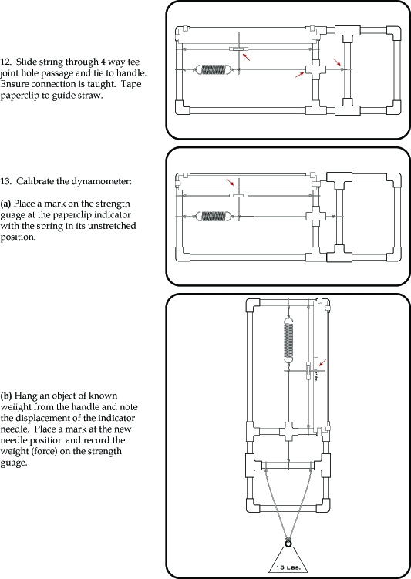
- Slide string through four-way T-joint hole passage and tie to handle.
Make sure connection is taught.
Tape paperclip to guide straw.

- Calibrate the dynamometer.
(b) Hang an object of known weight from the handle and note the displacement of the indicator needed. Place a mark at the new needle position and record the weight (force) on the strength gauge.
- With the spring in its un-stretched position, place a mark on the strength gauge at the paperclip indicator.

(c) The remaining indicator marks are based on the mark in part (b). Use a ruler to measure the distance between the two indicator marks. Place a mark at a distance of twice what was measured; this corresponds to twice the force used in part (b).

(d) Continue this pattern until a sufficient number of marks are shown in the strength gauge. Half the original distance corresponds to half the original force, three times the original distance corresponds to three times the original force, etc.
Congratulations on building your own hand dynamometer!

