Three Methods to Treat Blocked Arteries
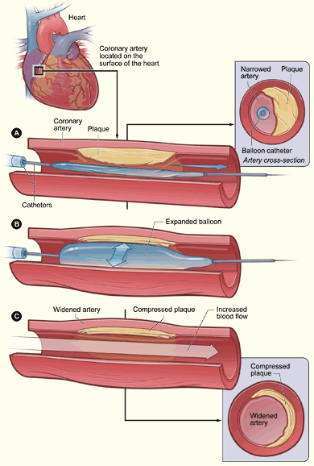
Angioplasty
(balloon catheter)
Angioplasty
(catheter with stent)
Coronary Bypass Surgery

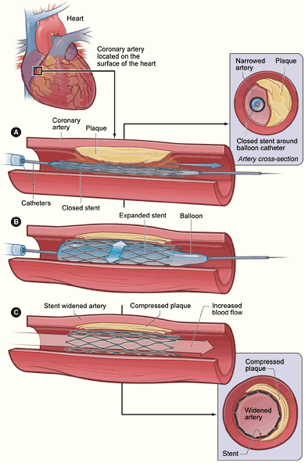

Image sources: (angioplasty) National Institutes of Health, US Department of Health & Human Services, http://www.nhlbi.nih.gov/health/dci/Diseases/Angioplasty/Angioplasty_WhatIs.html or OR http://www.nhlbi.nih.gov/health/dci/Diseases/Angioplasty/Angioplasty_howdone.html, (coronary bypass surgery) and National Health and Medical Research Council, Australian Government, http://www.nhmrc.gov.au/publications/synopses/withdrawn/cp35.pdf, pg 13, modified by Jay Shah, ITL Program, University of Colorado at Boulder.

