
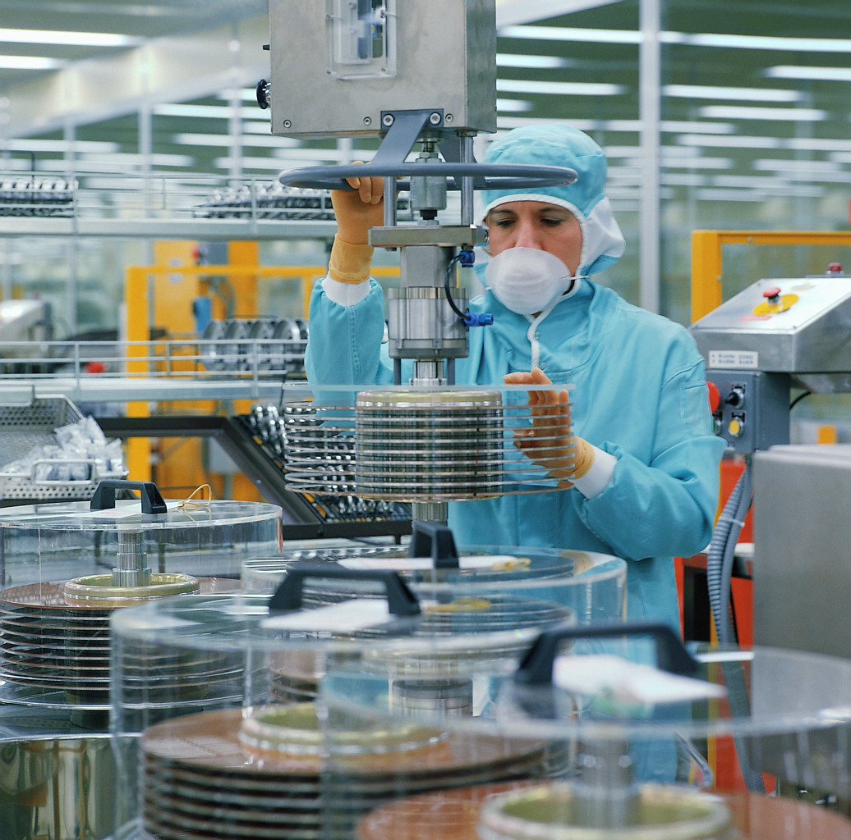
Face Mask Filters
Design Worksheet
- Product name (Give your filter a name): _________________________________________
- How many breaths could you take in one minute on your respiratory system model? _______
- Define the problem (Why are you making this product?): ___________________________________________________________________________
___________________________________________________________________________
- Design: What materials will you use? Why?
Material | Material Benefits (filter ability, comfort, durability, attachment, etc.)
- Draw a sketch of your design here. Label the different materials and sizes.

- Build a prototype of your design
- Analyze your design
Rank the various features of your face mask filter in the following chart:
Features | ← Not at all ——————— Extremely→
Is it easy to breathe through the mask? | 1 | 2 | 3 | 4 | 5 | 6 | 7 | 8 | 9 | 10
Are there gaps in the mask? (where polluted air can enter) | 1 | 2 | 3 | 4 | 5 | 6 | 7 | 8 | 9 | 10
Is it comfortable to wear? | 1 | 2 | 3 | 4 | 5 | 6 | 7 | 8 | 9 | 10
How well does it attach to the face? | 1 | 2 | 3 | 4 | 5 | 6 | 7 | 8 | 9 | 10
Is it durable? (So it will not fall apart?) | 1 | 2 | 3 | 4 | 5 | 6 | 7 | 8 | 9 | 10
Is it affected by water or humidity? | 1 | 2 | 3 | 4 | 5 | 6 | 7 | 8 | 9 | 10
How many breaths could you take in one minute on your respiratory system model with the filter mask? ___________
Was this more or fewer than the number of breaths without the filter mask? Why? ___________________________________________________________________________
___________________________________________________________________________
Looking at you analysis chart, how effective is your face mask filter? ___________________________________________________________________________
___________________________________________________________________________
You could not see the air pollution particles flowing through your mask. How would you test your mask’s effectiveness in removing harmful particles from the air? ___________________________________________________________________________
___________________________________________________________________________
- Redesign: What improvements would you make to your mask if you were to redesign it? ___________________________________________________________________________
___________________________________________________________________________
___________________________________________________________________________
___________________________________________________________________________
___________________________________________________________________________
___________________________________________________________________________
___________________________________________________________________________
___________________________________________________________________________

