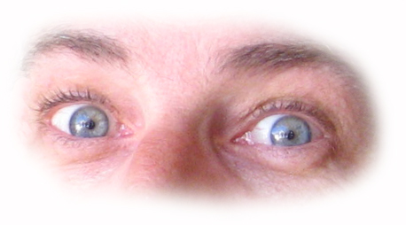
Protective Eyewear
Design Brainstorming Worksheet
Activity or sport to design for: mountain biking
Risks and hazards to eyes during this activity or sport:
Example Answers
- Eyes watering from wind in eyes
- Dirt and dust from trail
- Small rocks and sand kicked up from wheels
- Low branches and vegetation blocking the trail
- Bugs and plant matter in air
- UV rays from sun while riding on exposed ridges and open clearings
- Sun shining in eyes, creating glare, making it hard to see
- Loss of contrast in low-light settings (at dusk or in dense forest)
- Rough, erratic movements cause glasses to fall off
Design features: (Also note the risk/hazards #s each feature addresses)
- Full coverage lenses that are shaped to fit face contours (1,2,3,4,5)
- Curved lens that wraps around to protect the eyes from the sides, as well (3,4)
- UV protective film (6)
- Colored/shaded, polarized lens (7)
- Interchangeable lenses for use in different lighting conditions (7,8)
- Light-weight so they are comfortable and less likely to fall off during jostling (9)
- Spring action stems to provide clamping force on head (9)
- Thin, ergonomic design to integrate with helmet and straps (9)
- Lens made of scratch-resistant, shatter-proof plastic for durability and safety in a crash
- No sharp points or edges, for comfort and protection in case of a crash
Draw a sketch of what your protective eyewear will look like. Label all parts and materials.
